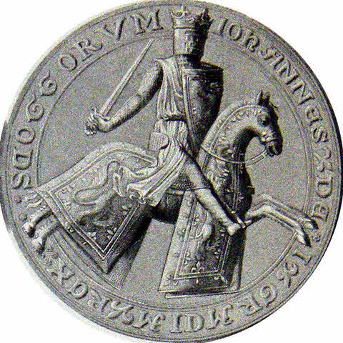
What happened to John Balliol?
Resource Sheet 6

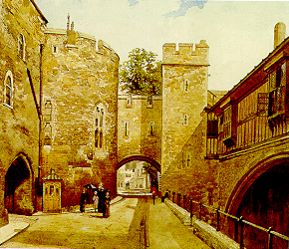
Edward managed to take over Scotland quickly due to the size of his army. One by one, important Scottish castles fell to the English. King Edward wanted to punish John Balliol and make an example of him. Edward stripped John Balliol’s crown from him and removed his royal seal. The Royal coat of arms was ripped from his coat. This earned him the nickname ‘Toom Tabard’, or ‘empty coat’. Edward also took other symbols of wealth from Scotland, including the ‘Stone of Destiny’ which was of important significance to Scots.
John Balliol’s Royal Seal
John Balliol was taken to London and imprisoned in the Tower of London. Edward was now in charge of Scotland.

Task One

Create a mind map using the information above.
What happened to John Balliol?

