Part One
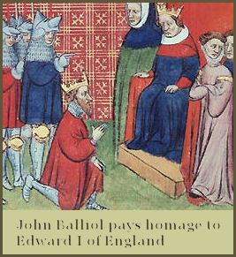
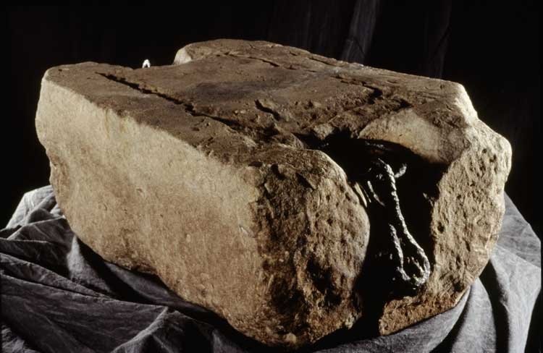
On St Andrew’s Day 1292, John Balliol was crowned King of Scotland on the Stone of Scone in Perth. This is called John Balliol’s coronation. John Balliol bowed down to King Edward and paid homage to him. This showed the Scottish people that John Balliol would really be King Edward’s puppet. They were not happy.
Resource Sheet 4

Vocabulary

Stone of Scone – a special stone used at the coronation of Scottish Kings and Queens. Sometimes called Stone of Destiny.

Coronation – when a new King or Queen is crowned

Paying Homage – agreeing that someone else is above you and you are their servant.

Part Two

King Edward soon started meddling in Scottish affairs. King Edward had taken England into a war with France and demanded that John Balliol send Scottish soldiers to help him. People were surprised when John Balliol said no! In fact, John Balliol made a treaty with France and entered into what is known as the Auld Alliance. This was very brave of John Balliol – the English had the strongest army in the world. Naturally, Edward was furious.

Vocabulary

Treaty – an agreement made with another country, often to help one another

Auld Alliance – the Scottish/ French friendship

Part Three

