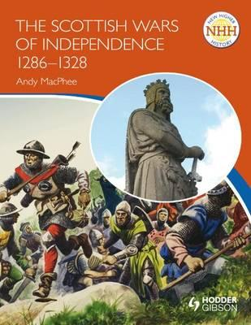
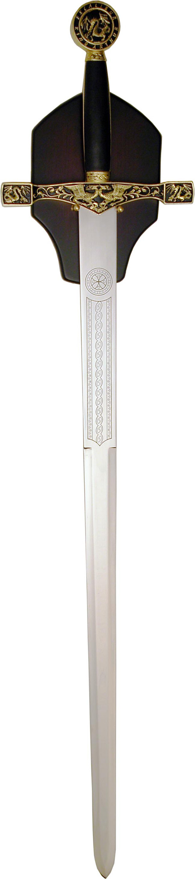
Primary or Secondary Source?
Resource Sheet 3

- The coat King Alexander was wearing on the night he died in 1286
- A description of King Edward, written by one of his knights
- A textbook about the Scottish Wars of Independence written in 1960
- A sword used by William Wallace found by an archaeologist in 1920
- Your teacher telling you about the Scottish Wars of Independence
- The film Braveheart
- Your grandparent telling you about William Wallace
- A painting of King Edward, completed in 1290
- The programme Horrible Histories telling us about the Scottish Wars of Independence
- Reading a webpage about King Edward I
