Robert the Bruce
Resource Sheet 14

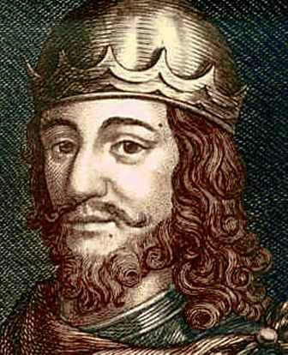

After the death of William Wallace, Edward became Overlord of Scotland again. The English were in control. Robert the Bruce, a Scottish noble hatched a plan to become King. John Balliol was still in the Tower of London. Bruce competed with John Comyn to become King. The two were great rivals although Comyn was John Balliol’s nephew so perhaps had a stronger claim. It is thought that the two men hated each other and all the other nobles in Scotland sided with either Bruce or Comyn.

In 1306 Robert the Bruce met with John Comyn. It is unclear why they met. Scottish versions of history say that they met to join forces but some English accounts say that Bruce arranged the meeting so that he could betray Comyn. After an argument, Bruce murdered Comyn in Greyfriars Kirk in Dumfries. This angered the Comyn family, the Church and Edward I. Bruce was excommunicated from the Church for his actions – this meant he could no longer be a member of the Christian Church. Within 6 weeks, Robert was crowned King of Scotland.

Because he had so many enemies, Robert the Bruce ran away into hiding for a while. When he returned he started a successful guerrilla campaign against the English. Edward sent an army north to fight Bruce’s men. Before his army reached Scotland, King Edward died. Robert the Bruce used this to his advantage. Edward II was weak. He managed to take back most of the castles and take back control of Scotland.

Bruce is remembered in Scotland as a hero and a patriot. He would eventually lead the Scots to many victories. However, some historians have suggested that he was a selfish man and wanted to gain control of Scotland at any cost.

