Wallace the Freedom Fighter
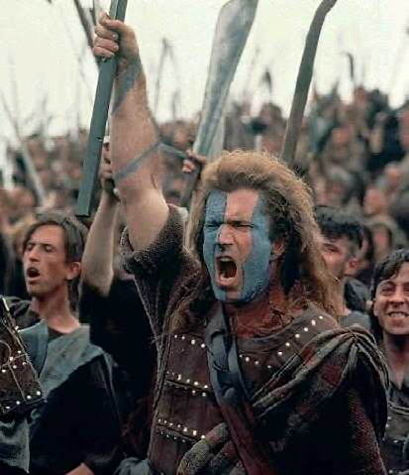
Resource Sheet 12

William Wallace was a hero and it is only right that he is remembered today as being a Scottish patriot. Wallace represented the people of Scotland and his actions were backed by most Scots. For years the English terrorised Scotland and under the conniving King Edward I managed to steal control from the Scots.

The English destroyed countless towns in Scotland and murdered thousands of innocent men, women and children. Should Scots have been expected to simply continue living this nightmare? Or should they turn to someone who wanted to end the nightmare for them? The answer was obvious and that is why the people of Scotland backed William Wallace.

Wallace stood for the rights of every Scottish person. He was a freedom fighter – he fought for freedom from the tyrannical English who had for years dominated Scotland. Scotland suffered greatly under English rule. England became rich at Scotland’s expense.

Wallace was a freedom fighter and a hero – there is no question of this.

