The Battle of Falkirk
Resource Sheet 10

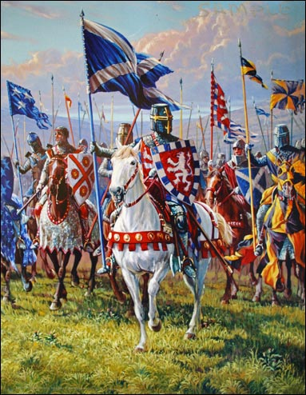
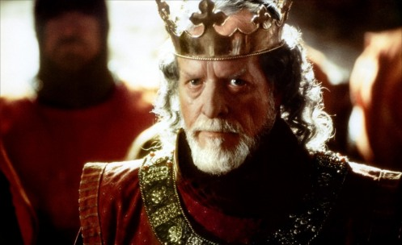

The Battle of Falkirk took place near the Scottish town of Falkirk in 1298. King Edward led the English forces against William Wallace’s Scottish army. Edward was furious at the defeat of his army at Stirling Bridge. He decided to invade Scotland to get revenge. He got together a large army and some Scottish nobles helped him.

Wallace was worried. He knew the English would be better prepared than they were at Stirling Bridge. Wallace used his schiltrons again. This time there were more schiltrons and bigger schiltrons. However, this time it was not enough to defeat the well trained English Army.

The battle was fought on open, flat land. There was no bridge to slow the English down. Edward’s army had longbows which took out huge parts of the Scots army at once and the English knights were too powerful for the Scots.

William Wallace resigned as Guardian of Scotland after his defeat at Falkirk. Several nobles also now left Wallace and joined Edward. These included Red Comyn, John Balliol’s nephew and Robert the Bruce.

