1. Answer the following questions in your jotter whilst watching the clip from Human Planet:

[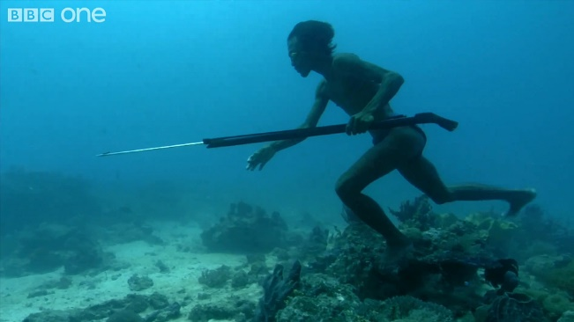](https://www.google.co.uk/url?sa=i&rct=j&q=&esrc=s&source=images&cd=&cad=rja&uact=8&ved=0ahUKEwjkndLA0MfRAhVDPxoKHSELACAQjRwIBw&url=http://otlfitness.com/category/uncategorized/page/3/&psig=AFQjCNFdq90k29Fwcg1UCNr2p9X88dTX0g&ust=1484689217030248)

1. How deep does he dive to reach the sea floor?
2. What rate does his heart rate slow to?
3. What volume of his lungs is still usable?
4. What gas filling his blood causes him to need to take a breath?
5. How long is he underneath the water for in this particular fishing expedition?

2. Answer the following questions in your jotter whilst watching the clip from Frozen Planet:

[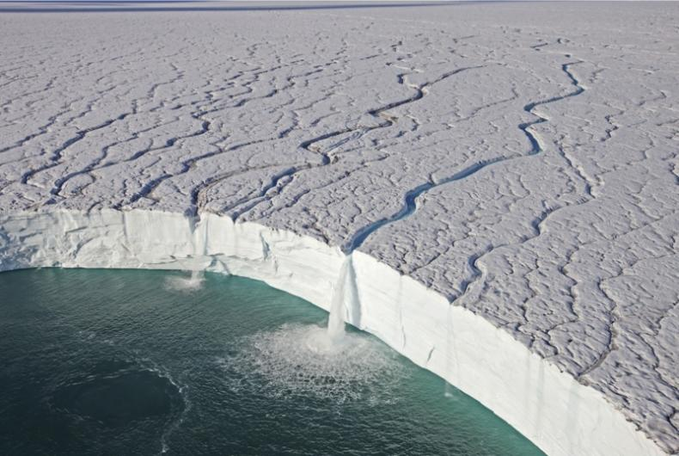](https://www.google.co.uk/url?sa=i&rct=j&q=&esrc=s&source=images&cd=&cad=rja&uact=8&ved=0ahUKEwiA7Nzg0MfRAhVEfxoKHVKABDoQjRwIBw&url=http://www.discoverwildlife.com/gallery/frozen-planet-episode-3-photo-gallery&bvm=bv.144224172,d.d2s&psig=AFQjCNFIX0csIXYeVj-HM1NisCiVmDvONQ&ust=1484689286131749)

1. What spectacular thing does the increasing power of the sun create?
2. How long is the melting ice sheet?
3. How many waterfalls does it contain?
4. Does the ice completely disappear during the Summer?