 | Information point |  | Pub
 | Cap Park |  | View Point
 | Public telephone |  | Picnic site
 | Camping site |  | Youth Hostel
 | Caravan site | 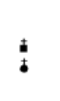 | Church
 | Golf course |  | Nature reserve
 | Foot path / trail |  | Museum
 | Castle |  | Country park

