**Direct Democracy: Definition, Examples, Pros and Cons**

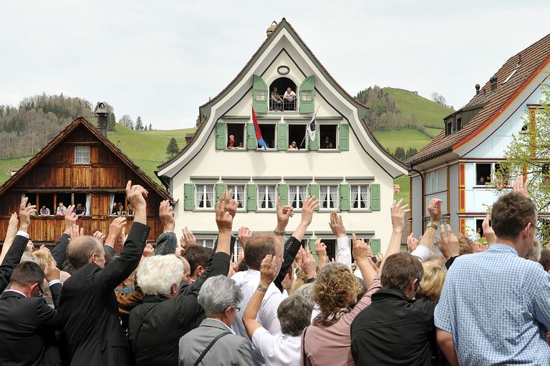Direct democracy, sometimes called "pure democracy," is a form of democracy in which all laws and policies imposed by governments are determined by the people themselves, rather than by representatives who are elected by the people.

In a true direct democracy, all laws, bills and even court decisions are voted on by all citizens.

### Direct vs. Representative Democracy

Direct democracy is the opposite of the more common [representative democracy](https://www.thoughtco.com/representative-democracy-definition-pros-cons-4589561), under which the people elect representatives who are empowered to create laws and policies for them. Ideally, the laws and policies enacted by the elected representatives should closely reflect the will of the majority of the people.

While the United States, with the protections of its [federal](https://www.thoughtco.com/what-is-federalism-3321880) system of “[checks and balances](https://www.thoughtco.com/separation-of-powers-3322394),” practices representative democracy, as embodied in the [U.S. Congress](https://www.thoughtco.com/powers-of-the-united-states-congress-3322280) and the state legislatures, two forms of limited direct democracy are practiced at the state and local level: [ballot initiatives and binding referendums](https://www.thoughtco.com/the-ballot-initiative-process-3322046), and [recall of elected officials](http://www.ncsl.org/research/elections-and-campaigns/recall-of-state-officials.aspx).

Ballot initiatives and referendums allow citizens to place – by petition – laws or spending measures typically considered by state and local legislative bodies on statewide or local ballots. Through successful ballot initiatives and referendums, citizens can create, amend or repeal laws, as well as amend state constitutions and local charters.

### Examples of Direct Democracy: Athens and Switzerland

Perhaps the best example of direct democracy existed in ancient Athens, Greece. While it excluded women, slaves, and immigrants from voting, Athenian direct democracy required all citizens to vote on all major issues of government. Even the verdict of every court case was determined by a vote of all the people.

In the most prominent example in modern society, Switzerland practices a modified form of direct democracy under which any law enacted by the nation’s elected legislative branch can be vetoed by a vote of the general public. In addition, citizens can vote to require the national legislature to consider amendments to the Swiss constitution.

### **Pros and Cons of Direct Democracy**

While the idea of having the ultimate say-so over the affairs of government might sound tempting, there are some good – and bad – aspects of direct democracy that need to be considered:

### **3 Pros of Direct Democracy**

1. **Full Government Transparency:** Without a doubt, no other form of democracy ensures a greater degree of openness and transparency between the people and their government. Discussions and debates on major issues are held in public. In addition, all successes or failures of the society can be credited to – or blamed on – the people, rather than the government.
2. **More Government Accountability:** By offering the people a direct and unmistakable voice through their votes, direct democracy demands a great level of accountability on the part of the government. The government cannot claim it was unaware of or unclear on the will of the people. Interference in the legislative process from partisan political parties and special interest groups are largely eliminated.
3. **Greater Citizen Cooperation:** In theory at least, people are more likely to happily comply with laws they create themselves. Moreover, people who know that their opinions will make a difference, they more eager to take part in the processes of government.

### **3 Cons of Direct Democracy**

1. **We Might Never Decide:** If every American citizen were expected to vote on every issue considered at every level of government, we might never decide on anything. Between all of the issues considered by local, state and federal governments, citizens could literally spend all day, every single day voting.
2. **Public Involvement Would Drop:** Direct democracy best serves the interest of the people when most people take part in it. As the time required for debating and voting increases, public interest, and participation in the process would quickly decrease, leading to decisions which did not truly reflect the will of the majority. In the end, small groups of people often with dangerous axes to grind, could control the government.
3. **One Tense Situation After Another:** In any society as large and diverse as that in the United States, what is the chance of that everyone will ever happily agree with or at least peacefully accept decisions on major issues? As recent history has shown, not much.

# Representative Democracy: Definition, Pros, and Cons

## Government Created by the People, for the People

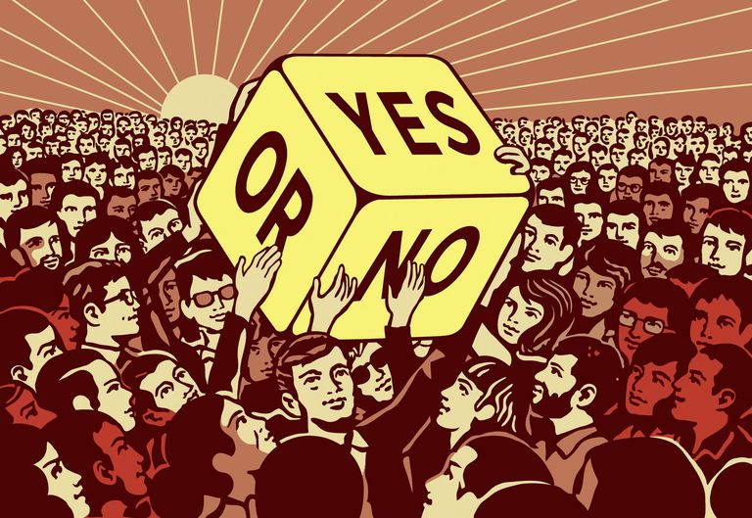

Representative democracy is a form of government in which the people elect officials to create laws and policy on their behalf. Nearly 60% of the world’s countries employ a form of government based on representative democracy, including the United States (a [democratic republic](https://www.thoughtco.com/republic-vs-democracy-4169936)), the United Kingdom is (a [constitutional monarchy](https://www.thoughtco.com/constitutional-monarchy-definition-examples-4582648)), and France (a [unitary state](https://www.thoughtco.com/unitary-state-government-pros-cons-examples-4184826)). Representative democracy is sometimes called indirect democracy.

### **Representative Democracy Definition**

In a representative democracy, the people elect officials to create and vote on laws, policies, and other matters of government on their behalf. In this manner, representative democracy is the opposite of [direct democracy](https://www.thoughtco.com/what-is-direct-democracy-3322038), in which the people themselves vote on every law or policy considered at every level of government. Representative democracy is typically employed in larger countries where the sheer number of citizens involved would make direct democracy unmanageable.

Common characteristics of representative democracy include:

* The powers of the elected representatives are defined by a constitution which establishes the basic laws, principles, and framework of the government.
* The constitution may provide for some forms of limited direct democracy, such as [recall elections](https://www.thoughtco.com/why-a-recall-wont-work-3367929) and [ballot initiative](https://www.thoughtco.com/the-ballot-initiative-process-3322046) elections.
* Elected representatives may also have the power to select other government leaders, such as a prime minister or president.
* An independent judiciary body, such as the [U.S. Supreme Court](https://www.thoughtco.com/current-justices-of-the-supreme-court-3322418), may have the power to declare laws enacted by the representatives to be unconstitutional.

In some representative democracies with [bicameral legislatures](https://www.thoughtco.com/why-we-have-house-and-senate-3322313), one chamber is not elected by the people. For example, members of the British Parliament’s House of Lords and the Senate of Canada obtain their positions through appointment, heredity, or official function.

Representative democracy stands out in sharp contrast to forms of government such as [totalitarianism, authoritarianism, and fascism](https://www.thoughtco.com/totalitarianism-authoritarianism-fascism-4147699), which allow the people little-to-no elected representation.

### **Representative Democracy in the U.S.**

In the United States, representative democracy is employed at both the national government and state government levels. At the national government level, the people elect the president and the officials who represent them in the two chambers of Congress—the [House of Representatives](https://www.thoughtco.com/house-of-representatives-3322270) and the [Senate](https://www.thoughtco.com/about-the-us-senate-3322271). At the state government level, the people elect the governor and members of the state legislatures who rule according to the state constitutions.

The [President](https://www.thoughtco.com/about-president-of-the-united-states-3322139) of the United States, the Congress, and the [federal courts](https://www.thoughtco.com/the-us-federal-court-system-3322407) share powers reserved to the national government by the [U.S. Constitution](https://www.thoughtco.com/us-constitution-and-bill-of-rights-4133019). In creating a functional system called “[federalism](https://www.thoughtco.com/what-is-federalism-3321880),” the U.S. Constitution also shares certain political powers with the states.

### **Pros and Cons of Representative Democracy**

Representative democracy is the most prevalent form of government. As such, it has both advantages and disadvantages to the government and the people.

#### **3 Pros of Representative Democracy**

1. **Efficient:** A single elected official represents the desires of a large number of people. In the United States, for example, just two U.S. Senators represent all of the people in their states. By conducting a limited number of national elections, countries with representative democracies save time and money, which can then be devoted to other public needs.
2. **Empowers the People:** The people of each of the country’s political subdivisions (state, district, region, etc.) choose the representatives who will make their voices heard by the national government. Should those representatives fail to meet the expectations of their constituents, the voters can replace them in the next election.
3. **Encourages Participation:** When people are confident that they have a say in their government's decisions, they are more likely to remain aware of issues affecting their country and to vote as a way of making their opinions on those issues heard.

#### **3 Cons of Representative Democracy**

1. **Not Always Reliable:** The votes of elected officials in a representative democracy may not always reflect the will of the people. The officials are not bound by law to vote the way the people who elected them want them to vote. Unless term limits apply to the official in question, the only options available to dissatisfied constituents are to vote the representative out of office in the next regular election or, in some cases, to demand a recall election.
2. **Can Become Inefficient:** Governments shaped by representative democracy may develop into massive [bureaucracies](https://www.thoughtco.com/bureaucracy-definition-examples-pros-cons-4580229), which are notoriously slow to take action, especially on momentous issues.
3. **Can Invite Corruption:** Candidates may misrepresent their stances on issues or policy goals in order to achieve political power. In office, politicians may act in the service of personal financial gain rather than for the benefit of their constituents (sometimes to the direct detriment of their constituents).

In the final analysis, a representative democracy should truly result in a government that is created “by the people, for the people.” However, its success in doing so depends on the people’s freedom to express their wishes to their representatives and the willingness of those representatives to act accordingly.