Legitimacy and Electoral Systems

For a government to be legitimate, they must have the authority to act on behalf of the people. A crucial part of our political process which produces legitimacy is the electoral system. In Britain, in particular, the legitimacy of governments has been increasingly called into question because of the way in which the electoral system works. Specifically, this has involved the increasing failure of the electoral system to produce results, and governments, which reflect the will of the people.
Firstly, under the electoral system for UK general elections, First Past the Post, a significant number of votes are wasted. For example, all the votes for the losing candidates are wasted in the sense that they are not represented in the House of Commons. Moreover, all the votes for the winning candidate over and above that which is needed to win are in fact surplus, as you only need one more vote than your nearest rival. Consequently, nationally the percentage of votes a party gets is in no way in proportion to the percentage of seats it gets in the Commons. Moreover most MPs are elected with less than half the votes in their constituency.

Nationally this means that governments in Britain are very rarely elected with more than 50% of the vote in a General Election. In fact in the 20th century this has happened only twice, in 1900 and in 1931. The system can also produce a situation where one party can win more seats than any other, but with fewer votes than another party. This happened in February 1974 when the Conservatives polled 37.9% of the vote, with Labour second with 37.1%. However Labour had 301 MPs to the Conservatives 297, and, as such, formed the government.

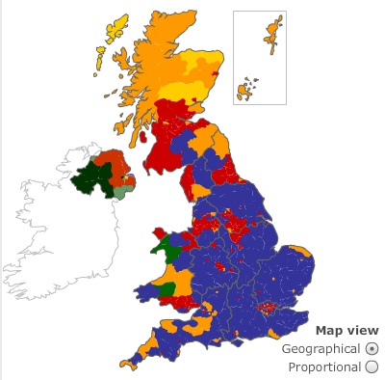
The FPTP system is very unfair on smaller parties. This is because it favours parties such as Labour and Conservative in Britain whose support is concentrated in certain areas. The ‘winner takes all’ principle means that smaller parties find it very difficult if not impossible to convert support into meaningful representation, particularly if their support is spread out.

This was vividly demonstrated in May 2005 when, on average, it took 26,858 votes to elect each Labour MP, compared with 44,241 for a Tory MP and 98,484 for each Liberal Democrat MP.

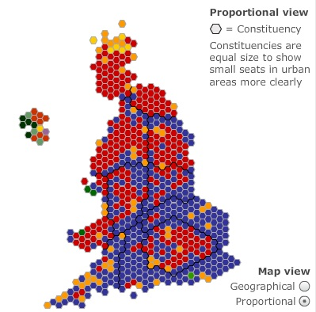
The FPTP can also lead to huge regional differences from one part of the country to the next. For example, in 2010 the Conservatives actually polled more votes than Labour in England, but once more did particularly badly in Wales and even more so in Scotland.

Critics of the current system also point out that in Britain, amongst the 650 constituencies, the vast majority are usually ‘safe’, and so the outcome of General Elections are dependent on what happens in a handful of ‘marginal’ seats.

A final argument is that single member constituencies are actually less representative than in a system where there are several representatives per constituency. This is because within an area of up to 100,000 people there is going to be a huge variation in terms of social class, ethnic background, religion, etc., which cannot possibly be represented by one person. Therefore in the Commons whole groups such as ethnic communities, women, working class people, etc., are very poorly represented.

Legitimacy and Elections

- Why is it important for electoral systems to be legitimate in democratic countries?
- What problems exist with the British electoral system that could affect the outcomes legitimacy? Combine the information in the booklet with your own knowledge.
- Write a detailed definition of the term ‘legitimacy’. Structure your answer as a short paragraph – Developed Points - Examples.
- Make a protest placard that questions the legitimacy of the current UK Government or political system.

