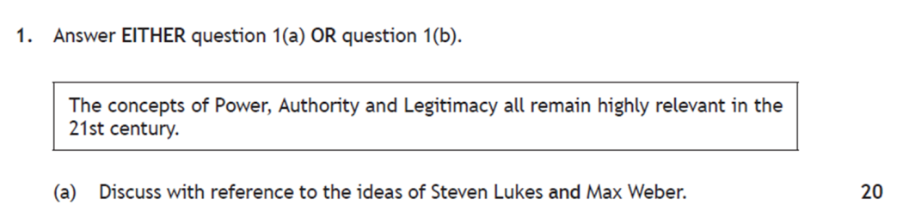**Higher Politics – Political Theory Essay Plan – 20 mark essay Power, Authority, Legitimacy**

**Paragraph 1 – Introduction – 2 marks**

* Define the main topic of the essay i.e. P,A,L
* Identify the issues the essay will discuss
* Identify the theorists who will be discussed in the essay
* What is your main argument

*Make sure all of this is related to the exact wording of the essay question* ^^^

**Paragraph 2 – Types of Power**

* Pick one or two types of power from Absolute Power, Power Politics/ Machiavellianism, Separation of Powers etc.
* Describe the type of power and how it is exercised
* Give a detailed example of the power in practice form past/ present
* Analyse – How does this type of power impact on citizens - *It can be argued that this type of Power….*

**Paragraph 3 – Lukes and the three types of Power**

* Discuss Lukes’ Three types of Power – Open Face of Power, Closed Face (Agenda Setting), Power as Thought Control/ Manipulating Desires

Each type should have:

* K: A detailed description of the type of power
* K Ex: a detailed example of this type of power in action
* A: A detailed discussion of its impact on citizens/ relevance

**Paragraph 4 – Weber’s Classifications of Authority**

* Discuss Weber’s Three types of Authority – Traditional, Charismatic and Legal- Rational

Each type should have

* K: A detailed description of the type of power
* K Ex: a detailed example of this type of power in action
* A: A detailed discussion of its impact on citizens/ relevance

**Paragraph 5 – Legitimacy**

* K: What is legitimacy? Definition and description - Use phrases *‘Legitimacy as Rightful Power’ ‘Authority is power cloaked in legitimacy’*
* K Ex: Leaders who lack legitimacy and why e.g. Brown, May
* A: Discussion on impact – what may happen if a leader or group lacks legitimacy? How can legitimacy be gained? ‘It can be argued that…’

**Paragraph 6 – Conclusion – 4 marks**

* Start *‘In conclusion’*
* Sum up your key ideas – good idea to try and provide a mini conclusion for each key paragraph – support each with an example
* Define the final argument i.e. *Legitimacy is the key concept which gives leaders authority* – and use evidence to back this up
* You can also do mini conclusions at the end of paragraphs – use ‘Overall…’ to signpost