Introduction
Teams is a facility that can be used to allow files to be shared between teachers and pupils, to allow pupils to ask questions and for announcements to be made. There are two main ways to access Teams – through the app which can be downloaded from the App Store (Apple devices) and Play Store (Android devices) and Glow. This guide will focus on the main features of accessing Teams through Glow. This is not an exhaustive guide to every aspect of Teams.

Getting Started
Once you log into Glow you see your launch pad that displays the shortcuts and apps you access – these are called tiles. The Teams tile looks like this:

If you already have this, you can skip to the next section. If you haven’t got this, follow these steps:

- Click on App Library at the top left
- In the search bar type in Teams
- Click on the Teams icon
- Select ‘Add to my Launchpad’
- Click on Launchpad at the top left

Accessing Teams
Once you have logged into Glow, Click on the Teams tile on your launchpad. You will then see lots of Teams, like this:
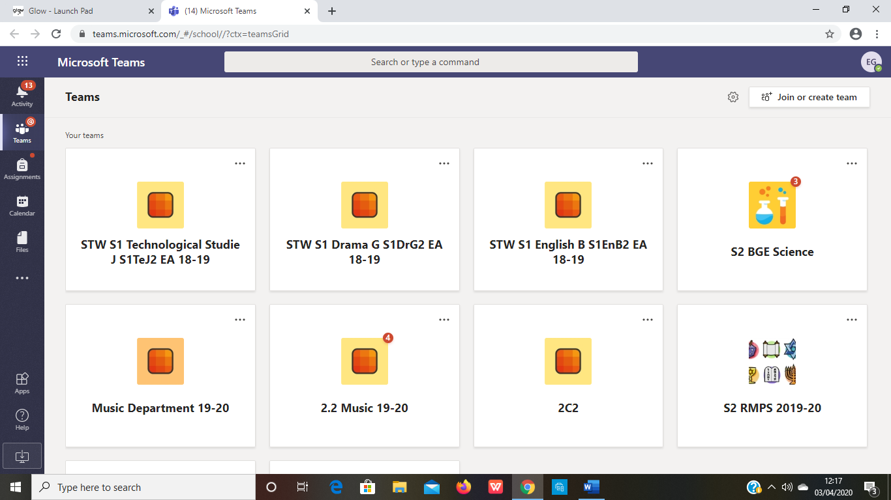

There are teams for every class but to keep things simple, you should access the team for your year group as this is where you will find instructions and notifications. In terms of submitting work for a teacher this can done through the team for that class (we’ll get to that in more detail later) but the instructions will be in the year group team.

To begin with you will need to join the Team for your year group by entering a code. To do so, click on Join or Create a Team at the top right of the screen.

You should then see this at the left of the screen

Enter your code (listed below) then click Join Team.

Year Group | Team Name | Team Logo | Team Code
S1 | Stewarton Academy S1 |  | 7ecce1h
S2 | Stewarton Academy S2 |  | 6p2lkfg
S3 | Stewarton Academy S3 |  | mkyj4h9
S4 | Stewarton Academy S4 |  | m74mvlw
S5 | Stewarton Academy S5 and S6 |  | 1lx93n7

Finding About Teams
When you access a team you will see this area at the top of the screen. Let’s look at some of these areas in detail.

Posts This is where announcements are made
Files This is where documents can be uploaded to by teachers.

Posts will be used for any notifications that teachers want to make to you. Each week instructions for your year group, including tasks to be undertaken by you will be posted here. Announcements for the whole year group will be made here.

Files is where any materials you need e.g. worksheets will be posted.

Each team is divided into different sections, called Channels, for each of your subjects. Each channel has its own posts and files. The first time you log into your year group team you need to make sure you can see each channel. Follow the steps below to make sure you can see them.

At the left-hand side of the screen, move the mouse to where it shows 11 hidden channels. Click on the arrow that appears to see the list of channels (below):

For each channel e.g. Art and Technical, move the mouse over it and click on Show. You will need to do this for all channels. Once you have done this you can see all the channels you need!

To upload work for your teachers you will need to follow the instructions that have been left for your class and subject. This is really important so that only you and your teacher can see your work.

