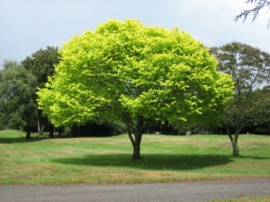
The Great Outdoors

Identify trees from the leaves and make rubbings to share your knowledge | Fly a kite | Go for a walk in the countryside | Collect some leaves and sticks and make a piece of art | Lie on the ground and find shapes in the clouds
Enjoy time in the water; paddling, surfing or swimming | Climb a tree (with an adult there) | Go for a cycle | Have a picnic | List the wildlife you can find in your garden or local park
Build an outside den using different materials | Draw or paint a landscape or seascape | Collect some shells and make a piece of art | Write a poem about the outdoors | Design a bug or bird home
Learn how to, and play hopscotch | Look for signs of summer – write or draw your findings | Draw a line drawing of a tree, flower, bush, plant etc | Make a map of your street | Carry out a survey – Record the different birds/insects/plants you find in your garden or local area
Carry out a transport survey – How many cars/buses/vans etc did you see. | Make an information booklet about a topic of your choice | Design and make a bee garden | Plant a seed and record its growth | Help someone to – wash the car, do the garden, walk the dog etc

