Snack time
Dear children at St Andrews ECC
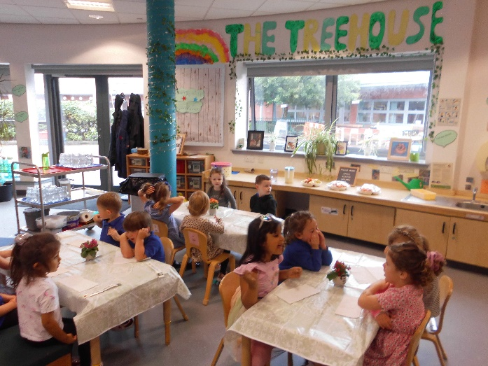
We are so happy to report that many of you seem to be enjoying our snack time in the ECC. Some of you used your thinking skills and came up with a fantastic name for our snack area - The Treehouse Café, and some others helped to make the incredible sign that is now above the snack area. How clever of you all!
Some of you have been enjoying our healthy fruit and those of you who are snack helpers have been learning to cut the fruit into bits to share. Rachel has commented on how helpful and clever you have all been and she is very impressed with the number sense you have shown counting out the pieces.
Our snack begins at a similar time each day and you are all free to come and go when it suits you, this has allowed you all to get into a good snack routine and to manage how much you need to eat at this time. You have all become super stars at remembering to wash your hands and then finding your name and posting it when you choose to come for snack. Very hygienic and clever reading skills!!
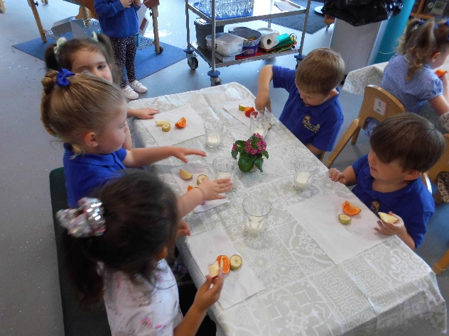
We have also been hearing lovely manners and some nice chatting amongst you all telling us and your friends about your likes and dislikes when trying the different fruits and generally having a chat about your days. These have shown us just how brilliant your social skills are and it is great to see you communicating nicely with your friends and letting us see how polite you can be.
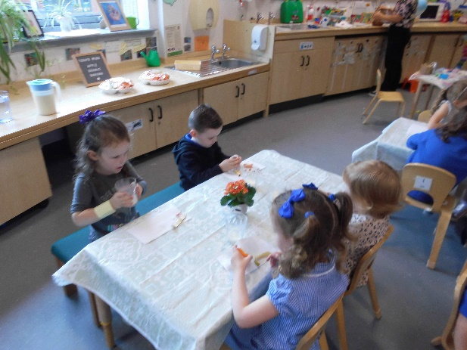
We hope in the next few weeks to begin getting you all to pour your own water or milk and to begin serving yourselves as we can already see how clever and capable you all are. We know this will make your more confident and independent and will also help to strengthen your hands and fingers and make picking up smaller items much easier. You will need strong fingers if you want to draw and write!
We hope you continue to have fun at snack times it has been great to see all the variety of skills you are developing and the enjoyment a lot of you have shown when having snack.
Happy Snacking
Love from St Andrews ECC staff

