Create some rules that people in the chocolate industry should follow to make sure workers are treated fairly.

**Fairtrade: The Chocolate Challenge**

_______________________________________________________________________________________________________________________________________________________________________________________________________________________________________________________________________________________________________________________________________________________________________________________________________________________________________________________________________________________________________________

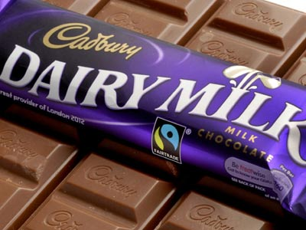

**Name: ______________________**

**Year: _____________**

**Favourite Chocolate Bar: __________________________**



How is chocolate made (from bean to shop)? Use pictures to support your ideas.



What do cocoa beans look like? Draw a picture.

What plants do they come from? Draw a picture.

How does Fairtrade help cocoa farmers?

_________________________________________________________________________________________________________________________________________________________________________________________________________________________________________________________________________________________________________________________________________________________________________________________________________________________________________________________________________________________________________________________________________________________________________________

How is the money that’s made from chocolate production shared out? Draw a bar chart to illustrate this.



Research chocolate bar wrappers. Paste some of your favourite designs here.



Design your own chocolate bar wrapper which includes the Fairtrade logo and all the relevant information.

