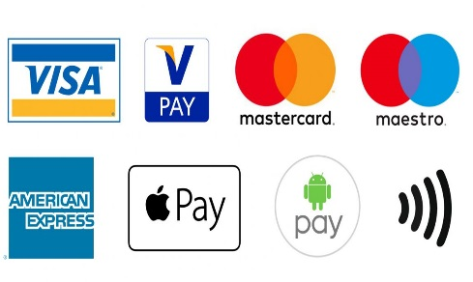**Methods of Payments**

Complete the table below – outline three advantages and three disadvantages for each payment method

|  |  |  |  |
| --- | --- | --- | --- |
| **Methods** | **Definition** | **Advantages** | **Disadvantages** |
| Cash |  |  |  |
| Direct debit |  |  |  |
| Credit card |  |  |  |
| Cheque |  |  |  |
| Contactless cards |  |  |  |
| Gift Cards |  |  |  |