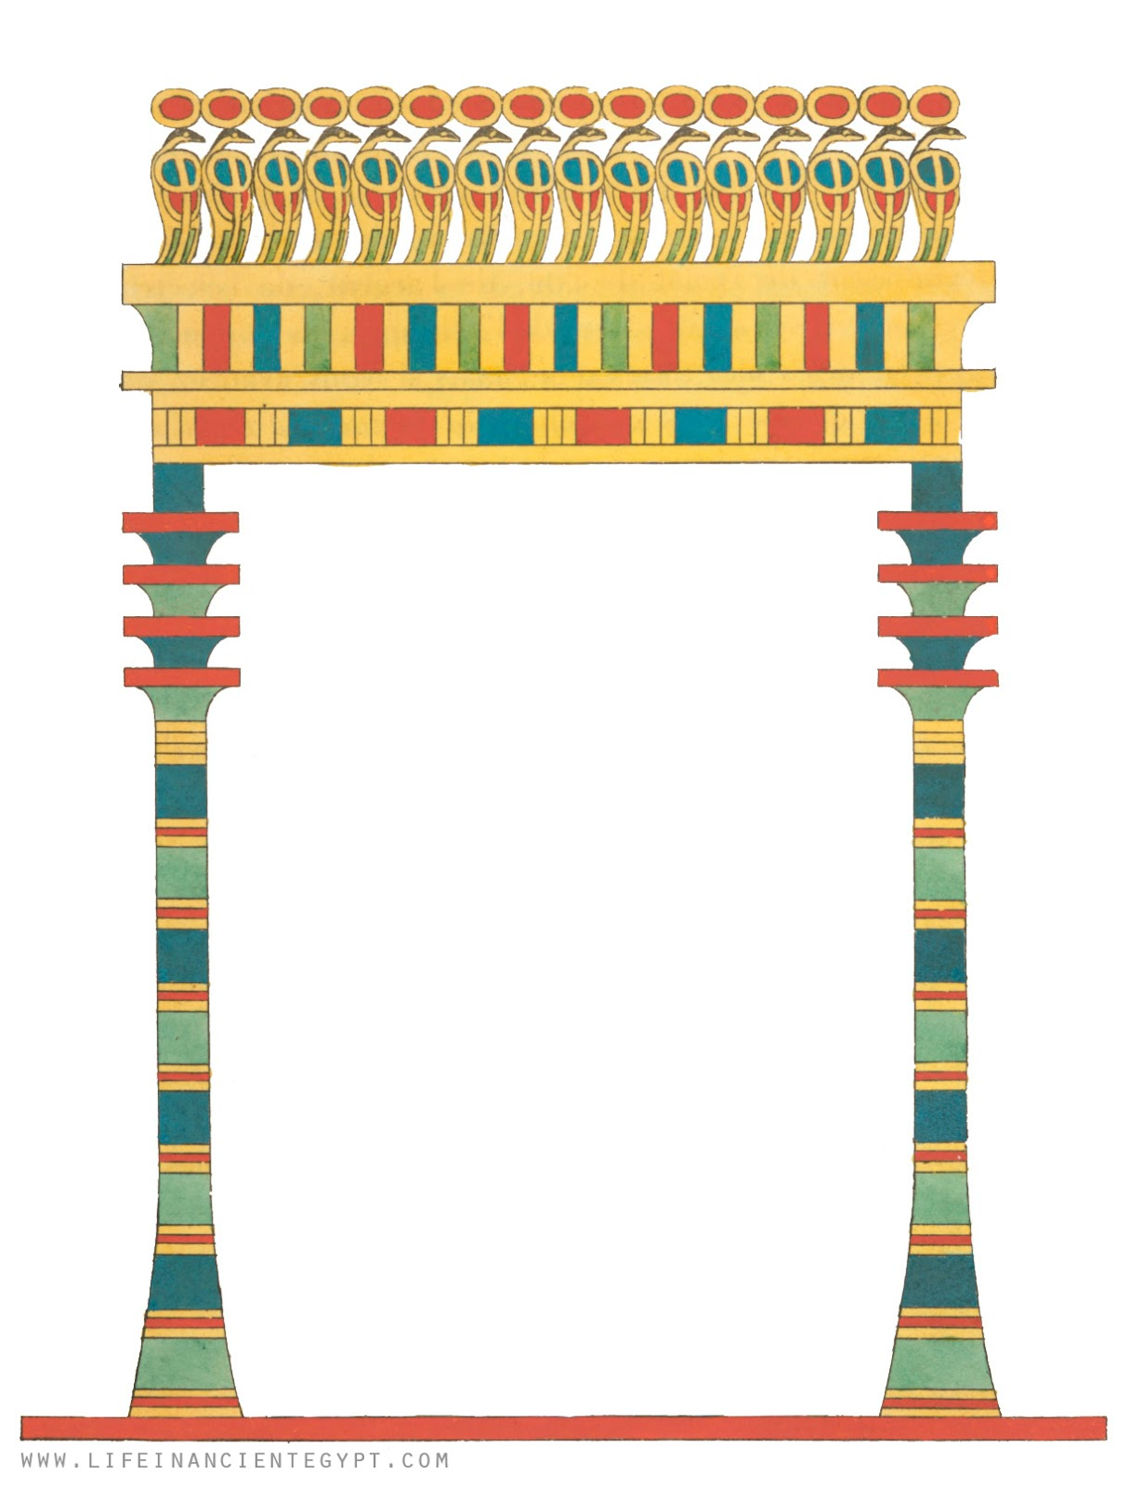

Name:

Name in Hieroglyphs:

God/Goddess of:

History: