**N5 Geography**

**Pick and Mix**

Pick any of the following questions to answer a total of 40 marks worth.

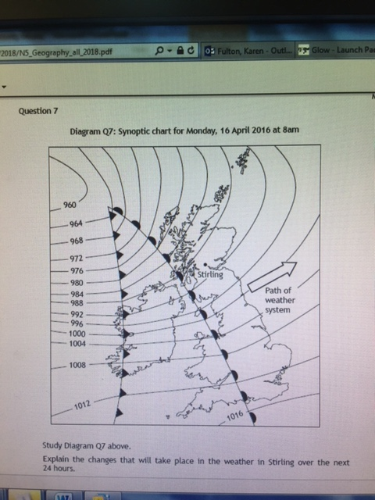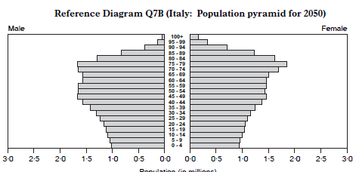Try to answer without the use of any notes. Remember to allow roughly 1 minute 30 seconds per mark.

What are the characteristics of the CBD of a developed world city you have studied. (8)

Describe the conditions of a shanty town you have studied in a developing world city.. (8)

Explain strategies put in place to manage traffic problems in a developed world city you have studied. (8)

Explain, in detail the weather conditions you would expect in Kilmarnock as a depression passes over the town. (10)

**Explain** the changes that will take place in the weather in Stirling over the next 24 hours (6)

**Explain** the factors which affect average temperatures in the UK (6)

**Explain** the changes in birth and death rates from stages 1 to 5 in the demographic transition model. Comment on overall population growth rates. (12)

**Explain the factors that affect the world’s population distribution. (8)**

Discuss the consequences of the 2050 population structure for the future economy of Italy and the welfare of its citizens. (6)

Explain why the use of one individual development indicator can be misleading, comment on an alternative. (6) (6)