Geography

Human Environments: Urban

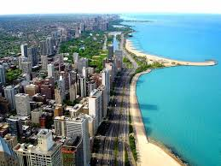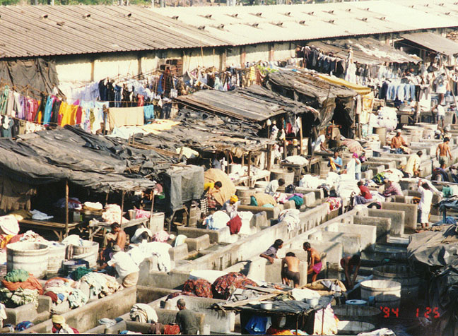

A Case Study of Mumbai, India

Mumbai: Site and Growth

Mumbai (formerly known as Bombay) is the largest city in India. Just like many of the cities found in Developing countries, Mumbai has many contrasts. There is a lot of glamour in the city, with 5 star hotels such as the Hyatt Regency and the Taj Mahal Palace, designer shops and exclusive apartment complexes. India’s film industry (Bollywood) is also based here. There are also many reminders of when the British ruled such as double-decker red buses like those found in London and cricket grounds. However, with a population of around 20 million, it is also one of the most crowded cities in the world. There is widespread poverty, a large criminal underworld and the largest slum found in Asia. Also, there is a huge mix of different religions, cultures and ethnic groups, leading to some tensions.

Site

The original site of Mumbai was an island off the west coast of India. It later grew as a trading and fishing port, and then as a small industrial centre which spread onto six more neighbouring islands. The wetlands between the islands is now reclaimed land in order to form one island – Bombay Island.

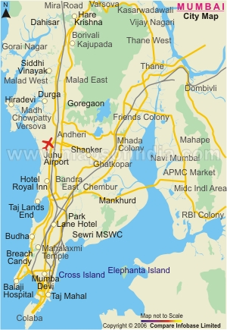 Map of Mumbai (mapsof india.com)

Growth

Once railways and factories were built, Mumbai grew in size and importance. The first railway lines connected Mumbai with the cotton-growing areas found inland which led to the building of weaving and cotton spinning mills. By 1900, many hundreds of thousands of people worked in the cotton industry alone, with others employed in other industries such as engineering and chemicals. These industries were attracted to Mumbai because of the large labour force on offer and the rail and water communications.

Since India gained its independence from Britain in 1947, the manufacturing industry in Mumbai has expanded and the service industries have developed even faster. Financial services, such as banks, insurance companies and finance houses have set up home in Mumbai, making it the biggest and most prosperous city in India.

In the last 100 years, the film industry has expanded and Mumbai now has the biggest film industry (Bollywood) in the world. It produces more films per year than Hollywood and it relies on wealthy people, of which Mumbai has more than any other Indian city, to fund the films. Also, because of the varied scenery and the guaranteed six months of dry, sunny weather, Mumbai is an ideal spot to film outdoors.

Since the 1990’s, multi-national companies for example insurance (Prudential), travel (British Airways) and technological (IBM) have all moved their call centre operations to Mumbai. There are many reasons to move here because wage rates are much lower than in developed countries such as the UK. This allows the company to increase their profits as wages make up most of the operating costs of a call centre. Also, there is an educated workforce which means call centres often attract graduates as wages are better than teaching. Lastly, productivity is much higher than in a developed country.

As industry was expanding, Mumbai was able to generate more money which it used to improve transport networks such as road, water and air. New schools and hospitals could be built and many entertainment venues and shopping malls were constructed for the wealthy people of Mumbai.

Mumbai today

Mumbai is the industrial powerhouse of India. Its port handles 40% of India’s trade by sea and its airport handles 60% of trade by air. The factories found in Mumbai make 25% of all goods that are made by India and its people pay 33% of all the income tax raised.

Land Uses

As Mumbai grew, its original site was taken over by businesses, making it the CBD. The CBD has expanded both westwards and southwards to occupy most of south Mumbai. Just as with most cities around the world, the main land uses are hotels, government buildings, entertainment, offices and shops. There are also some old industrial areas in the CBD, especially the old docks on the eastern side of the island. The remainder of the old industry is located next to the CBD though many of the old factories, particularly the cotton mills, have now closed.

New industrial areas and technology parks can be found in the suburbs. To the east is Navi Mumbai which has been built in the last 40 years, with Mumbai’s new port, many new industries, shopping centres and homes for more than one million people. Housing is found all over the city, including in the CBD.

Task 1 – Site and growth of Mumbai

(a) Create a table in your jotter to show the positive and negative aspects of Mumbai
(b) Describe the site of Mumbai
(c ) Describe how Mumbai has grown
(d) Why do multi-national companies such as IBM locate call centres in Mumbai?
(e) Describe how Mumbai has grown outwards over the years
(f) In what ways is Mumbai’s CBD similar to the CBD of Glasgow?

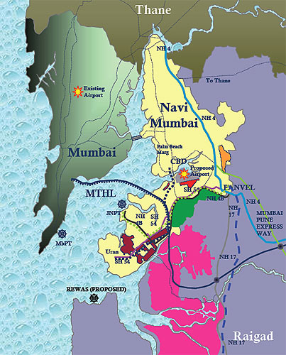
Housing Problems in Mumbai

In the last fifteen years, Mumbai’s population has increased by around 5 million (the size of the population of Scotland). Mumbai has tried to cater for the tastes and incomes of the different people who live and come to the city. Housing is varied, with million pound apartments for rich factory owners, stylish mansions for the stars of Bollywood, tenement housing for workers, shanty town housing for the poor and squatter settlements for destitute immigrants. Shanty towns and squatter camps are located all over the city and more live in them than any other housing type.

Squatter Camps

Squatter settlements are where the poorest accommodation is found. They are defined as places where people settle on land which they do not own or rent and build their own house, which is little more than a makeshift shelter.

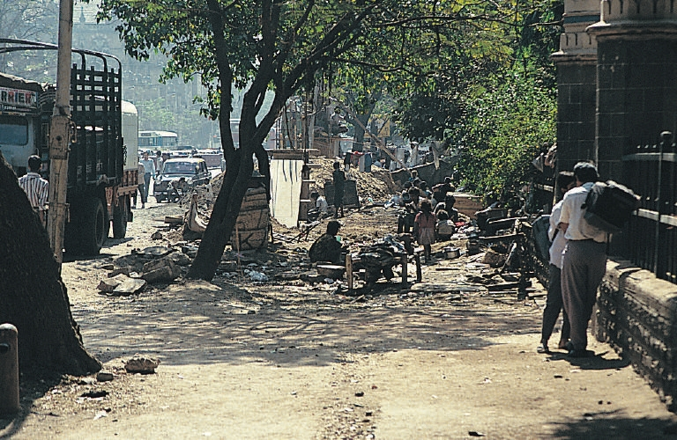

They are made of materials that people can find easily, such as cloth, supported by wooden poles. There are no amenities in a squatter settlement, meaning there are no toilets, water or electricity. This is because the authorities do not provide services, such as health centres or schools, as the camps are illegal. Therefore diseases such as malaria, cholera and dysentery are easily spread because of contaminated water sources, vermin and rats. Children are often poorly educated so cannot get well-paid jobs in order to escape from the conditions.

Most who live in squatter camps are new immigrants from rural areas, who arrive with no money or jobs, meaning they cannot afford accommodation. They set up on available land eg along main roads or beside rubbish tips or on streets near the city centre. The locations are often very unsafe. Landslides can occur with construction on hill sides and swampy areas attract mosquitos which spread malaria.

Shanty Towns

Squatter settlements will grow until they are large enough to be known as a shanty town, provided they are not bulldozed through. Shanty towns will have slightly better living conditions than a squatter camp, but are still extremely poor. The following characteristics are all found in a typical shanty town:-

- houses are very small and very overcrowded. On average, they house a family of between 6 and 10 people over an area of 9m²
- houses are made from scrap materials, though some may have brick walls and tin roofs
- if a house has electricity, then it has been obtained illegally
- Water supply is limited – usually from a standpipe which hundreds share and works only for a couple of hours a day
- Toilets may be provided in the form of a community toilet which is used by hundreds, if not thousands of people. There are too few of them and they are poorly maintained and very unhygienic.
- Open gutters carry sewage away in many areas
- Rubbish is dumped on available space as there is no refuse collection
- Roads are found, though they are often unpaved and not signposted
- Most children will not receive an education as there are very few schools
- There are no police, fire or medical services, leading to high levels of crime and violence. Fires are very common and spread easily
- There are also high levels of drug use, suicide and disease
- Shanty towns are extremely overcrowded
- Some people have developed workshops or small industries in the shanty town

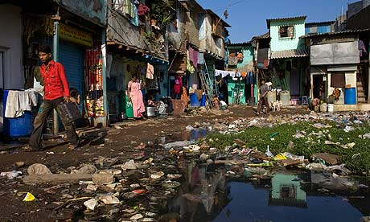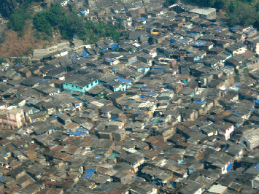

Solutions to housing problems

Squatter areas and shanty towns have given the authorities in Mumbai many concerns. The living conditions are very poor, disease is an everyday occurrence and crime is high. Many are in very unsafe areas, such as beside sewage or rubbish dumps or along train lines. Shanty towns are often built on steep slopes which are prone to landslides and mudslides.

The Indian government have tried many initiatives to improve living conditions in shanty towns and to reduce the severe overcrowding problem.

Thousands were evicted from their homes in order to bulldoze the shanty town. However, this is not successful as people will simply build elsewhere, often on very unsafe ground.

The government have also tried to relocate people to safer areas which have basic provisions such as clean water and toilets. They were moved to high-rise buildings, most often in the suburbs. This was unpopular as it meant people would have to travel longer distances to get to work. They were also concerned that the authorities would go back on their promises.

An alternative plan is to improve the conditions in shanty towns. This can be done by providing more toilets, standpipes and schools, and giving people materials such as bricks in order to reinforce walls. People can also be given the legal rights to the land. This initiative has the potential to work in some shanty towns. However, there are some areas which are so overcrowded that it would be very difficult to improve them and would cost the government too much money.

Self-help schemes have been introduced, where by people living in shanty towns can help themselves by forming co-operatives and organise improvements themselves. They may be given the chance to plan and design these areas and have a say in how the area can be changed.

One last method that the city authority has introduced is the building of a new town – Navi Mumbai. The hope is that people will want to live here, rather than the overcrowded parts of the city, so therefore relieving pressure on areas. Over one million people live here in twenty separate but connected settlements. It is hoped that Nazi Mumbai will be able to offer enough jobs and services for all of the people living there and will reduce the housing problems found in Mumbai.

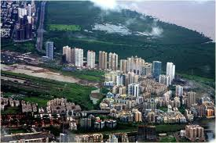

Task 2 – Housing problems and solutions

(a) Give the definitions for a squatter area and a shanty town
(b) Describe, in detail, the ways that shanty towns are better than squatter areas
(c) Describe five problems found in shanty towns
(d) Why do few children attend schools in shanty towns?
(e) Make a table in your jotter to show the methods used by the Indian authorities to solve the problems of shanty towns and suggest how successful the methods have been
(f) Which of the solutions do you think is best to solve Mumbai’s housing problems? Give reasons for your answer

Dharavi: A Case Study of a Shanty Town

This shanty town has been chosen as it is the one featured in Slumdog Millionaire, as well as other Bollywood films. It is near the centre of Mumbai, next to the financial district. Dharavi is situated between two railway lines in an area of 175 hectares. One million people live in this small space, meaning it suffers from severe overcrowding.

Growth

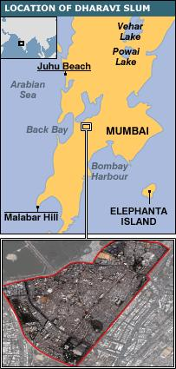
The area, that was once a fishing village until it was drained, has attracted migrants from all over India, including embroidery workers, potters and leather tanners. They have moved here in order to use their skills to start workshops in Mumbai. More and more people have continued to be attracted in Dharavi from the countryside who are searching for a higher standard of living in the city, or have been forced from their farms. Dharavi has grown rapidly, particularly at the end of the twentieth century when people were moving here at a rate of about 200 people per day.

Features of Dharavi

- Houses – most have started as a single room, but have been added to through the years. Some of the older ones may even have another floor or separate kitchen area. The average size is 3 x 3metres, with between six and ten people in each.
- Building materials – New arrivals to the city build around the edge, using flimsy materials such as cloth, wood and corrugated iron. A maze of alleys will lead you through to the heart of the shanty town, where the older and sturdier housing is found. Over the years they have been improved by using bricks or concrete.
- Land use – one million live on this small space in 85 distinct areas with different languages, religions, cultures and social groups (castes). Also, there are around 15,000 one-room factories, with 5000 leather and 3500 garment workshops, and a large pottery district and recycling area. There are also hundreds of small shops and food locations.
- Ownership – the local authority owns the land in Dharavi. Residents are illegal squatters as they do not pay rent to the government. However they do pay a type of rent to a local landlord who protects their area in the shanty town.
- Toilets – there is, on average, one toilet for every 500 residents. Many people will simply use the shallow river close by as the public toilets are commonly blocked.
- Water – water is provided via a standpipe that often only works for a couple of hours each day.
- Electricity – if a home has electricity, it is often obtained illegally by tapping into the city’s power lines, or is unreliable and irregular.
- Employment – almost everyone works in order to survive as there is no unemployment benefit system. 80% of people work in the workshops and small factories in Dharavi itself. In many buildings, the ground floor is the workshop and the family will live above.

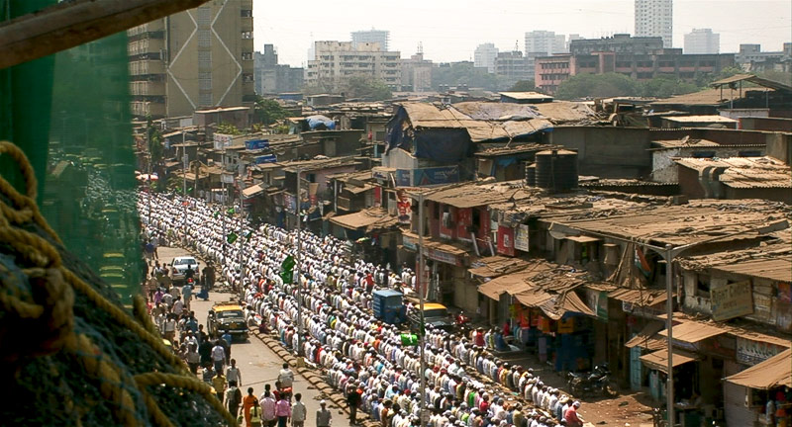

Problems

- It is unhealthy – poor sanitation is probably the biggest problem as there is raw sewage running between rows of shacks which children play in. The pipes which supply water can be cracked, with sewage seeping out. This leads to pollution of the water supply and is the main cause of illness for the people. The hospital closest to Dharavi receives around 3000 cases per day of people from the shanty town with diarrhoea and diseases such as typhoid. Malaria, tuberculosis and diphtheria are also commonplace, as well as illnesses related to malnutrition. Working conditions can be dangerous with toxic substances and overcrowded factories, so diseases spread easily. This means that life expectancy is only 50 years.
- Lack of basic services – there are very few toilets, little safe water and no rubbish collection. This means that there are many rats and flies which can spread diseases. The local authority have only, in the past 50 years, provided services to the area, with 60 primary schools, 4 high schools and a state hospital being built. However, this is still far too few with most having to pay for private health care and education, meaning few children will attend school. Literacy rates are very low, as is life expectancy. The major issue for families is not being able to afford the medicine which may be required if someone falls ill.
- No taxes are paid – the government and local authority will lose out because no one pays them rent on the land. Few workers or owners of factories will pay tax either. This is called the informal sector, outside the normal laws. This means that there is no protection against factories releasing dangerous toxic substances or employing children. It also means Mumbai has less money to spend on improving conditions in the city.
- Poor image – Some will say that Mumbai is dirty, overcrowded, illegal, an eyesore, made of rough shacks and smelling of sewage, which will put both tourists and businesses off coming to the city.

Task 3 – Dharavi Shanty Town

- Describe the location and growth of Dharavi
- Describe the variety of housing found
- Look at all the features of Dharavi – what would you find most difficult to tolerate and why?
- Life expectancy is 15 years less than other parts of India, explain why
- Explain why literacy rates are low
- What is meant by the informal sector
- Give one advantage and one disadvantage of the informal sector

Dharavi: Benefits and Redevelopment

Although Dharavi has many issues, it also brings benefits to its inhabitants and Mumbai as a whole.

Benefits

- It provides cheap, affordable housing – Mumbai’s government cannot build enough homes for all of the people and renting accommodation can be expensive. Rent in Dharavi can be as little as £3 per month, so pretty much everyone can afford it.
- It provides employment – with the thousands of small workshops and factories providing low wages, most of the residents are employed. Many skilled workers work here and pass on their skills to others. There is also now a small tourist industry, with guided tours of Dharavi on offer.
- It brings the city a lot of money – some of the good’s manufactured in the shanty town is exported over the world, creating a value of £300 million each year. Most of this money is spent in Mumbai. Recycling is big here, with around 80% of waste recycled.
- It is sociable – there are communal areas where people can sit and chat, and many of the daily chores such as washing are done together. The sense of belonging to a community is strong.
- Very low crime rates – crime rates are lower here than anywhere else in the city
- People work hard and are enterprising – they pass on these attitudes to the next generation, which must be of benefit to Mumbai.

Changes

Dharavi Redevelopment Project

Many people, including the local authority, think redevelopment of the shanty town area is the way forward. In 2004, the Dharavi Redevelopment Project was drawn up and approved by Mumbai authorities, although it is yet to be started.

Some features of the project are detailed below:-

- Part of Dharavi will have to be bulldozed, where around 57000 families live
- High-rise apartments will be constructed for some residents
- Each family will receive an apartment measuring 21m²
- Each apartment will have electricity, sewerage and water
- Only residents who lived in Dharavi since before 2000 will be eligible to an apartment, others will be rehoused elsewhere
- Only industries which do not produce pollution will be allowed
- About half the area will be used for building expensive housing, malls and offices
- The project will take seven years to build, costing around £2 billion
- It will be paid for by private companies

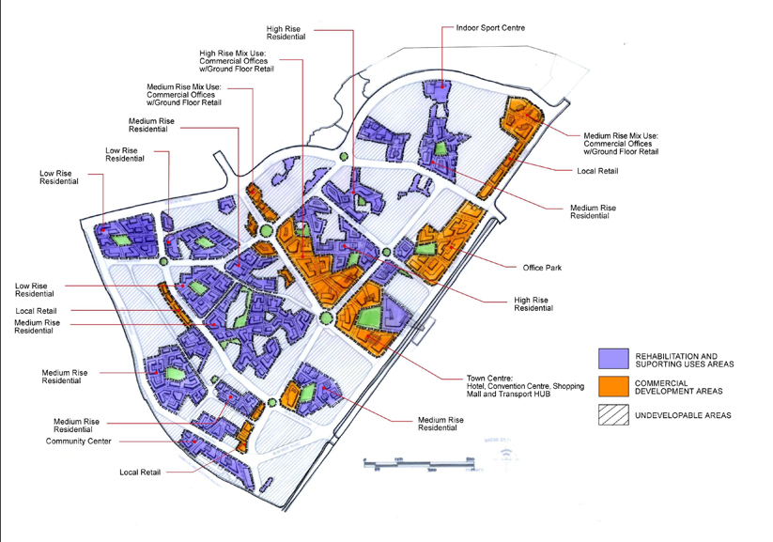

The main disadvantages are:-

- Only some families will be rehoused in Dharavi which is where most want to live
- People are unhappy that they will be given small apartments as many have built extra storeys, which will not be possible in the new apartments
- Many families live above their workshop, which again will not be possible in the new, high-rise apartments.
- People have concerns that industries, such as metal working, that pollute will be banned from the redeveloped area
- There is not enough space being given to industries such as recycling and pottery which employ a lot of people and create a large amount of money but need large spaces. If there is no land available to recycling then there will be a lot of waste and litter in Mumbai.

It is believed that the redevelopment of Dharavi will only benefit well-off residents who will have luxury apartments and shopping. Those who are in poverty may be worse off as they are removed from their homes and sent to other parts of the city, sometimes much further away from their work.

Self-Improvement Plan

There are no other plans in place for Dharavi, but some have suggested self-help schemes as these have been incredibly successful in other locations. Self-help involves the residents, where by they carry out improvements themselves. This type of plan would involve the following:-

- First the residents form separate self-help groups in the different areas
- One group must persuade the authorities to give them ownership of their land
- They can then design their own improvements, including:-
building more toilets, with proper maintenance
improving the water supply
making stronger walls
building another floor onto their houses
- The people of Dharavi have a huge range of skills and can form groups to carry out improvements
- Some self-help groups could negotiate loans
- Others will negotiate with the authorities to provide them with some basic services eg legal electricity

Such a self-improvement plan:-
- Costs much less because the people do much of the work themselves
- Allows the thousands of businesses to continue
- Means that everyone can remain in Dharavi
- Brings the improvements that the residents want
- Brings the community together through discussion and agreements

There are huge difficulties involved in trying to improve conditions in areas as overcrowded as Dharavi. Mumbai authorities do not have the money to improve these areas on their own. So what would you do?

Task 4 – Redevelopment of Dharavi

- Why is Dharavi an asset to Mumbai?
- Do you think the problems outweight the benefits. Explain your answer
- Describe the main features of the Dharavi Redevelopment Project
- Describe three benefits and three drawbacks of the project
- What are self-help schemes?
- What improvements would a self-help scheme make to Dharavi?
- Decribe the benefits and drawbacks to self-help schemes for the residents of Dharavi
- What do you think is a better scheme – redevelopment or self-help – and explain your answer

