Population

1. Give reasons why the birth rate has decreased in developed countries such as Scotland. (6)
2. 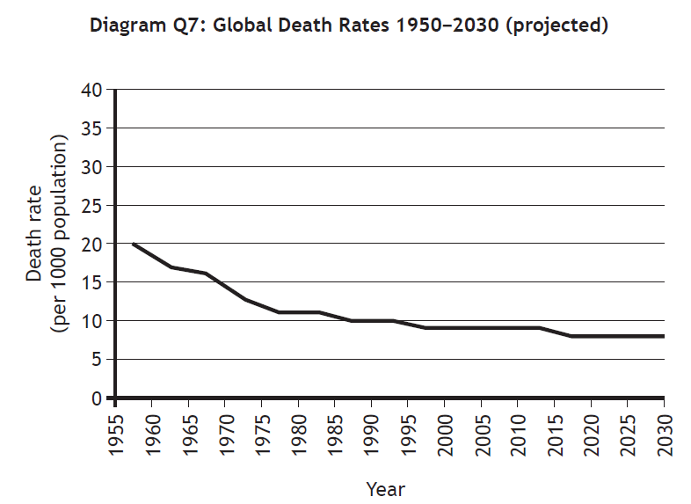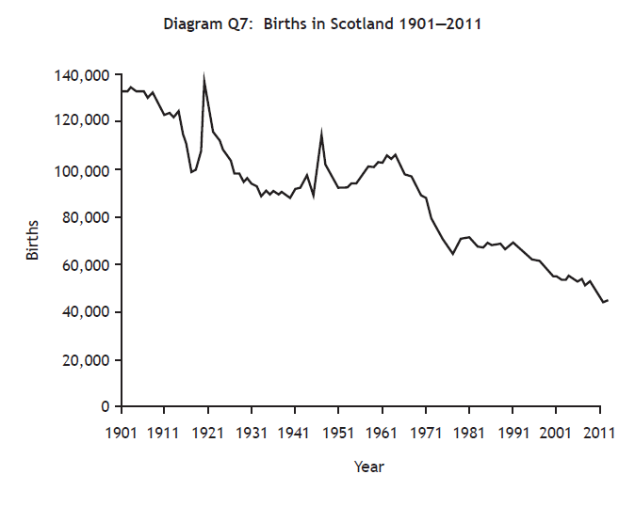Give reasons for falling worldwide death rates. (6)

3. Explain why there are areas of different population density across the world. Your answer should refer to both physical and human factors. (6)

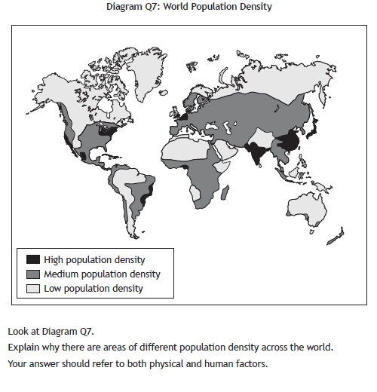

1. 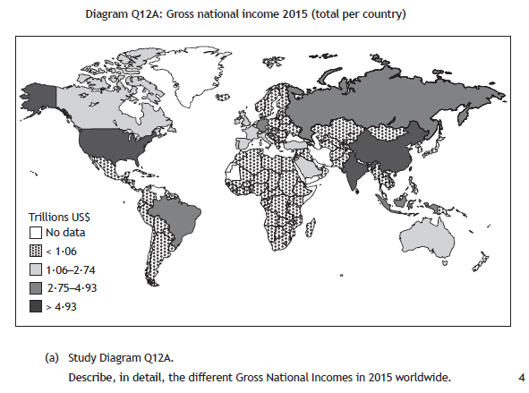a) Describe, in detail, the different Gross National Incomes in 2015 worldwide. (4)
2. b) Choose one social and one economic indicator shown in the table.

Explain how your two chosen indicators show the level of development in a country. (4)

