Population Distribution and Density



Distribution of population means the way in which people are spread out across the earth’s surface. In other words, it shows where people choose to live. Population distribution can be shown using a dot map. When you look at this map it shows the areas of the world that are most and least populated.

World Population Distribution

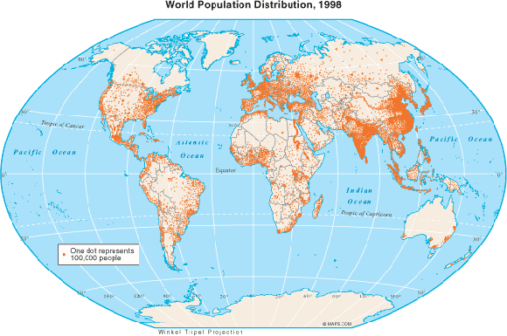

You can see from this map that some places of the world are far more populated than others making these places crowded and others quite empty. The places with lots of people living in them are said to be densely populated while those with hardly any people in them are said to be sparsely populated.

Density describes the number of people living in a certain area. The area used is normally a square kilometre (km2). The figure for density is found by dividing the total population of a place by its area. A choropleth map is usually used to show population density. These maps are easy to read as they show generalisations, but the problem with this is that they have a tendency to hide concentrations. For example, if you look at the map below it appears that Brazil has a low population density. However, in reality many parts of the country actually have very high densities. You can also see from the map that Egypt looks like it has an evenly spread population whereas it is actually concentrated along the Nile Valley.

Patterns of distribution and density can be affected by both physical and human factors. Physical factors would include relief (the shape of the land), climate, vegetation, soils, natural resources and water supply. Human factors would be economic, political or social. The following table gives reasons with examples why some parts of the world are more densely populated than others. You should be aware that often it is a combination of the above factors that determines the population density of an area.

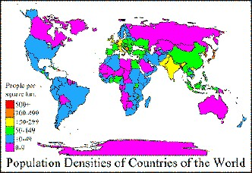

**Physical**

|  |  |  |
| --- | --- | --- |
|  | **Densely populated** | Examples |
| Relief | * Flat plains and low-lying undulating areas * Broad river valles * Foothills of active volcanoes | Bangladesh  Ganges valley  Etna, Pinatubo |
| Climate | * Evenly distributed rainfall with no temperature extremes * Areas with (i) high sunshine totals (ii) heavy snowfall for tourism * Seasonal monsoon rainfall | North-west Europe  (i)Spanish Costas  (ii)Swiss Alpine Valleys  Bangladesh |
| Vegetation | * Grasslands – easy to clear/farm | Paris Basin |
| Soil | * Deep fertile silt left by rivers * Volcanic soils | Nile Valley and delta  Etna |
| Natural resources | * Minerals, e.g. cola, iron ore * Energy supplies e.g. HEP | Pennsylvania, Johannesburg  Rhone valley |
| Water supply | * Reliable supplies | North-west Europe |
| Natural routes | * Gaps through mountains, confluence of valleys | Rhine valley, Paris |



|  |  |  |
| --- | --- | --- |
|  | **Sparsely populated** | Examples |
| Relief | * High rugged mountains * Worn-down shield lands | Andes  Canadian Shield |
| Climate | * Limited annual rainfall * Low annual temperatures * High annual humidity * Unreliable seasonal rainfall | Sahara Desert  Greenland  Amazon Rainforest  Sahel |
| Vegetation | * Forest | Amazonia, Canadian Shield |
| Soil | * Thin soils in glaciated or mountainous areas * Lacking humus * Affected by leaching | Northern Scandinavia  Sahel  Rainforests |
| Natural resources | * Lacking minerals * Lacking energy supplies | Ethiopia  North-east Brazil |
| Water supply | * Unreliable supplies | Afghanistan |
| Natural routes | * Mountain barrier | Himalayas |

**Human**

|  |  |  |
| --- | --- | --- |
|  | **Densely populated** | Examples |
| Economic | * Ports * Good roads, railways, airports * Industrial areas (traditional) * Development of tourism * Money available for new high-tech industries | New York, Sydney  Germany, California  Pittsburgh, Ruhr  Banff (Canada), Jamaica  California, South of France |
| Political | * Government investment * New towns * Reclamation of land | Tokyo, North Italy  Satellite towns around Cairo, Brasillia  Hong Kong Island, Dutch Polders |
| Social | * Better housing opportunities * Education, health facilities, entertainment * Retirement areas | Arizona  Sydney, Milan  Spanish Costas, Canary Islands |

|  |  |  |
| --- | --- | --- |
|  | **Sparsely populated** | Examples |
| Economic | * Limited facilities for ports * Poor transport links * Lack of industrial development * Lack of tourist developments * Lack of money for new investments | Bangladesh  Himalayas  Sudan  Iraq  Nepal, Gaza |
| Political | * Lack of government investment * Depopulation of rural and old industrial areas * Loss of land, e.g. deforestation, and soil erosion | D.R. of the Congo  NE Brazil, Belgian coalfield  Amazonia, Apennines, Sahel |
| Social | * Poor housing opportunities * Limited education, health facilities, entertainment * Poor facilities for retirement | Afghanistan, Soweto  Rwanda  Eritrea |

**Population Change**

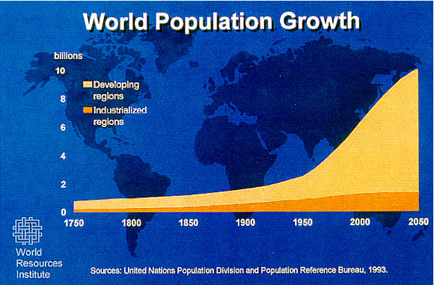

The graph to the right shows the world’s population growth since 1750. It shows that the world’s population increases only slightly and very slowly, growing from 1 billion in 1750 to around 2 billion in 1900. However, from the year 1900 the speed at which the population grows increases at a much faster rate as each year passes. There is a huge increase from around 2.5 billion in 1950 to over 6 billion in 2000. On Monday 31st October 2011 the world’s population reached a staggering 7 billion. That means it took only 11 years to increase by 1 billion, whereas from the year 1750 it took almost 200 years to increase by 1 billion.

The graph also shows the difference in rates of growth between developed and developing countries. Since the early 1900s developing countries population has grown at a much faster rate than that of developed countries.

**Birth and Death Rates**

The world’s population is increasing because the number of people being born is greater than the number of people dying.

**Birth rate** = the number of people being born per 1000 of the population in a year, shown as e.g. 90/00

**Death rate** = the number of people being born per 1000 of the population in a year, shown as e.g. 50/00

Currently the world’s average birth rate is 200/00 while its death rate is 80/00. This means that the world’s natural increase is 20 – 8 = 120/00

Developing countries have higher birth and death rates than developed countries. There are a number of factors responsible for this:

In some cultures, large families have a high status

Children can take care of their parents in their old age

Factors Affecting Births

There is a lack of contraception and family planning

Infant mortality (death) rates are high in developing countries

Children can help their families on farms or by earning money

There are fewer medical facilities

There is a lack of clean water

Factors Affecting Deaths

Many people live in poor housing with poor sanitation

Many people do not have enough to eat

Diseases are more widespread

Developed countries have lower birth and death rates than developing countries. There are a number of factors responsible for this:

More women work and have a career

Contraception and family planning are widely available

Factors Affecting Births

People get married later in life

Children are very expensive to raise

Safe, clean water is provided

Advanced medical facilities and advice are available

Factors Affecting Deaths

Proper sanitation facilities are provided

People are generally well fed



**The effects of rapid population growth**

Population structure

In many developing countries birth rates are higher than death rates and because of this the population is rising rapidly. The population structure of these countries can be shown using a population pyramid and would look like the one below.

As the birth rate is high there are many children, this means that the base of the pyramid is wide. It may frequently be the case that more than half of the population is under the age of 15. There are fewer people of working age, between 15-60 years. This is due to the fact that until recently the death rate was high and many children did not survive until adulthood. For the same reason there are very few old people.

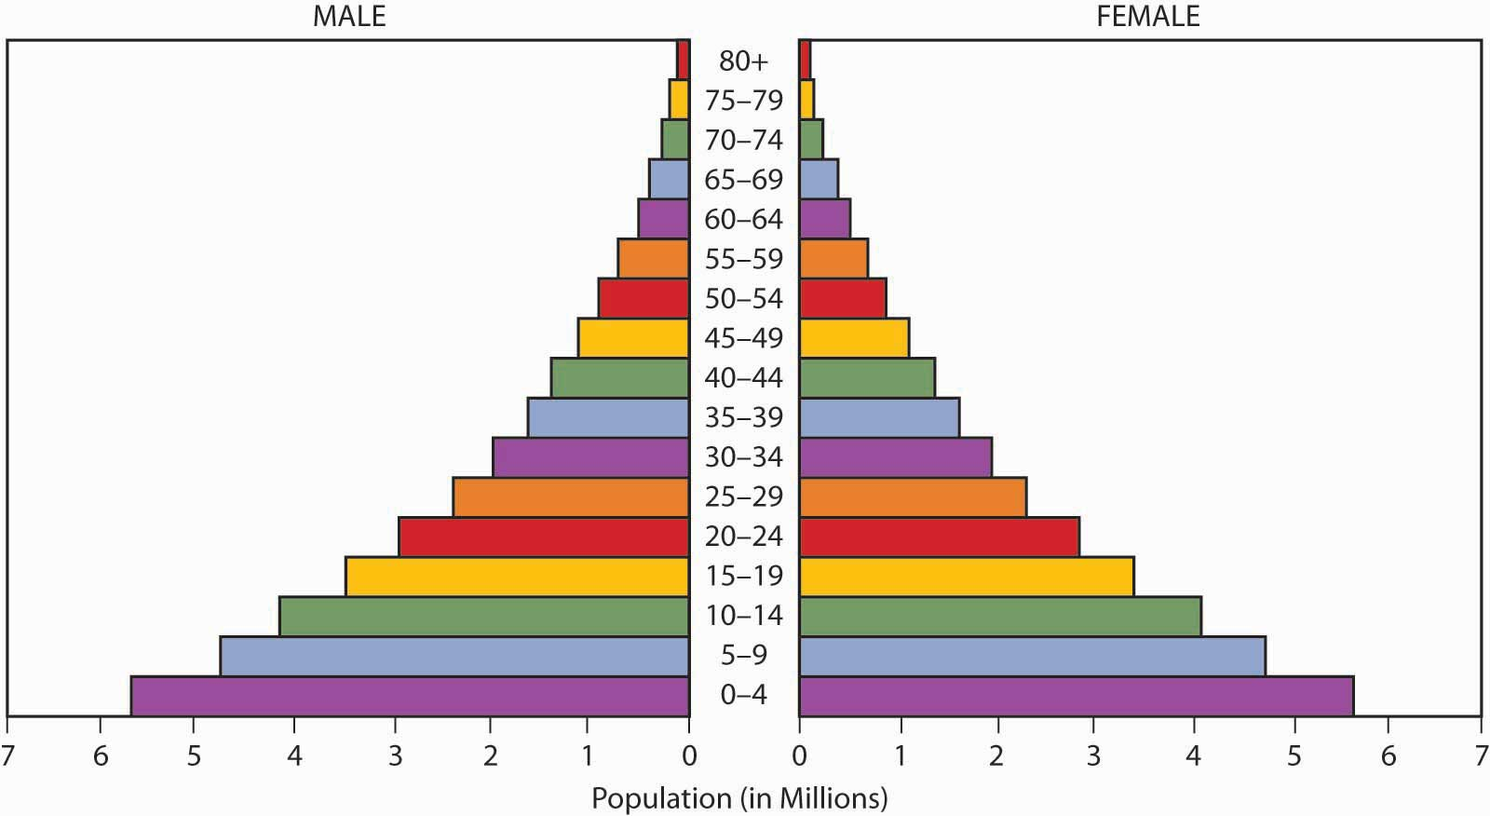

**Advantages of Rapid Growth**:

* Country has a large number of people available for the armed forces, therefore more powerful and less vulnerable to attack.
* Country has an increased number of workers to produce goods in factories and on farms.
* Wage rates are lower due to number of workers available – this attracts international companies wanting to reduce their labour costs.



**Disadvantages of Rapid Growth:**

* Farms become smaller and have to be farmed more intensively to produce enough food – this makes the soil poorer, therefore more trees need to be cut down in order to provide more land.
* Trees are used for fuel and building which leaves the land bare, soil is washed away leaving less land for farming. People become poor and hungry and move to the cities.
* In urban areas the population is increasing due to people moving from the countryside.
* The authorities cannot build enough houses for everyone so people build their own shacks which lack even the most basic of amenities such as toilets and water supply.
* There are not enough jobs for everyone so unemployment rises and crime rates increase.
* Traffic congestion worsens and services can’t cope with the extra people so schools and hospitals become overcrowded.

Countries (especially developing countries) may wish to control their rapid population growth. There are a number of ways that this can be done.

* China’s one child policy which was introduced in 1979
* More family planning clinics
* Greater provision of education for females – evidence shows that areas where female education is higher are areas where birth rates are lower
* Opportunities for abortion and sterilisation
* Incentives given to limit family sizes, e.g. free health care and preferential housing

Countries are trying very hard to improve farming so that they are able to feed everyone. High-yielding crops are used, more fertilisers and pesticides are being applied, and more land is being reclaimed and irrigated.



**The effects of slow population growth**

Population Structure

Most developed countries have low birth and death rates and their populations are rising only slowly, if at all. Their population structure would look like the one below.

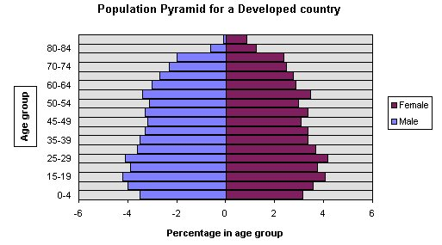

There are few children in the population because of the low birth rate. In the past the birth rate was higher and so there are now many adults. There are also many old people because the death rate is so low and people live to an old age due to good health care etc.

This structure has an advantage over the typical developing country as there are more people of working age and fewer children and so less money needs to be spent on education. However, the structure is not ideal.

The number of old people in the population is increasing rapidly. Therefore, more money is required to pay for pensions, more care services e.g. meals on wheel, sheltered housing and old people’s homes. Health care costs are very high as old people use these services a lot including medication. All of these costs are met through taxes, but there are now fewer people of working age paying taxes. There are also fewer people for the armed forces and fewer potential parents for the future.



Solutions

Some developed countries are concerned about how slow their population growth is. These countries can adopt measures to try to solve their problem.

In France, mothers with three children can take a year off work – and receive up to 900 Euros a month from the government to stay at home. Families get cheaper public transport and holiday vouchers. All mothers receive about 200 Euros a month until their child is 3 years old.

Policies for slowly growing populations:

* More paternity leave to encourage parent to have more children, e.g. in the UK fathers have two weeks of paid leave.
* More maternity benefits such as those provided in France
* Raise retirement age to increase the number of taxpayers and reduce pensions, e.g. in the UK retirement age for women was raised to 65 in 2010
* Encourage more women to work which increases the workforce and the number of taxpayers, e.g. more retraining schemes, provision of crèches in the workplace
* Allow more immigrants to increase the number of taxpayers and workers
* Encourage people to take out private pension schemes to reduce the cost of providing public pensions

**The Demographic Transition Model**

The Demographic Transition Model (DTM) shows the changes in birth and death rates over time. The DMT has four main stages that countries move through over time. The least developed countries would be at stages 1 and 2 while the most developed would be at 4 or possibly even 5.

Like all models, this model has its limitations. It was assumed that the sequence of population change resulted from an increase in industrialisation. While it is mainly true that developed countries have reached stage 4, it is now recognised that many of the developing countries will never become industrialised.

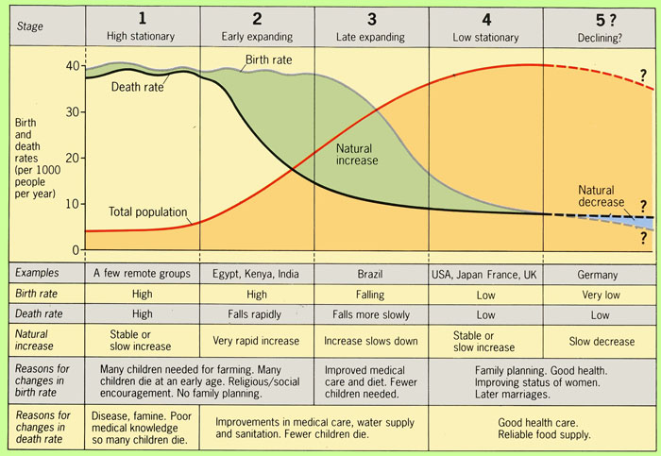

**Stage 1** – both birth rates and death rates are high and fluctuating. This gives a small population growth.

**Birth Rates are high because:**

* **No birth control or family planning**
* **So many children die in infancy that parents produce more so that some may survive**
* **Many children are needed to work on the land**
* **Children are regarded as a sign of virility**
* **Religious beliefs**

**Stage 1 cont.**

**Death Rates are high due to:**

* **Disease and plague (bubonic, cholera and kwashiorkor)**
* **Famine, uncertain food supplies with resulting poor diet**
* **Poor hygiene – no piped, clean water and no sewage disposal (poor sanitation)**
* **Little medical science – few doctors, hospitals, medicines etc.**
* **Lack of vaccinations for preventative measures against diseases**



**Stage 3** – birth rates fall rapidly, to around 20 per 1000 people, while death rates continue to fall slightly, 15 per 1000 people to give a slowly increasing population.

**The fall in birth rates may be due to:**

* **Family planning – contraceptives, sterilisation, abortion and government incentives**
* **A lower infant mortality rate therefore less need to have so many children**
* **Increased industrialisation and mechanisation meaning fewer labourers are needed**
* **Increased desire for material possessions (cars, holidays, bigger homes)**
* **Emancipation of women, enabling them to follow their own careers rather than being solely child bearers**

**Stage 2** – birth rates remain high, but death rates fall rapidly to about 20 per 1000 people giving a rapid population growth.

**The fall in death rates result from:**

* **Improved medical care – vaccinations, hospitals, doctors, new drugs and scientific inventions**
* **Improved sanitation and water supply**
* **Improvements in food production (both quality and quantity**
* **Improved transport to move food, doctors, etc.**
* **A decrease in child mortality**

**Stage 5 –** birth rates are now slightly lower than death rates which means there is a slight natural decrease in the population

**Stage 4** – birth rates 12 per 1000, and death rates 10 per 1000 remain low, fluctuating slightly to give a steady population

**Measuring Development**

The countries of the world are all at varying levels of development. Most are trying to improve the standard of living of their population – this is known as development. The countries whose people enjoy a high standard of living are known as ‘developed’ countries, whereas those with a lower standard of living are known as ‘developing’. It is very difficult to work out the standard of living of one person or even all of the people living in one country. The best that we can do is to use several indicators of development and measure them. A few examples of these indicators are the average income in the country, life expectancy, literacy rates etc. We can use two development indicators, economic indicators and social indicators.

Economic indicators measure the wealth and level of industrialisation of a country. The following table shows examples of these:

|  |  |
| --- | --- |
| **Indicator** | **Definition** |
| **Gross Domestic Product (GDP)** | The value of all the goods produced and services provided in a country in one year. This is divided by the number of people living in the country to indicate the wealth of the average person. |
| **Gross National Product (GNP)** | This is similar to the GDP, but it also includes services earned abroad. |
| **Energy used per person** | The amount of energy (coal, oil, gas etc.) that is used in a country can indicate level of development. Countries with a lot of industry and high standards of living will use a lot of energy, gas and electric in homes and fuel in their cars. |
| **People employed in agriculture** | Countries with a high percentage of its people working in agriculture will have little industry to produce wealth. In addition, its farms are likely to be small and make little profit. A high percentage of people in agriculture is a good indicator of a less developed country. |

Problems with economic indicators.

A country may produce a lot of wealth but it may not be spread amongst the population evenly. It may be the case that a small number are very rich while the majority of the people are poor. The amount of wealth a country has does not give information on the people’s quality of life, for example, how healthy or well-educated they are. Also how much money the people have has to be compared with prices in their country to see what people can buy with that amount of money.



Social indicators show how a country uses its wealth to improve the quality of life of its people.

|  |  |
| --- | --- |
| **Indicator that measures:** |  |
| **Health** | * Population per doctor * Infant mortality (number of infants who die before they are 1 year old) * Life expectancy |
| **Diet** | * Calories per person per day * Protein per person per day |
| **Education** | * Percentage of children attending primary school * Adult literacy |

Problems with social indicators.

Social indicators also use averages, so they do not tell us the differences within a country. For example, the average number of calories per person per day could be 2500, but half of the people may only receive 2000 and be undernourished whereas the other half have 3000 and are well fed. Using one indicator on its own does not give enough information of quality of life. People may be well fed but we do not know how healthy or how well educated they are.

**Comparing social and economic indicators**

It is generally the case that countries that score highly on economic indicators also do well according to social indicators. This is because they can use their wealth to provide proper schooling, hospitals, food and decent housing. Countries with little wealth just cannot afford to provide all of these social services for their people.

When looking at social and economic indicators, sometimes a country can seem more developed according to social indicators while others look more developed according to economic indicators. For example, as a country’s income per person increases, you would expect that their life expectancy would also increase but this is not always the case.

|  |  |  |
| --- | --- | --- |
| Indicators of development | China | India |
| GNP per person ($) | 4,940 | 1,410 |
| Energy use per person (kg) | 1,807 | 566 |
| Life expectancy (years) | 72 | 64 |
| Calories per person per day | 2,970 | 2,300 |
| Adult literacy (%) | 92 | 74 |

This table shows five indicators of development comparing China and India. This is a more reliable way of measuring development. According to the indicators in the above table, China is more developed than India.

An alternative is to use a range of indicators to produce a single combined index. Two examples of these are:

* Physical Quality of Life Index (PQLI):

This combines life expectancy, infant mortality and adult literacy to produce an index from 0 to 100. The higher the PQLI, the higher the quality of life of the people in the country. A PQLI of over 77 is considered good.

* Human Development Index (HDI):

This combines life expectancy, adult literacy, GNP/person, cost of living and school enrolment to produce an index from 0 to 1, where an HDI of 0.8 or above is considered developed.

The following table shows the world’s 10 most developed countries.



|  |  |  |
| --- | --- | --- |
|  | **Highest PQLI** | **Highest HDI** |
| **1** | Ireland | Norway |
| **2** | Switzerland | Australia |
| **3** | Norway | Netherlands |
| **4** | Luxembourg | United States |
| **5** | Sweden | New Zealand |
| **6** | Australia | Canada |
| **7** | Iceland | Ireland |
| **8** | Italy | Liechtenstein |
| **9** | Denmark | Germany |
| **10** | Spain | Sweden |

**Reasons for Differences in Levels of Development**

Through the use of one or more development indicator, the world can be divided into ‘developed’ or ‘developing’ countries. These can be seen on the map below.

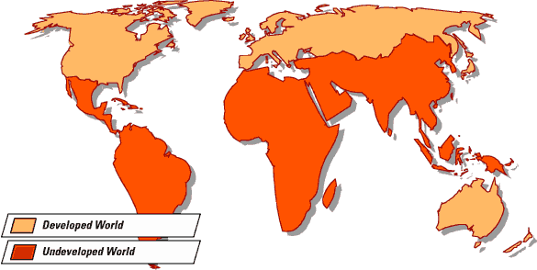

Developed countries

Developing countries

There are fewer developed countries, nearly all in the northern hemisphere and most in temperate latitudes. The developing countries have ¾ of the world’s people and they are found both in the northern and southern hemispheres and include all the countries within the tropics.

The following table shows that there are big differences in living standards within developing countries. For example, the average income in South America is 6 times what it is in Africa and life expectancy is 16 years longer. And, within the continent of African, people of Libya earn 50 times more than people of the Democratic Republic of Congo and live 30 years longer.

There are a number of reasons for the varying levels of development in the world. The factors involved can be divided into two categories, Physical and Human.

|  |  |  |  |
| --- | --- | --- | --- |
| Continent | **GNP per person ($)** | **Life expectancy** | **% attending secondary school** |
| North America | 32,077 | 79 | 99 |
| South America | 9,024 | 74 | 92 |
| Europe | 25,434 | 77 | 99 |
| Asia | 2,941 | 70 | 85 |
| Africa | 1,976 | 58 | 69 |
| Oceania | 39,052 | 77 | 92 |

|  |  |  |
| --- | --- | --- |
|  | **Developed country** | **Developing country** |
| World population | 25% | 75% |
| World income | 85% | 15% |
| World industry | 80% | 20% |



**Physical Factors** affecting standards of living around the world**:**

|  |  |  |  |
| --- | --- | --- | --- |
| Factor | Problem | Why this is a problem | Example |
| Climate | Very cold | * Difficult to build roads and railways * Remote and unlikely to attract much industry * Too cold to farm * Expensive to live due to high heating bills, food expense * House difficult to build due to permafrost | Mongolia |
|  | Very dry | * Not enough rain for crops * At risk of crop failure and famine * Remote and unlikely to attract industry * Soil made poorer by wind erosion | Ethiopia |
| Relief | Very steep | * Difficult to build roads and railways, remote and unlikely to attract industry * Poor farming due to steep land, inability to use machinery and thin soils | Nepal |
| Resources | Lack of minerals | * No valuable minerals (e.g. diamonds, gold) to sell to other countries * No fuels (e.g. coal, oil) to encourage industry to set up | Malawi |
| Environment | Unattractive scenery  Much disease | * Not attractive to summer tourists (e.g. no sunny beaches, hot climate) or winter tourists (no cold, snowy slopes) * A country is unable to develop if many of its people suffer from disease and are unable to work properly | Burkina Faso  Sierra Leone |
| Natural disasters | Floods, drought, earthquakes, volcanoes, hurricanes | * Areas prone to natural disasters have crops ruined, factories and homes destroyed, roads and railways unusable * Costs millions of £’s and may cause famine and unemployment – can take years to recover | Bangladesh |

**Human Factors** affecting standards of living around the world:

Some countries find it difficult to develop due to the harsh physical environment but have managed to overcome these problems and enjoy a high standard of living. Some examples are Japan, Australia, Switzerland and Canada. It follows then that there must be other factors involved that affect standards of living around the world. These are human factors. Some examples are given below. The following table compares human factors in the developed and developing world.

|  |  |  |
| --- | --- | --- |
|  | Developing world | Developed world |
| Average birth rate (per 1000 people) | 22 | 10 |
| Average death rate (per 1000 people) | 8 | 8 |
| Average natural increase (% of population) | 14 | 2 |

**Population Growth**

As you can see from the table above, the population is rising 7 times faster in developing than in developed countries. This means problems for the poorer countries.

In the countryside farms become smaller as there are more people who require land. This means that farmers grow less food and so their families may go hungry.

In the cities, the services are put under great stress. There are too many people demanding the use of schools, hospitals beds and jobs for what is available. The result is that many people are forced to live in shanty towns (makeshift homes), are unemployed and do not receive treatment if they are ill.

Due to the high birth rate, there are many young children in developing countries. For example, in Niger over half of the people are 14 years old or younger. These children need to be fed, clothed and educated.



**Industrialisation**

The table below compares the developed with the developing world in terms of industry.

|  |  |  |
| --- | --- | --- |
| % of people working in: | Developing world | Developed world |
| * Agriculture | 45 | 3 |
| * Manufacturing | 23 | 27 |
| * Services | 32 | 70 |
| **% of world’s industry** | 15 | 85 |

The table above shows that there are fewer factories and offices in developing countries. Factories and offices produce profits that increase the wealth of a country. Many people would be employed and this would provide a regular income for them. Without industry, it is difficult for a country to develop. Despite there being little industry in developing country cities the population here is rising rapidly. The result is that many people are unemployed and have a low standard of living.

A reason for the lack of offices and factories in developing countries is that there are few people there who can afford to buy the products. The goods have to be transported huge distances to be sold and this increases costs. Roads and railways are poorer and there are fewer banks from which to borrow money. There are also fewer secondary schools and universities, this means that there are few people with the necessary skill to work in modern factories and offices. There are some industries found in poorer countries but they are often foreign owned (multi-national companies), so the profits do not stay in that country to increase its wealth.

As the table below shows, due to lack of factories, developing countries only have primary goods to export (such as crops and minerals). The price of primary goods are generally low and so little money is made on these sales. Developing countries need to import manufactured goods, these are more expensive and so the money they receive for their exports does not cover the cost of the imported goods. This means that they have less money to provide services such as, school and hospital equipment and agricultural machinery – services that would mean a higher standard of living. Due to lack of money, developing countries have had to borrow money from developed countries in order to buy the manufactured goods that they need. This means that money is used to repay debts that could have been spent on services to improve people’s standard of living.



Developing countries can find it difficult to export the few goods that they do produce because other countries put up trade barriers to protect their own industries. Developing countries may find that they are only able to export a limited number of goods to countries such as USA – this is known as a quota. They may also find that a tax or tariff is put on their goods and so their price is too high for people to buy.

|  |  |  |
| --- | --- | --- |
|  | Developed world | Developing world |
| **Imports** | Manufactured and primary goods | Expensive manufactured goods |
| **Exports** | Expensive manufactured goods | Cheap primary goods |
| **Trade balance** | Trade surplus | Trade deficit |
| **Debts** | Lend money to poor nations | Borrow money at high interest rates |

