St Joseph’s Academy

Higher Geography

Human Environments – Urban

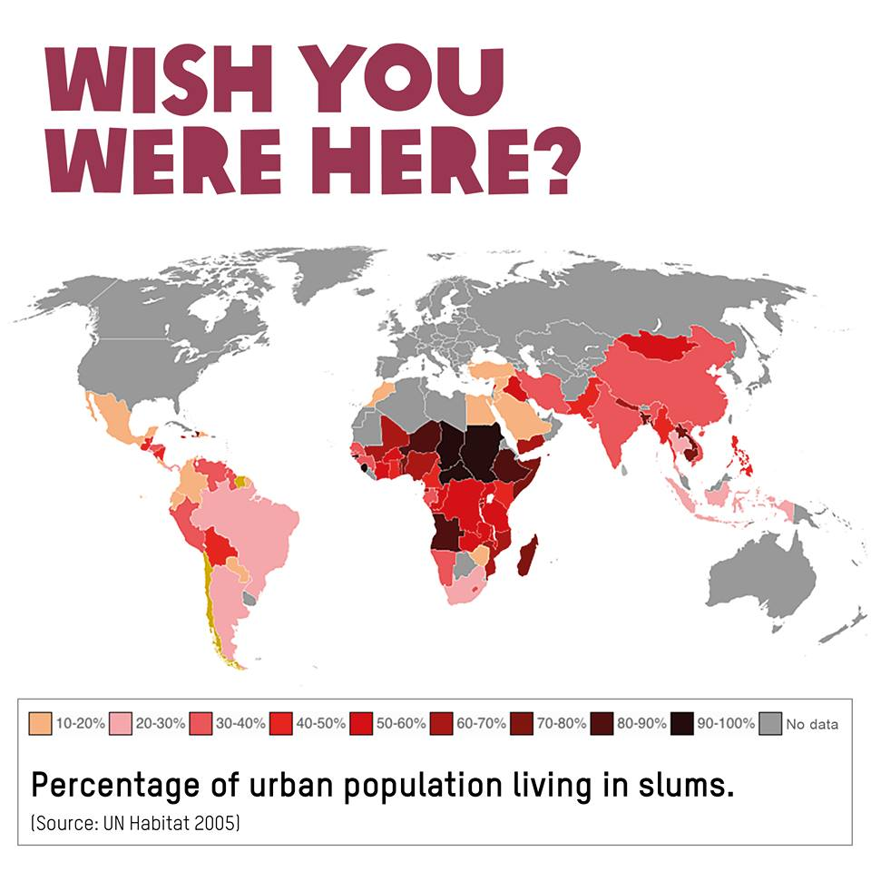

Name ...................................

**Homework**

1a) **Explain** why there is a need for housing management in a Developed World city. (5)

1b) With reference to a developed world city you have studied, **suggest** the housing management strategies which have taken place in the inner city. (5)

1c) With reference to a named city you have studied in the Developed World, **evaluate** the solutions to traffic congestion. (5)

2a) With reference to a developing world city you have studied, **evaluate** the solutions to housing management strategies which have taken place. (5)

2b) **Explain** why there is a need for traffic management in a Developing world city you have studied. (5)

2c) With reference to a named city you have studied in the Developing World, **suggest** the solutions to traffic congestion. (5)

“A developed world city I have studies is Glasgow.”

“A developing world city I have studied is Mumbai.”

**Lesson one: Introduction to Urban (National 5 Re-cap)**

*The Burgess Model*

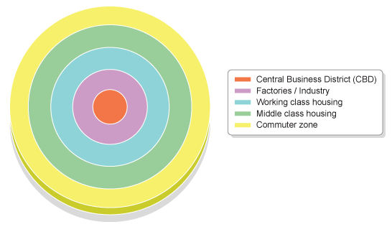

|  |  |
| --- | --- |
| **ZONE** | **NAME** |
| **1** |  |
| **2** |  |
| **3** |  |
| **4** |  |
| **5** |  |

**1**

**2**

**3**

**4**

**5**

*The Central Business District – CBD*

* The CBD is the oldest and busiest part of the city
* It is the centre of shopping and entertainment

*Characteristics of the CBD*

* Old historical buildings & churches e.g. Glasgow Cathedral. This is because it is the oldest part of the city.
* The Town Hall e.g. Glasgow City Chambers
* Many transport hubs as it is the most accessible part of the city e.g. Buchanan bus station, Central Station, Queen St. Station.
* Main roads & motorways lead into/around the area e.g. M8, M74, A8
* Buildings are tightly packed in a grid iron pattern. This is because the land is highly sought after and there is very little open space
* High buildings as land is expensive therefore cheaper to build upwards rather than outwards.
* Entertainment hub – lots of bars, restaurants, nightclubs, shops
* Financial centre – lots of offices, banks and government buildings

*The Inner City*

* The inner city is the 2nd oldest part of the city
* It surrounds the CBD.

*Characteristics of the Inner City*

* Tenement flats – this is because these flats housed workers during the industrial revolution. They were designed to pack as many people in as possible.
* Little open space – gardens/parks not considered important for health and wellbeing during the industrial revolution.
* Brownfield sites – old industrial sites and buildings which are no longer in use, may contain industrial waste and remains of old factories
* Derelict buildings – many run down, old buildings are left abandoned and can be hubs for crime e.g. graffiti and vandalism
* Low-order shops – places to buy everyday essentials e.g. grocery store
* Areas of regeneration – many areas are being improved with new homes being built e.g. Athlete’s village

*The Suburbs*

* The Suburbs are new, more modern areas of the city.
* Some areas date back to 1930’s/1940’s (Older Suburbs) whereas some are newly built (New Suburbs)

*Characteristics of the Suburbs*

* The suburbs usually have 2 storey homes with front and back gardens
* Many of the homes have their own private drive way as these were built for people with cars
* The streets are winding and have cul-de-sacs, this limits through traffic making it safer for children to play
* There is more green space and homes are not close to industry
* The suburbs are usually well-connected to the CBD through good transport links such as train stations and motorways
* Many homes are privately owned and are usually well looked after

*The New Business Zone*

* The New Business Zone is an area where new shopping and business parks are built.
* They are close to residential areas in order to obtain a workforce
* They are easily accessible by motorway for custom and delivery vehicles
* They usually have space to expand and have large (free) car parks.
* An example is The Glasgow Fort.

*The Urban/Rural Fringe*

* The Urban/Rural fringe is the boundary between the city and countryside
* In recent years this area has been increasingly developed as many people seek a quiet life, away from the hustle and bustle of the city
* Homes are large and very modern
* An example is the newly built estates in Gartcosh

**Lesson two: Need for housing management - Glasgow**

*Case Study: Glasgow*

The original site of Glasgow was on the banks of the Molindar burn and at a natural ford on the river. The terraces of the river provided early settlers with flat land to build on and to grow crops. The River Clyde also provided food and water and the form allowed it to develop as a trade centre for people travelling from other areas in Scotland. Situated on the West coast, Glasgow was in an ideal location to trade with the American colonies and the raw materials imported encouraged the growth of the textile and tobacco industries. This, alongside the industrial revolution, resulted in a large influx of people looking for work. In the 1950s Glasgow’s population rose to over 1 million. Today Glasgow is Scotland’s largest city with a population of 593 245 recorded in the 2011 census.

*Need for housing management*

During the 1800s the development of the shipbuilding industry in Glasgow, and its increasing need for workers, caused an enormous rise in the city’s population. This saw the rapid development of tenement blocks to house the workers. Between 1900 and 1951 the population of the city continued to rise – reaching a peak of 1.1 million in 1951. The tenement flats become slums and Glasgow was one of the poorest cities in Europe.

After the Second World War, it was evident that Glasgow faced major housing problems. The tenements were in terrible condition and simply not safe for people to live in so the decision was taken to move some residents to council estates on the edge of the city or new high rise flats.

*Problems with tenements*

* The flats were very small and the rooms were usually dark and damp.
* They were often overcrowded with families of up to 10 cramped in one or two rooms.
* The overcrowding and damp conditions caused disease such as tuberculosis and bronchitis, to spread quickly.
* 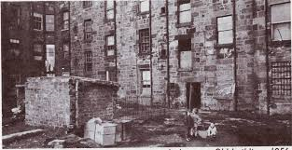Due to their close proximity to the factories where most residents worked, people were often exposed to smoke and chemicals causing furthers diseases like asthma.
* The houses lacked basic amenities such as electricity, running water, central heating and even indoor toilets.
* The entire tenement often shared only one or two toilets on the landing or an outhouse was found at the back of the building.
* In the tenement closes it was common to find rats living among the filth.
* Due to the poor conditions in the tenements, life expectancy in areas like the Gorbals was often no more than 50 years.

*Problems with council estates*

* When people were moved from the tenements to council estates on the edge of the city the close-knit community spirit of the old inner city areas was destroyed.
* When building these council estates the planners forgot entirely to include space for local amenities like shops, pubs, cinemas and community buildings. Neither did they provide any places for people to work.
* Most of these areas only had a post office, one telephone box and a half hourly bus service to the city centre. This means that those without cars had very few ways to travel out of the area to access the amenities they needed.
* People were left feeling isolated and unhappy in these new areas and so the estates became run down and vandalised.
* 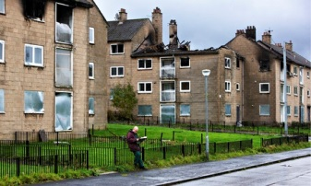There was high unemployment among the residents and crime rates rose dramatically.
* Families chose to leave the area and many houses were abandoned and fell into disrepair.

*Problems with high rise flats*

* The high rise tower blocks were no better. A ‘build-em-high, build-em-quick’ approach saw hundreds of high rise flats constructed across the city.
* In their rush to build these high rise flats poor materials were used which later led to structural issues. Also, due to their flat roofs and the often rainy Scottish climate dampness was common.
* Similar social problems to those of the council estates occurred e.g. people felt isolated, especially those living on the upper floors when the lifts were out of service or vandalised.
* Again, families chose to leave the high rises and many flats were left empty which attracted criminals, drug dealers and squatters.

**Lesson three: Housing management strategies**

*Comprehensive development areas*

Given the worsening living conditions in the tenement houses of Glasgow the city council made the decision to bulldoze large areas if tenements and build better housing for the inner city residents. Glasgow called these areas CDAs – comprehensive development areas. In total 29 inner city slum areas were designated CDAs, including Goven, Partick, Springburn and the Gorbals.

Knocking down the tenements meant that the residents needed to be houses elsewhere. Glasgow moved these people into outer city council estates and high rise flats. However, some were also moved into specially designed new towns or allowed to return to tenements that had been renovated instead of demolished.

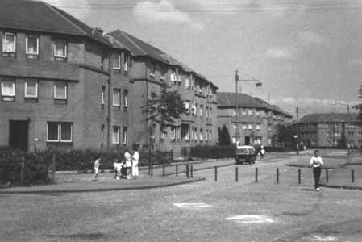*The council estates*

Glasgow established four main council estates for over 200,000 people from the inner city during the 1950s and 60s – Castlemilk, Drumchapel, Easterhouse and Pollok. These areas were originally planned as low density, semi-detached houses, with gardens and set in attractive countryside. However, cheaper 3 and 4 storey buildings of flats were eventually built instead as it was realised that the original plans would cost the council too much money and take up too much land.

*The new towns*

There were three new towns built around Glasgow during the 1950s and 1960s to house the overspill from the inner cities. East Kilbride is the largest of these towns with a population today of just under 75,000 (2011 census).

Unlike the council estates, the new towns were thoroughly planned settlements, designed to incorporate workplaces and services such as shops, libraries, schools and leisure centres for residents. Foreign companies were encouraged to locate in industrial estates on the edge of new towns. They were offered incentives such as loans or grants and new buildings so that they would provide jobs for residents in the area. Houses were a mix of flats, cottages, semi-detached and detached housing to attract a range of people. East Kilbride’s well-known road network of roundabouts and few traffic lights was typical of new towns to help keep traffic flowing quickly and easily.

*Tenement renovation*

Not all the tenements had been demolished in the CDAs so the decision was made in the late 1970s to renovate those that remained e.g. Partick. Several flats were often combined to make one larger flat. Electricity was installed, along with central heating, double glazing and internal bathrooms. The outer walls were cleaned to remove pollution that had built up from the old industries and the surrounding areas were landscaped to look more pleasant. Streets were often made into one-way systems to reduce traffic and make the area safer for families with children.

*The Gorbals Regeneration*

The Gorbals, situated just south of Glasgow City Centre was part of the post-war redevelopment scheme. Industry developed in the area in the 1930’s and low quality tenement housing was built to house the workers. Workers poured in and it became one of the most overcrowded slum areas in Scotland. The houses were cramped, damp, suffered from pollution and had no inside toilets. In the 1930s the area developed a gang culture and become known as one of the roughest areas in Glasgow, if not the UK.

The Crown Street Regeneration Project was set up in 1990 to revitalise the area. The aim at Crown Street was to regenerate the area and create a place where people would want to live, where people could enjoy the privacy of their homes but still be part of the local community.

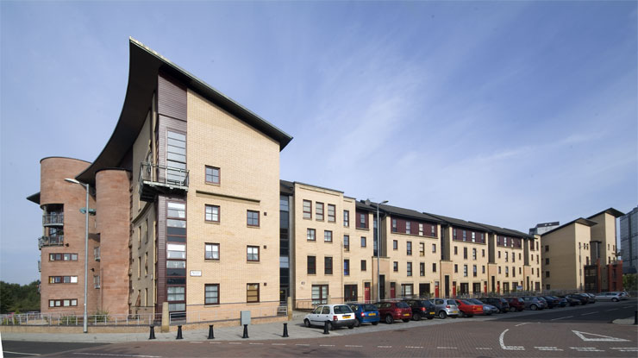High quality, expensive and largely owner occupied new 'tenement style' properties were built in the Gorbals. This attracted young professionals to the area. Crown Street was well planned and had plentiful private parking as well as numerous green spaces, including Gorbals New Park. The flats also incorporated private gardens for residents. This increased the desirability of the area for potential buyers.

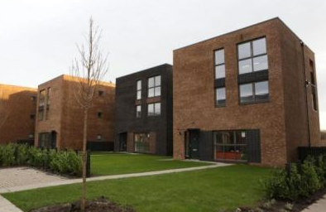

*Athlete’s Village*

As part of the Commonwealth Games regeneration, a 33 acre site in Dalmarnock was developed as the ‘Athlete's Village'. A total of 700 high quality two, three and four bedroom houses were built, 300 were sold to private owners and 400 for social housing. Moreover, they are made of sustainable material and are energy efficient as many of them contain solar panels, thus reducing the energy bills for residents. Developers state that homes give out 60% less carbon emissions and are 40% more energy efficient.

The Village is in a fantastic setting along the Clyde, and many of the houses will have views of the river. The development will contain extensive landscaped spaces, water features and play areas, which will combine to provide a very desirable residential environment. Each house is built to the highest standard, with generous room sizes.

The homes are suitable for singles and couples as well as families. The starting prices on the development will allow first time buyers to buy both flatted and terraced units and provide an affordable alternative to the highly sought after areas of the city where many buyers have been priced out of the market.

**Lesson four: Impact/evaluation of housing management strategies**

|  |  |
| --- | --- |
| **Strategy** | **Evaluation** |
| Comprehensive Redevelopment (knocking down tenements and moving to high rise) | This was not successful as many high rise flats fell into disrepair. The flats suffered social problems as residents felt isolated and crime was rife. Over 100 high rise flats in Glasgow have been demolished, including the Red Road flats. |
| New Towns | New towns such as East Kilbride have grown since the 1960’s as it offers quieter, less hectic environment but is also an excellent location for commuters as its 25 minutes from Glasgow’s CBD.  Due to the greenbelt land around the town and the financial incentives given, many foreign companies set up in business parks on the outskirts, which provided well paid employment for residents. |
| Tenement Renovations | This strategy was successful as communities were kept together increasing community spirit. Tenement areas in Partick and Denniston are now popular with students and young professionals and are seen as desirable places to live.  However, some areas such as The Oatlands and Dalmarnock failed after refurbishment. The areas were rife with drugs and crime and those who could afford to moved out. The empty and abandoned tenements were demolished and the land was sold to private house builders in 2005 for £1 |
| Crown Street, Gorbals | It has achieved its aim of creating a place where people want to be. The area has a thriving local centre and most of the residential units are occupied. The main streets are lively and the public spaces are well maintained.  Crown Street was seen as a success as the council and developers worked with the local people which gave them a sense of ownership of the area. Murals and artwork on buildings depicting local history were by local artists. |
| Athlete’s Village | It is anticipated that the quality of life of residents will improve as houses are modern and have outdoor space. Also, leisure facilities such as the Emirates Arena are close-by, encouraging people to live a healthy lifestyle |

**Lesson five: The need for traffic management in a developed world city**

Glasgow like many large cities, suffers from problems caused by increased traffic. Traffic congestion in Glasgow is a result of the increased volume of cars on the road today. In 2000 the Department for Transport (DfT) recorded 978, 317 cars on major roads in Glasgow. By 2013 this number had risen to 1,113,685, an increase of 135,000. It is clean that more people are choosing to travel by car as it is more convenient than public transport.

*More cars on the road*

* Cars are now more affordable & many families own more than one car
* This means there are more cars on the road, adding to congestion.
* Also, as population grows more cars are added to the road and more people are now completing the school run by car.
* This extends the rush hour

*Cars preferable over public transport*

* Some people see public transport as being too costly and therefore prefer to use their own car.
* Also, for some public transport is not suitable. For people who work shifts or live in areas with a poor public transport network it is difficult to find public transport which suits them. e.g. living in a small village and working nightshift.
* Therefore they use their car as it is more convenient.

*Commuters from suburbs*

* Many people now live in the suburbs of Glasgow e.g. Newton Mearns
* *25% of people who work in the city live outwith*
* They use their cars to commute into the city centre and use only a few roads to do this e.g. M8, M77 and M74.
* These roads then suffer from traffic congestion as large numbers of people are using them to travel in the same direction.

*Commuters converging*

* Many of the commuters use roads which converge (meet) on a few main arteries e.g. Great Western Road
* This means there is a large number of cars heading in the same direction on only a few main roads

*Few bridging points*

* There are only a few bridging points across the River Clyde in Glasgow.
* This means many people need to cross the river at only a few places, leading to congestion.
* The Kingston Bridge deals with over 170,000 cars per day!

*Old narrow roads*

* Many roads in Glasgow’s city centre were built before the age of the car e.g. Medieval times
* The roads are narrow and not built to allow cars to manoeuvre
* As cars exit new & large motorways they meet and need to squeeze into narrow roads e.g. Bath St.
* This causes bottleneck and congestion

*More delivery vehicles*

* An increase in online shopping e.g. Amazon means there are increased delivery vehicles on the road
* These vehicles are heavy and cause damage to roads.
* As roads require resurfacing, many are closed causing major delays and congestion

*Lack of parking*

* In the CBD there is often a lack of affordable parking
* This means many cars are parked along the sides of the road, narrowing the road width
* This makes it difficult for traffic to flow due to the restricted space e.g. St. Vincent street

*Increased tourists*

* Glasgow is a popular destination for tourists & shoppers
* At particular times of the year e.g. Christmas Glasgow becomes very busy as people visit the attractions e.g. Christmas lights and market at George Sq.

**Lesson six: Strategies employed to manage traffic congestion in a developed world city**

*Construction of New Roads*

1. New dual carriageways have been built to improve access to the city centre e.g. Springburn Expressway & Clydeside Expressway. The M80 (North) and M77 (South) have also improved access into Glasgow for commuters from Stepps (M80) and Newton Mearns (M77)
2. The M74 has been extended in order to relieve congestion on the M8, one of Britain's busiest motorways. The extension cost £500million and homes and businesses were demolished to make way for the new road

*Improvements to public transport*

1. Glasgow City Council and FirstBus worked together to introduce revised bus routes and timetables called Simplicity. The aim is to make journeys across the city quicker
2. Park and ride schemes have been introduced across the city. This is when commuters can travel to a nearby train station and park their car and then continue their journey to the CBD by train. An example is Shield’s Road in the south of the city

*Improvements to traffic flow*

1. One way systems have been introduced to help improve traffic flow in the CBD e.g. Bath st. This stops cars being held up as cars wait to turn right
2. Bus lanes have been introduced in busy areas such as West George St. around George square. This makes bus travel faster and therefore more appealing to people reducing the number of cars on the road
3. Parking restrictions have been put in place e.g. parking metres in Bothwell St. and increased traffic wardens. This reduces the number of cars parked along the roadside, allowing traffic more space to flow freely

**Lesson seven: Impact/evaluation of traffic management strategies**

*Construction of new roads*

1. Large motorways such as the M80 and M77 reduce the number of cars on smaller roads such as Great Western Road. This helps reduce congestion in built up areas making it safer for pedestrians
2. The M74 extension was controversial when it was first proposed. Many people had to leave their homes and businesses had to close to make way for the new road. People were also concerned about noise and air pollution.
3. However, the extension has been successful in reducing congestion on the M8. Around 20,000 vehicles have been removed from the M8 between Baillieston and Charing Cross. Journey times are also around 15 minutes faster

*Improvements to public transport*

1. There has been a significant increase in passenger numbers on trains between Edinburgh and Glasgow. Stations such as Carntyne and Shettleston connect passengers to the city centre in both Edinburgh and Glasgow with trains every 15 minutes between the hours of 0700hours and 1800hours.
2. First Bus has made some improvements such as adding new buses, some which contain wifi. However, some have complained that services have been amalgamated and some popular routes cancelled or experiencing reduced services. Also, there are two buses which use the number 60 but have different routes and this may be confusing for passengers.

*Improvements to traffic flow*

1. In recent years there has been public outcry as there has been a significant increase in the number of bus lanes in Glasgow’s city centre. The newly introduced bus lane at Nelson Madela Place earned the council at least £800,000 in its first two months. Drivers are fined £30, increasing to £60 after 14 days for driving in the bus lane

**Homework 1**

**To be handed in on lined paper.**

**Put your name on it.**

**Lesson eight:** **The need for housing management in a developing world city**

There are literally hundreds of shanty towns in Mumbai but probably the most famous is Dharavi, because it featured in *Slumdog Millionaire* and also in some British TV programmes and Bollywood films. It is near the centre of Mumbai, next to the financial district, and occupies a small area of 175 hectares (less than one square mile) between two railway lines. In this very small area it is estimated that up to one million people live in extremely crowded conditions.

Water comes from standpipes but is only available for 2 hours a day. There is only 1 toilet per 500 people which is usually blocked. Most people use the shallow river as a toilet.

Recent arrivals build their houses with flimsy material such as wood, corrugated iron and cloth. The oldest buildings are made of brick and concrete as they have been improved over the years. There is a maze of alleyways to get to them.

Most houses have electricity but it is tapped from the city’s power line so is dangerous and illegal.

Local residents are squatters as they do not pay rent to the government who own the land. They do however pay rent to a local landlord who looks after the land.

Dharavi is home for 1 million people, 15,000 one room factories and huge recycling industry. There are also small shops and eating places for the local residents.

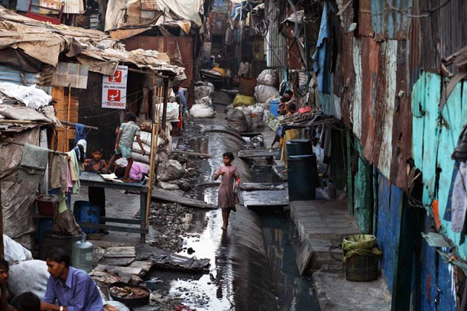

However, there are some benefits of living in a shanty town in Dharavi.

* It provides cheap, affordable housing. Mumbai cannot build enough houses for its entire people. Renting accommodation elsewhere in the city is expensive. Rents in Dharavi can be as little as £3 per month, so even the poorest can live here.
* It provided a lot of employment. There are thousands of small factories and workshops here which pay low wages but which together give employment to most of the residents. Many skilled people work here and pass on their skills to others, for example metal smiths, garment workers and potters. Now there is even a small tourist industry, with guided tours of the shanty town.
* It brings the city a lot of money. Some of Dharavi’s goods are exported all over the world – the total value of everything made here in a year is over £300 million. Much of this money is spent in Mumbai. The recycling industry here is vast, and 80% of all Mumbai’s waste is recycled (compare this to 23% in the UK).
* Very low crime rate. Conditions are overcrowded, most houses do not even have doors and certainly no locks, but crime rates are lower here than in the rest of the city.
* It is very sociable. There are communal open areas where people can sit and chat, and many of the daily chores, such as washing and repairing clothes, are done together. The feeling of belonging to a community is very strong.
* People work, very hard and are very enterprising- they pass on these attitudes to the next generation, which must benefit the city.

**Lesson nine: Housing management strategies employed in a developing world city**

Solution 1: Large scale redevelopment – Dharavi Redevelopment Project (DRP) $2billion development project, as proposed by the cities Slum Rehabilitation Authority, threatens the recycling district and part of Dharavi. The land upon which Dharavi is built is next to Mumbai’s financial district. This makes it a prime target for redevelopment. Many people, including the Mumbai authorities, think the problems in Dharavi outweigh the benefits and that the area should be redeveloped.

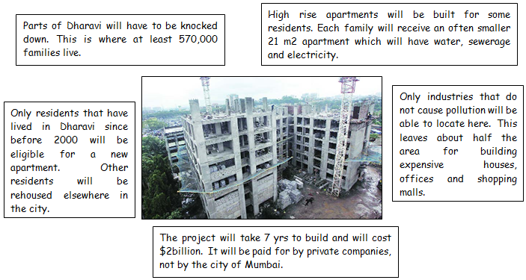

Solution 2: Local Based Improvements –Slum Rehabilitation Scheme (SRS)/Local projects

There is an alternative to large scale redevelopment and that is to allow local people to design the improvements to the slum.

Self-improvement schemes involve the following:

* The residents form separate self-help groups in different areas of Dharavi.
* One group of residents persuades the authorities to give them ownership of their land.
* Then they design their own improvements. These include: building many more properly maintained toilets, improving the water supply, building another floor onto the houses, making stronger walls.
* The people of Dharavi have a huge range of skills and can form self-help groups to carry out many of these improvements.
* Some self-help groups will negotiate small loans from banks. Others will negotiate with the authorities to provide them with some basic services, such as electricity and piped water.

The Society for the Promotion of Area Resource Centres, better known as SPARC, is an NGO (Non-governmental organisation) that supports the efforts of local people to get better housing for their many members. Ideas generated from local people supported by this charity include adding an extra floor to buildings so that all family members can be accommodated in the same building. These flats also had 14-foot high ceilings and a single tall window so are well ventilated, bright, and less dependent on electric fans for cooling. Their loft spaces add extra room without seeming crowded, and include small spaces for bathing. But toilets are placed at the end of each of the building’s four floors, and kept clean by the two or three families who use each one.

**Lesson ten: Impact/evaluation of housing management strategies**

1. Large scale redevelopment

Although there are clearly positives about the redevelopment, there are however some drawbacks.

* Only some of the families will be rehoused in Dharavi. Many families are currently living above their workshops which would be impossible in the new apartments. This will separate communities and make people work away from where they live.
* People are unhappy that they will be given such small apartments. Although the new apartments have more floor space, in the shanty town residents have made an extra storey in many of their houses, which will not be possible in a block of flats.
* People are concerned that many of the workshops which give off pollution, such as the metalworking, will be banned with the new laws.
* There is not enough space being given to industries such as pottery and recycling- these employ many people and bring in a lot of money, but they need large areas of land. If there is no recycling, there will be a lot of waste and litter all over the city.
* These areas have strong safe neighbourhoods that have low crime and communal areas. Also at risk are the local shops and markets and the community spirit which has taken generations to develop.
* Current redevelopment projects are densely populated and house lots of people. They are not good for community cohesion.

1. Slum Rehabilitation Schemes/Local projects

As the National Slum Dwellers Federation has repeatedly proven, housing the poor works best, costs less and is better for the environment, when the poor themselves have a say in what is being built.

Diseases such as cholera have been reduced due to the planning and management of upgraded mains sewers. Within 12 years 15% of Dharavi has been redeveloped.

Overcrowding is reduced as the self-help schemes support the efforts of local people to improve their housing for example by adding an additional floor to buildings. Toilets have been added and are shared by two or three families who help keep them clean, which has reduced the incidence of water related disease. However this idea only work when water is running in Dharavi.

**Lesson eleven: The need for traffic management in a developing world city**

Developing countries often have similar problems to those in developed nations, caused largely by mass movements of people during the working day. However, the problems are often made worse due to lack of development.

* Insufficient money to pay for the ever-increasing costs of providing a transport infrastructure which works.
* A transport system which is inherited from previous colonial rulers.
* An emphasis on building huge ports, high grade roads and railways to move goods about for industry rather than a transport system focused on the mass movement of people.

Mumbai has the biggest port in India. The first railway was built in 1853 and encouraged the manufacturing industry as it was easy to bring raw materials from surrounding farms by railway to the port. Mumbai was originally built on several islands so bridges had to the built. Bombay island itself is very narrow, with little room for roads and railways. Therefore there are few roads and railways which reach the centre, however 8million commuters go there every day.

This results in congested roads with potholes, poorly maintained roads that flood, people selling things at the side of the roads, parked cars at the side of the roads, and overcrowded buses and trains with people clinging to the sides and roofs.

Increasing population, wealth and economic growth of car and two wheeler ownership has only made the situation worse. On average, 200 cars and 300 two wheelers are added to the roads every day as people are choosing their own vehicle instead of public transport.

**Lesson twelve and thirteen: Strategies employed to manage traffic congestion in a developing world city and their evaluations**

1. *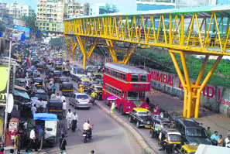Skywalk project – encourage walking*

What is it? A series of 36 elevated pedestrian walkways in Mumbai, India.

Why is it needed? Mumbai is a pedestrian-dominated city with 60% of the trips being made through walking. Pedestrians, however, have great difficulty in navigating through the commercialised areas. Passengers exiting railway stations have a tough time accessing other areas such as bus stops, taxis and parking lots, which are scattered throughout the city. In addition to this, the majority of the footpaths are occupied by illegal vendors. An elevated walkway was, therefore, proposed in 2003. The walkways are located above the ground to aid safe and free flow of pedestrians around the city.

******Evaluation Around 12 million people are currently using the skywalks every day. The skywalks generate revenue through advertising spaces and help in recovering the construction and maintenance costs. Pedestrians are separated from vehicular traffic thus reducing accidents and improving vehicular flow.

### *Traffline*

What is it? Traffline is a digital traffic agent that allows commuters to check traffic conditions in their city at any time of the day. You can view a real-time traffic map with colour-coded lines indicating congestion, slow and fast moving traffic with details on jams, road accidents and best alternate routes available on their website and mobile app. They also have a helpline and Twitter for those who are not comfortable using a map interface.

It gets its traffic data from various sources. The base information comes from moving probes - taxis, public transport vehicles and others – that have GPS installed in them. Accident and event-related information is collected from people on the field and Traffline’s followers on Twitter who report information voluntarily.

Evaluation It does not help reduce the number of vehicles on the roads and may not therefore be as valuable as improvements to public transport systems, although it does help commuter chose the best route for their journey.

1. *Best Buses*

What is it? Part of the Mumbai Urban Transport Project (MUTP) set up in 2002, which is using four methods to solve traffic congestion:

* Improve railways – more tracks, more stations
* Improve roads – new road links between the main highways, widen some roads up to six lanes.
* More buses – 500 new eco-buses
* Speedup road traffic – flyovers instead of intersections, subways instead of pedestrian crossings.

As of 2013, the BEST runs a total of 4,680 buses, ferrying 5 million passengers over 365 routes. BEST operates one of India's largest fleets of buses. The bus transport service covers the entire city and also extends its operations outside city limits into neighbouring Navi Mumbai. In addition to buses, it also operates a ferry service in the northern reaches of the city. Smart cards to speed up payment and GPS tracking of buses to monitor them in real time are enhancing the customer experience.

Evaluation This is affordable transport for the poor which is a key part of Mumbai’s transport system. Future planning of ‘bus lanes’ to allow buses priority access through the busiest parts of the city would further enhance their role in keeping the city’s population moving.

1. *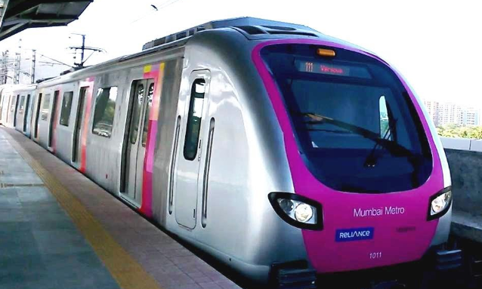The Mumbai metro*

What is it? A metro system is under construction in Mumbai. The system is designed to reduce traffic congestion in the city, and will be built in three phases over a 15-year period, with overall completion expected in 2021. Parts of it opened in 2014. When complete, the core system will comprise of three high-capacity metro railway lines, spanning a total of 63 kilometres (39 miles).

Metro system is much preferred in any city for their high-capacity and attractive features. However, if considered from the point of view of Mumbai, the metro system is much needed for following reasons:

1. Limitations that are faced in the expansion of road network
2. Present rail and road scenario not apt for future travel needs
3. The role of bus system is limited in the area of offering feeder services to railways

Evaluation The metro will be fast and is environmentally friendly. It will help connect some suburban areas to the city, and is needed as the bus network alone cannot cope. However, the cost of the project has increased from RS 4321 crore to RS 2356 crore, eventually costing $10billion but the length of tracks has been extended to provide a better service.

**Homework 2**

**To be handed in on lined paper.**

**Put your name on it.**

**Past Paper Questions**

|  |  |  |
| --- | --- | --- |
| **Explain** why there was a need for housing management in Glasgow. | **6** |  |
| **Discuss** the housing management strategies put in place in Glasgow. | **6** |  |
| **Evaluate** the effectiveness of the housing management strategies put in place in Glasgow | **5** |  |
| **Explain** why there was a need for traffic management strategies in Glasgow | **5** |  |
| **Explain** the traffic management strategies which have been put in place in Glasgow. | **5** |  |
| **Evaluate** the effectiveness of the traffic management strategies in Glasgow. | **5** |  |
| **Explain** why there was a need for housing management in Mumbai. | **5** |  |
| **Discuss** the housing management strategies put in place in Mumbai. | **5** |  |
| **Evaluate** the effectiveness of the housing management strategies put in place in Mumbai. | **5** |  |
| **Explain** why there was a need for traffic management strategies in Mumbai. | **5** |  |
| **Explain** the traffic management strategies which have been put in place in Mumbai. | **5** |  |
| **Evaluate** the effectiveness of the traffic management strategies in Mumbai. | **5** |  |