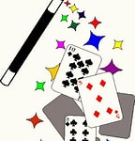
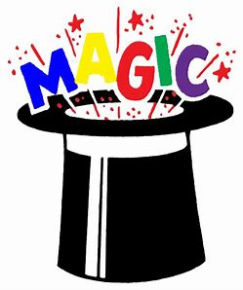

Teaching Magic to Improve Children’s Health & Wellbeing

Name of child……………………………………………………………………………………………
Date of request………………………………………………………….
Requested by…………………………………………………………
Requester contact number and email……………………..….…………………………………………….
Questions for initial request:

1. Are there any situations or circumstances which are known to cause the child distress (known triggers, peers etc.)?

2. Every child has their “THING”, be it music, movies, sports, comic books, etc. What is this child’s “THING”?

3. Does the child have any pets?

4. Does the child have brothers/ sisters?

5. Is there anything I would need to know about the child’s family circumstances?

What is the main outcome you hope to achieve for this child/young person or group of children?

Email request to scott@scotlandsmagician.com following parental consent for 1-1 interventions. Email cc to: Margaret.manson@aapct.scot.nhs.uk
Scotty will call you back to have further discussions and contact details for the child/ family or link person for any individual or group interventions.
Following agreed interventions Scotty will update the requester by email or phone call.

