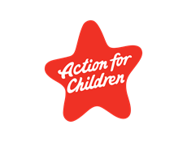  Who we are  ‘’We work to make sure every child and young person has the love, support and opportunity they need to reach their potential’’  Contact Us  43 John Finnie Street  Kilmarnock  East Ayrshire  KA11BH  Tel: 01563 572 479  Email – Joe.Bryers@actionforchildren.org.uk  Website - www.actionforchildren.org.uk  [Company Name]  [Street Address]  [City, ST ZIP Code] |  |  | Community Support Service  (East Ayrshire)  Overview of Service  Action for Children will work alongside East Ayrshire council, schools and relevant partners to engage and support young people whose mental health and wellbeing and has been impacted through the Covid 19 Pandemic.  Action for children understands the pressures this pandemic has had on young people in the community, due to usual support systems being limited, leading to increased difficulties with emotional health and wellbeing.  Our trained staff will focus on each individual unique challenges they encounter and focus on the negative feelings and emotions these Young People face. The challenges could include loneliness, anxiety, frustration, or isolation as well as many others.  We will use our experienced staff to engage with these young people improving their mental health and wellbeing to reduce the likelihood of current feelings escalating in to negative/harmful behavior.  We will deliver mostly evening and weekend contacts with the young people using a range of targeted interventions designed to improve their mental health and wellbeing.  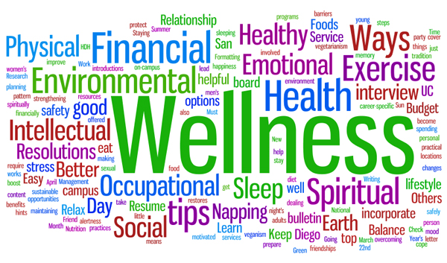  This Photo by Unknown Author is licensed under CC BY-SA-NC
4 |  |  | 1

What our Model Includes  Mindfulness within Schools – (DAY)  - Young People are able to learn coping skills and techniques to develop positive responses to life stressors.  - Further participation- Referrals can be made to enter onto the below programme, which is delivered within the community during the evenings.  Blues Programme – (EVENING & WEEKENDS)  - Group Based Support – The Blues Programme  ‘Blues is a group-based intervention for 12-18 year old, proven to reduce indications of anxiety and depression.  - Uses CBT (Cognitive Behaviour Techniques) to help young people make connections between thoughts, feelings and actions.  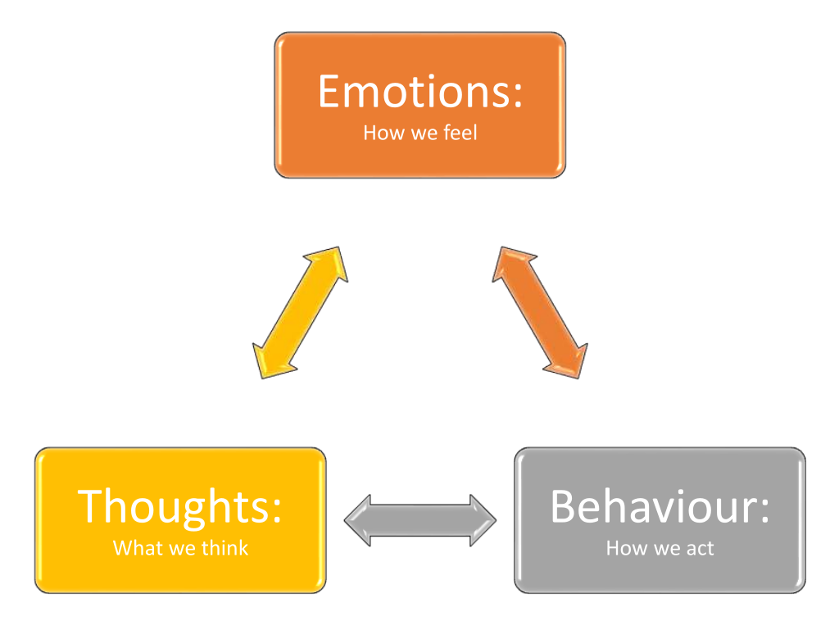  This Photo by Unknown Author is licensed under CC BY-SA |  |  | Continued…  1:1 Mentoring / Mini Group Sessions -  - Wellbeing and Mindfulness Awareness, building a holistic package of support to the individual needs.  - Health and Fitness – Key Workers will support interested young people who need extra support to access local fitness resources until the individual is confident enough to attend on their own. This could include a range of hobbies. We also have a trained Instructors who can introduce some basic skills to any young people that has a keen interest in sport or activities.  - Role Modeling/Mentoring – Where appropriate staff will spend time with Young People and act as a role model. Keyworker will challenge views and opinions whilst educating and building one’s confidence. This could include a ‘walk and talk’ session as well as visits and even mini group activities (In line with Scottish Government Covid Guidelines)
2 |  |  | 3

