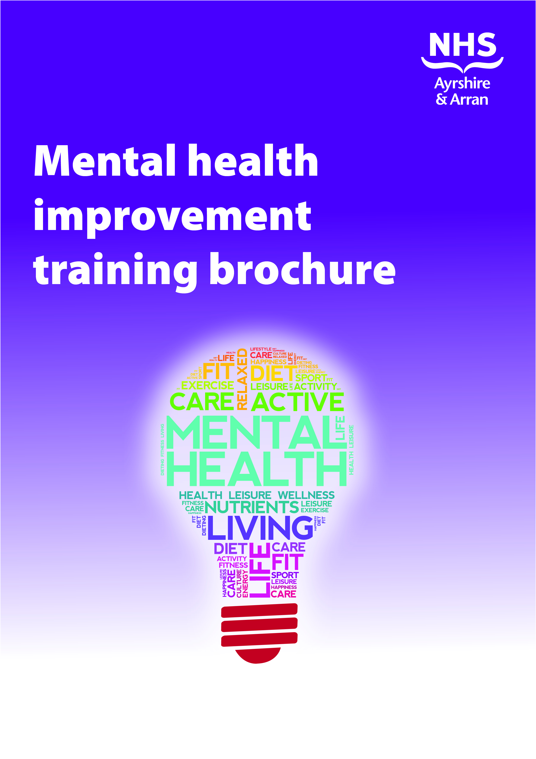

Introduction
A wide variety of training courses are available in Ayrshire and Arran. Most courses are free of charge and are open to anyone interested in learning more about how to promote good mental health and wellbeing in a range of settings. Please go to each individual course page for details on aims, learning intentions, who should attend and how to book. Training courses have been organised in the categories below to help guide you to the appropriate training for your needs. Some courses fall in to more than one category.
- General awareness training
- Topic specific training
- Settings based training
- Training specific to children and young people
The document will be reviewed regularly so please ensure that you have the most current version.

Contents Page
 | Category |  |  |  | Page numbers
 | General awareness | Topic specific | Settings based | Young people
ASIST 11 – Applied suicide intervention skills training |  |  |  |  | Page 1
Early brain development and attachment – infant mental health |  |  |  |  | Page 2
Fetal Alcohol Spectrum Disorder (FASD) |  |  |  |  | Page 3
Mental health and substance use |  |  |  |  | Page 4
Mental health improvement: a practical approach |  |  |  |  | Page 5
Mindfulness – an Introduction to |  |  |  |  | Page 6
SafeTalk – Suicide awareness for everyone |  |  |  |  | Page 7
Stress awareness |  |  |  |  | Page 8
Stress awareness for workplaces |  |  |  |  | Page 9
Wellness Recovery Action Plan (WRAP®) |  |  |  |  | Page 10
E learning Modules |  |  |  |  | Page 11

ASIST 11 – Applied Suicide Intervention Skills Training

Category: Topic specific
Aims  This is an intensive 2-day interactive and practice dominated course that teaches you how to:  - preserve life where a person may be a danger to themselves;  - listen and talk to a person with suicidal intention without judgement; and  - provide comfort to a person with suicidal intention. | Course duration: 2 days
Learning outcomes
By the end of the course you will be able to:
- identify people who have thoughts of suicide;
- understand how your beliefs and attitudes can affect suicide interventions;
- seek a shared understanding of the reasons for thoughts of suicide and the reasons for living; and
- review current risk and develop a plan to increase safety from suicidal behaviour for an agreed amount of time.
Who is it for?
General community members and frontline staff.
Date of course(s)
Contact Charlene Nisbet for dates of future courses.
To book
Call Charlene Nisbet, Choose Life Administrator on 01292 513146 or email chooselife@aapct.scot.nhs.uk

Early brain development and attachment- infant mental health
Category: Topic specific

Aim  To raise awareness of early brain development and attachment and its impact on infant and children’s emotional wellbeing and wider development. | Course duration: ½ Day
Learning outcomes
By the end of the course you will:
- be able to define infant mental health;
- have increased knowledge about early brain development and concepts of attachment;
- be able to identify interventions to promote infant mental health;
- have increased knowledge that allows you to signpost to resource materials.
Who is it for?
Open to anyone who would like to increase their knowledge in infant mental health.
Date of course(s)
On request.
To book
Email Karen Lee at Karen.Lee@aapct.scot.nhs.uk

Fetal Alcohol Spectrum Disorder (FASD)
Category: Topic specific
Aim  To provide an awareness and understanding of Fetal Alcohol Spectrum Disorder (FASD) | Course duration: 3 hours  (9.30am – 12.30pm)
Learning outcomes
By the end of the course you will:
- have a clear understanding of the alcohol guidelines for pregnancy;
- have a clear understanding of how alcohol may impact on fetal development;
- have a clear understanding of what FASD is and the difficulties that those affected may experience;
- have information on strategies to support individuals that display characteristics of FASD;
- have a clear understanding of the prevalence of FASD; and
- be aware of the support services available within Ayrshire and Arran.
Who is it for?
Open to anyone who would like to increase knowledge in Fetal Alcohol Spectrum Disorder (of particular interest to staff within Health and Social Care and Education)
To enquire
Email FASDtraining@aapct.scot.nhs.uk

Mental health and substance use
Category: Topic specific

Aim  To increase awareness of the link between substance misuse and mental health issues. | Course duration: 1 Day
Learning outcomes
By the end of the course you will:
- have an overview of mental health presentations including mood disorder, anxiety, personality disorder and psychosis;
- be familiar with the potential link between mental health presentations and substance misuse;
- have knowledge of risk behaviour in association with mental health and substance misuse;
- be aware of dual diagnosis (the co existence of mental health issues and addiction); and
- be able to adapt theoretical knowledge to work with service users.
Who is it for?
People with a basic understanding of substance misuse who are looking to develop an understanding in relation to mental health.
To enquire
Call the Prevention and Services Support Team on 01294 322339 or email psst@aapct.scot.nhs.uk

Mental health improvement: a practical approach
Category: General Awareness
Aims  To raise awareness of the importance of mental health improvement and provide delegates with the knowledge, skills and tools required to promote mental health improvement within the environment they influence. | Approx Course Length: 2.5 hours
Learning Outcomes
By the end of the session you will:
- Be aware of the concept of mental health improvement and the role it plays in promoting wellbeing, preventing mental illness and facilitating recovery
- Be able to identify the components and benefits of a mentally healthy environment
- Have information on approaches, self-help tools and additional resources that are effective in promoting mental health improvement
- Be confident in supporting the development of an action plan for mental health improvement to implement in your own setting
Who is it for?
This course is aimed at anyone who is interested in mental health improvement within the environment they influence. Participants include workplaces.
Date of course(s)
On request
To book
Email Karen Lee at Karen.Lee@aapct.scot.nhs.uk

An Introduction to Mindfulness
Category: Topic specific and settings based (workplace)
Aim  To raise awareness of mindfulness and its use in mental health improvement within the workplace. | Course duration: 1 hour
Learning outcomes
By the end of the course you will:
- have an understanding of mindfulness
- be aware of potential benefits
- understand how you can develop the skill of mindfulness
- have an awareness of common misconceptions
- have an awareness of local and online resources
- have had the opportunity to try mindfulness techniques
Who is it for?
Employees and employers interested in learning about and raising awareness of mindfulness. Open to any business or organisation within Ayrshire and Arran, delivered within the workplace to up to 16 delegates per course.
Date of course(s)
On request.
To book Email the Workplace team AA-UHB.HWL@aapct.scot.nhs.uk

SafeTalk – suicide awareness for everyone
Category: Topic specific
Aims  By the end of the course you will be able to:  - recognise that a person might be having thoughts of suicide;  - engage that person in direct and open talk about suicide; and  - move quickly to connect them with someone trained in suicide intervention. | Course duration: 3 – 3.5 hours
Learning outcomes
By the end of the course you will:
- move beyond common tendencies to miss, dismiss or avoid suicide;
- identify people who have thoughts of suicide; and
- apply the TALK steps (Tell, Ask, Listen and Keep Safe).
Who is it for?
Anyone who wishes to be more suicide alert.
Date of course(s)
Contact Charlene Nisbet for dates of future courses.
To book
Call Charlene Nisbet, Choose Life Administrator on 01292 513146 or email chooselife@aapct.scot.nhs.uk.

Stress awareness
Category: Topic specific
Aim  To increase awareness of stress and how to manage stress. | Course duration: ½ Day
Learning outcomes
By the end of the course you will:
- have an overview of stress;
- have a definition of stress;
- be able to identify sources and symptoms of stress;
- be able to develop strategies for managing your own stress;
- have an understanding of the role of the organisation;
- learn simple techniques to combat stress; and
- gain further information about stress.
Who is it for?
Any NHS staff who would like to know more about stress and how to manage stress.
Date of course(s)
Contact Occupational Health to enquire about dates.
To enquire
email aa.Occupational.Health@aapct.scot.nhs.uk

Stress awareness for workplaces
Category: Topic specific and settings based (workplace)
Aim  To raise awareness of stress in the workplace | Course duration: 1 hour
Learning outcomes
By the end of the course you will:
- have an understanding of the meaning of stress;
- recognise when you are stressed;
- understand what can cause stress;
- identify how you respond to stress;
- develop coping mechanisms; and
- develop your own personal action plan.
Who is it for?
Employees interested in learning about and raising awareness of stress in the workplace. Open to any business or organisation within Ayrshire and Arran, delivered within the workplace to up to 16 delegates per course.
Date of course(s)
On request.
To book
Email the Workplace team AA-UHB.HWL@aapct.scot.nhs.uk

Wellness Recovery Action Plan® Workshop (WRAP®)
Category: General awareness
Aims  To provide people with the opportunity to learn about and develop their own Wellness Recovery Action Plan® to help manage mental wellbeing. | Course duration: 18 hours
Learning outcomes
By the end of the course you will have learned the following.
- The key concepts of mental health recovery, Wellness Tools and all parts of WRAP®.
- The process of developing your own plan which could help you to:
- manage your wellbeing and improve your quality of life;
- decrease and prevent intrusive or troubling feelings and behaviours;
- increase personal empowerment; and
- achieve your personal goals and dreams.
Who is it for?
Available to all but advertising may be targeted in response to need.
Date of course(s)
Ad hoc in response to need.
To book
Email HITraining@aapct.scot.nhs.uk

E-Learning Modules
Category: All
Below is a selection of e-learning modules that are all free of charge. Some may require you to set up an account to enable you to login and undertake the learning.
MindEd https://www.minded.org.uk/

‘MindEd’ is a free educational resource on children and young people's mental health for all adults.

About Mental Health https://www.samh.org.uk/about-mental-health/elearning-for-teachers

‘We all have mental health’ is an introduction for teachers to provide an introduction to mental health; equip individuals with the skills and knowledge to recognise and respond to a pupil who is experiencing a mental health problem; and lead a conversation about positive mental health.

Mentally Healthy Workplaces https://elearning.healthscotland.com/login/index.php

‘Mentally healthy workplaces’ training is for anyone who wants to learn more about mental health in the workplace. Create an account via the link below which will allow you to search for the online training plus other e-learning modules.

Self Harm Lifelines http://www.selfharmlifelines.org.uk/register.html

‘Self harm lifelines’ training will give you an overview of the area of self-harm and how those who do self-harm can be supported.

Save a Life https://www.zerosuicidealliance.com/

‘Save a life’ training will give an overview of the area of suicide and how to support people who are at risk.

Future Learn https://www.futurelearn.com/courses/categories/health-and-psychology-courses/psychology-and-mental-health

A wide selection of online training to learn about mental health, mental health problems, or develop your career in mental health with online mental health courses and psychology courses.

