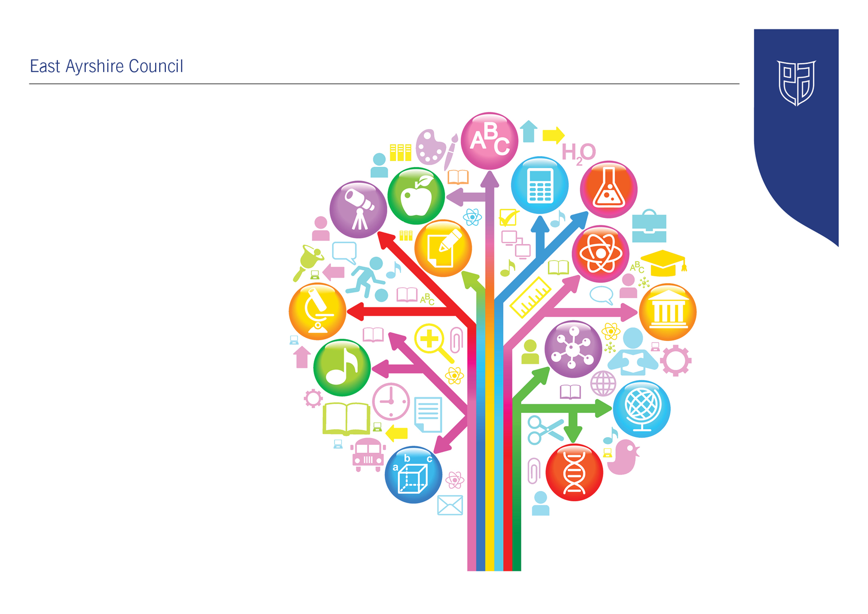
Standards and Quality Report
2021-2022

Riccarton Early Childhood Centre

Establishment Context
Riccarton Early Childhood Centre (ECC) serves the community of Riccarton, Bellfield and Caprington in Kilmarnock. The centre is within an area of high social and economic deprivation currently 75% of children live in areas of SIMD 1 & 2, as outlined in the Scottish Government publication, Scottish Index of Multiple Deprivation 2020v2
The centre is registered with the Care Inspectorate to provide a care service for a maximum of 64 children aged 3-5 years in full day provision. The session runs from 8.45am- 2.45pm during the academic year. In session 2021-22, we had 36 funded 4 year olds, 4 returning for an additional year, and 22 funded 3 year olds.
The building compromises of two large playrooms, a large outdoor area and a family learning zone. Children can access the outdoor area freely from the main playroom. Staff carefully consider the learning environments both indoors and outdoors in line with Realising the Ambition: Being Me to ensure they are child- centred, play based, and developmentally appropriate to meet the varied learning needs of all the children. Inquiry, curiosity and creativity is at the heart of the learning and we use natural, open-ended resources to encourage children to be inspired, and continually motivated .Our learning environments are nurturing, positive, inclusive, and skilled interactions are crucial to develop positive relationships and support or extend children’s learning through play.
Children’s progress is carefully monitored through individual developmental milestone trackers, pace and challenge meetings, staged intervention and IEPs. This ensures we improve outcomes for all. Effective teamwork and professional dialogue results in knowledgeable judgements on children’s progress. A range of assessment approaches implemented throughout the centre monitor pupils’ progress and plan for next steps. During the academic session 2021-22 almost all children, 94%, made significant progress across their learning and development and becoming confident learners. We measure this using our wellbeing trackers. Most of our children are making positive improvements in literacy, numeracy, health and wellbeing as appropriate to their developmental stage. Data collated on children achieving elements of their developmental milestones shows 94% achieving in health and wellbeing, 82% of children achieving in maths and numeracy, and 81% achieving in Literacy. See attachment 1.
This year, we also gathered data on children attending for an additional year. All these children made excellent progress. 100% achieving health and wellbeing, 91% achieving Literacy and 91% achieving numeracy. See appendix 2
Finally, appendix 3 demonstrates that our children from the most deprived areas are making outstanding progress and therefore we are ensuring equity for all our learners. See Appendix 3
High quality interventions and data gathered demonstrates that all children receiving targeted support are making progress in their communication and language skills.
We value our partnership with parents, carers and extended families. We use information from home to build on previous learning and children’s interests. This session, due to the pandemic we were unable to offer our home visits however, we were able to offer PEEP sessions outdoors for all newly registered children and their families. This proved to be a preferred model with our families and increased partnership working with parents from the onset of their educational journey. Through implementing this model, we have noticed an increase in the number of key adults (parents, carers, grandparents and childminders) attending other family learning events. We have a close working partnership with our community Practitioner and our colleagues from vibrant communities and in collaboration; we usually offer a wide variety of parental engagement events such as junior joinery, book bug, healthy eating cookery classes and play & stay sessions. Unfortunately, due to COVID-19 restrictions we were unable to offer these events but hope to resume them next session.
Parents and carers are consulted regularly on the activities and experiences we offer through electronic surveys using FORMS. Their views directly influence the improvements we make. This ensures we continue to provide the highest quality service and that we meet all our family’s needs and ensure equity for all.

We make the most of our local environment through a programme of visits and visitors. Our annual programme of events consists of weekly outdoor woodland visits, Care Home intergenerational visits, local shops and the garden centre. We participate in fitness and sports inspired activities such as classes at the athletics arena, dance and football coach specialists. The programme gives children an understanding of the world in which they live and promotes the world of work.
Last session our improvement priority was to promote more learning in the areas of science, technology, engineering and maths (STEM) We organised visits from the STEM ambassador in a local engineering company to work alongside the children in carrying out experiments, we planned weekly visits to Bridgend Motor group to see first-hand mechanics at work. Unfortunately, these activities had to stop due to the pandemic. We hope to resume them when safe to do so.
Staff are involved in a robust programme of self-evaluation using HGIOELC and Realising the Ambition: Being me. Appropriate training is organised to ensure they continually improve their practice to influence the children’s learning. This is evidenced in HGIOELC floor book.
Celebration and recognition of individual achievements is promoted, valued and evident within the work at the ECC. We celebrate individual achievements daily through distribution of golden tickets, lunchtime super stars and at the end of every week, a joyous “Star of the week” event occurs.
Parents and carers are encouraged to inform and share children’s achievements out with the centre and this is evident in each child’s online learning journal. As a direct result of visiting specialists to the centre, the children participating in activities out with the centre has increased.
In November 2020, Riccarton ECC received the Times Education Award for the best Early years Centre in the UK.
In February 2022, Riccarton ECC received Communication Friendly accreditation.

Establishment Vision, Values and Aims
Our Vision
At Riccarton Early Childhood Centre we strive for excellence.
We seek to provide a safe, welcoming centre where all our children are nurtured, respected, included and motivated to learn. A place where children’s rights are central and every child is encouraged to reach their full potential.

Our Values

Nurturing Relationships, Respect, Happiness and Wellbeing, Child Centred and Partnership

Our Aims

- Provide a safe, happy, nurturing and stimulating environment in which every child and all involved in their development will feel welcome, respected, valued and confident.
- Provide a relevant, progressive and balanced curriculum indoors and outdoors with high quality, learning experiences that supports and challenges children.
- Ensure children are at the centre of their learning, consulted in decision-making and experiences take account of their individual interests and needs.
- Create an environment that encourages respectful relationships. Children will be supported to understand their feelings and become emotionally resilient and recognise that everyone has equal status and equal opportunities.
- Establish and nurture strong partnership links with parents and the wider community to work productively together to encourage innovative and forward thinking ideas to continually improve the service we provide.

Improvement Priority | As we enter a period of recovery from the pandemic we wanted to prioritise the physical, mental and emotional wellbeing of children, practitioners and parents. | Rationale for improvement priority based on evidence  Due to the COVID-19 pandemic we need to ensure that the centre is safe and nurturing for the return of staff and pupils. Our main priority was to support the emotional wellbeing of children, parents and practitioners. Through self-evaluation we felt we needed to improve our partnership with parents further and in particular transitions into the centre.
NIF Priorities  Improvement in attainment, particularly in literacy and numeracy | NIF Driver  School Leadership | HGIOS/ HGIOELCC QI’s for self-evaluation  1.3, 1.4, 1.5, 2.4, 2.6, 3.1
Progress and Impact | - Staff participated in an audit exercise to review the learning environment indoors and outdoors before coming back fully the centre. Using national guidance Realising The Ambition: Being me. This resulted in the Playrooms being updated, changing the layout of some areas, adding new resources, environmental print and signs to make areas more inviting.  - We continue to encourage children to access the outdoor area freely each day in all weathers. The data we gather demonstrates that almost all the children access outdoors every day.  - We have continued to embed our annual Health & Wellbeing planner that incorporate PATHS activities and resources.  - As the centre was working within cohorts, we identified a need for a nurture area in both areas. With the support of parents, we had a successful fundraiser that enabled us to purchase an outdoor shed and this was transformed into an additional nurture area that can be accessed by staff and children in cohort 1 and provide a safe base for our most vulnerable children who may require some chill out or 1:1 time.  - We enhanced transitions to the centre using the outdoors. We Planned and delivered a programme of PEEP sessions for parents and children. We created a virtual tour video and photo books from home to settle new children. Parents and grandparents attended outdoor stay & play sessions in the first term.  - We have continued to support our most vulnerable children with all children identified as requiring support identified quickly through our targeted interventions and supports. With and a range of assessments used and support groups put in place. These range from one to one support, attention and listening groups, communication champion support groups - Working collaboratively with SLT towards targets for children receiving support. ELLAT and Numeracy support groups and challenge groups in place to ensure all children reach their full potential. Evidence gathered through developmental milestone trackers and pace and challenge meetings show all children are making significant progress.
Next Steps | We will carefully plan the removal of cohorts and open up the indoor environment for all children and staff. We will continue to use best practice guidance to support us in further creating an enriched environment for children outdoors and indoors. This environment will be welcoming, cosy, relaxed and safe for children to be independent in their learning. Play spaces will be reviewed regularly and be well resourced with increased natural and sensory play opportunities to encourage children’s confidence, curiosity and creativity. We will continue to audit our environment and evaluate interactions and experiences.  Continue to promote the wellbeing effects of outdoor play. We hope to extend the natural woodland area to improve the outdoor learning environment for children and staff.  We will continue to ensure quality interactions and learning experiences responsive to children’s needs and interests, embedding Realising The Ambition: Being Me and through a programme of rigorous monitoring and reflection.  Continue to strive towards Rights Respecting Silver award. Staff will continue to focus on promoting children’s rights through daily practices ensuring that children remain at the heart of all decision-making processes and children’s Rights are embedded in the centre

Improvement Priority  (Expressed as outcomes for learners) | To improve standards in literacy. Increase staffs knowledge and skill in communication and language techniques and children’s progression across key skills. | Rationale for improvement priority based on evidence  To strive for our Communication Friendly Accreditation
NIF Priorities  Improvement in children and young people’s health and wellbeing | NIF Driver  Teacher Professionalism | HGIOS/ HGIOELCC QI’s for self-evaluation  1.4, 2.3, 2.4,
Progress and Impact | - As part of our Communication Friendly accreditation journey, we specifically looked at ensuring quality interactions and learning experiences outdoors to ensure they were responsive to children’s needs and interests. Staff identified this was an area for improvement and as a result the quality of interactions at the end of term has greatly improved as a result.  - Staff continue to implement strategies they learned during a wide variety of training on I CAN, listening and attention, phonological awareness, Teacher talk, ASD, staff/ child interactions and Makaton. This training has improved practice with a consistent approach throughout the centre. Staffs knowledge and skill has had a direct impact on improving children’s communication and language skills, which is evident in their assessment trackers and Pace and challenge meetings. Almost all children have made progress in their literacy skills.  - We implemented responsive planning in line with Realising the Ambition: Being Me. We ensure learning walls are updated regularly and capture children’s voice. This learning is evidenced in floor books to enable children to recap and re-visit their learning throughout the academic year.  - We devised an annual planner to support Makaton signs in daily routines and this is shared with parents and carers through our online learning Journal platform.  - We introduced a Speech and language resource pack to support staff in providing activities, which promote 4 stages of listening. This consistent approach at group times has had a positive impact on the development of children’s attention and listening skills and is highlighted in the data that we gather.  - Our Equity and excellence lead practitioner participated in intense training with speech and language therapist and as a result was able to offer and deliver a programme “More than Words” for parents with children diagnosed with Autistic Spectrum disorder  - We continued to support our most vulnerable children with targeted interventions and support. Monitoring children’s progress  - All staff participated in trauma informed and Autism awareness training and were able to implement strategies which had a positive impact on supporting vulnerable children within the centre.  - Following guidelines children continued to have the opportunity to attend woodland visits and Care home garden visits.
Next Steps | - Create a programme of learning outcomes focus for literacy and numeracy for each planning cycle. Incorporate learning experiences into responsive planning.  - Audit current resources used to support key skills in developmental trackers.  - Organise and purchase new resources to support key skills. Continue to embed responsive planning in line with Realising the Ambition: Being Me. Ensure learning walls are updated regularly and capture children’s voice.  - Create designated Literacy area in Willow woods to promote early reading and writing skills.  - Following on from our Communication Friendly Accreditation, we want to ensure four stages of listening and Makaton signs are incorporated into every group time. Continue to promote Makaton signs in daily routines and share with parents through online platform.  - Continue to support our most vulnerable children with targeted interventions and support. Monitoring children’s progress termly. Continue Targeted support groups for children identified requiring Literacy/ numeracy support  - Devise specific trackers to support children with additional support needs.  - Resume stay and play sessions for parents/carers indoors to raise awareness of the importance of high-quality literacy and numeracy experiences and outdoor learning in supporting children’s early development. Workshops will be informative and practical and planned carefully to cover different concepts within different sessions. Surveys will be used to gather feedback and measure impact of sessions attended on awareness and changes made at home.

Improvement Priority  (Expressed as outcomes for learners) | To improve standards of numeracy and ensure equity for all. | Rationale for improvement priority based on evidence  Through self- evaluation using current national guidance, we identified a need to improve our numeracy provision indoors and outdoors. We identified a need to promote numeracy activities within the centre and at home.
NIF Priorities  Closing the attainment gap between the most and least disadvantaged children | NIF Driver  Assessment of children’s progress | HGIOS/ HGIOELCC QI’s for self-evaluation  2.2, 2.5, 2.7, 3.2
Progress and Impact | - After In- house training on Realising The Ambition: Being Me and an audit of indoor and outdoor areas we set up areas and purchased resources to ensure that numeracy skills as listed on our developmental milestone trackers are supported fully. We continue to use open ended and natural resources.  - We continue to support children’s numeracy targets through small group time activities that will support and also provide appropriate challenge.  - Our technology and numeracy champions linked up to devise an annual programme of activities and skills. They promoted home learning activities and parental engagement via Learning journals  - We offered stay and play sessions for parents outdoors with a maths/ numeracy focus. These were well attended with almost all our families.  - Our new developmental milestone trackers have assisted in setting children’s smart targets and group time planning to ensure activities are at a level that is suited to each child’s stage of development. New trackers can break each area of curriculum down to make simpler targets or more challenging ones. Staff commented on having a greater understanding of planning and assessing children’s progression over time and assisted in target setting differentiating group time activities.  - We continue to use Learning journals for all children and the feedback from parents via online surveys has been very positive. Data gathered demonstrated that almost all our families were accessing learning journals and the majority participating in home learning activities. Staff have provided a wide range of online learning experiences that offer differentiation, and is supportive of all children’s individual targets.
Next Steps | - Create an annual plan of experiences including visits to engineering companies Bridgend garage, STEM ambassador at Spirit aero systems. Visits to local care home, Vets, police officer, Firefighters, dance and music specialists  - Promote parental engagement sessions in collaboration with vibrant communities and community practitioner: Healthy eating workshops, junior joinery, outdoor learning woodland visits  - Promote Cooking, baking, STEM and woodwork activities into weekly routine and designated planning area.  - Continue pace and challenge meetings twice yearly to identify support and challenge  - Extend home link activities to support children’s targets

Care Inspectorate Inspection
Date: 30.09.2021
QUALITY THEME | GRADE | KEY STRENGTHS | REQUIREMENTS or RECOMMENDATIONS | IMPROVEMENT ACTION
Nurturing Care & Support | Excellent
Children are safe and protected | Excellent
Play and Learning | Excellent
Staff skills, knowledge and values | Excellent

Education Scotland Inspection
Date: 13/08/18
QUALITY INDICATOR | GRADE | KEY STRENGTHS | AREAS FOR IMPROVEMENT | IMPROVEMENT ACTION
Leadership of Change | Excellent
Learning , Teaching & Assessment | Excellent
Ensuring Wellbeing, Equality & Inclusion | Excellent
Securing Children’s Progress | Excellent

Establishment Self Evaluation: How Good is Our Early Learning and Childcare 4 Quality Indicators
Quality Indicator 1.3 Leadership of Change | The centre vision, values and aims are in line with national and local authority priorities and reviewed every three years in consultation with all stakeholders. This is part of our self-evaluation cycle and they were last reviewed and refreshed in session 2020/21. This is displayed in a prominent position at the front entrance of the centre. They are also contained within our handbook, improvement plan and website.  There is a robust annual programme of monitoring and self-evaluation within the centre. The management team demonstrate very strong leadership. They are highly visible within the centre and provide very good support to the staff team. They are highly committed to inspiring staff and parents to strive towards providing the highest possible service. Through monitoring and modelling good practice and working collaboratively, they guide strategic improvement with appropriate pace of change. Appropriate training is organised during late nights to ensure staff have the opportunity to continually improve their practice to ensure impact to the children’s learning. This is evidenced in HGIOELC floor book, improvement plans and staff PRD records. All staff are aware of the National Induction resource and most recently becoming familiar with new national guidance, Realising The Ambition. We will use this a reflection tool to drive forward improvements.  Staff use data effectively across the centre to ensure all children  are achieving their full potential. Data from deciles,  attendance and developmental milestones, support closing the attainment gap. The SMT meet with staff to discuss children’s support & challenge termly (Pace and challenge meetings) this ensures strategies and targeted support is relevant and meets the needs of all the children.  All staff are highly committed and work effectively as a strong team. Using HGIOELC and Realising the Ambition as self-evaluation tools. Staff look inwards, outwards and forwards to improve quality of provision. They research practice out with Scotland, they visit other centres and other local authorities. They participate in peer monitoring with practitioners in other centres. Practitioners take on leadership roles, and are involved in driving forward areas for development. Children are given the opportunity to join a club or committee that’s of interest to them e.g Eco, Science, Tech, Creative  Next Steps  To continue to use staff skills effectively to ensure the greatest  impact on raising attainment and closing the attainment gap.  Staff are working collegiately reflecting on national guidance “Realising the Ambition” to improve environments for our children and families.  Continue to access appropriate funding to support the centres vision  for improvement.  Devise an audit of training to continually motivate and upskill staff  Continue to support staff with time to lead their leadership areas  Evaluation – 6 Excellent
Quality Indicator 2.3 Learning, Teaching and Assessment | The centre places a strong emphasis on ensuring that children and families feel valued, safe, secure and respected. Our learning environments are nurturing, positive and inclusive. Inquiry, curiosity and creativity is at the heart of the learning. Most practitioners have a good understanding of child development and pedagogy, they interact positively to respond to children’s interests and deepen their learning. Almost all children are engaged, highly motivated and interact well during activities.  There is a very good variety of planned and purposeful play indoors and outdoors. There is a balance between free play and structured group activities to focus on individual learning targets and differentiation. Almost all children are able to make decisions and informed choices about their learning.  Personal care plans have been reviewed and updated following consultation with all stakeholders. Almost all staff are becoming more confident in the use of electronic profiles to record children’s learning and achievements and they have been received well by parents, data collated shows this has increased shared learning between the centre and home. Children’s learning journals demonstrate a wide range of learning across the curriculum and that, most children are making progress within their learning journey and that we are celebrating their success. Developmental milestone trackers, observations and group plans demonstrate evidence of children’s progress. Almost all staff are confident in using data from developmental milestone trackers to identify children that require support or challenge. Regular progress meetings with staff identify individual children who require support & challenge which allows staff to triangulate targets in planning. Staff are very knowledgeable of the staged intervention model within the centre and in collaboration with partner agencies, support children to achieve their best through personal plans and targeted intervention.  All staff are engaging in regular moderation and assessment activities giving them an opportunity to share and discuss professional judgement and achievement of a level. Staff are encouraged to access professional learning through the EAC gateway system. We work collaboratively with partner agencies such as, SALT practitioners, health professionals and educational psychologist to provide regular training sessions for staff.  Next Steps  Continue to embed communication friendly strategies and Makaton within the centre  Create a programme of learning outcomes focus for literacy and numeracy for each planning cycle. Incorporate learning experiences into responsive planning.  Continue to provide small targeted group sessions to support concentration/ listening skills and clarity of speech  Continue to improve family engagement activities  In line with Realising The Ambition, continue to improve learning environment and experiences both indoors and out  Evaluation- 6 Excellent
Quality Indicator 3.1 Ensuring Wellbeing, Equality and Inclusion | At Riccarton ECC we believe that promoting HWB is at the heart of everything we do and we have a clear focus on improving outcomes for children and families. We have devised a whole centre approach to improving the health and wellbeing for our learners and their families with the aim that they develop the knowledge, understanding and skills to make positive life choices and this is firmly embedded into everyday practice. Our approach has had a direct positive impact on all our children, but specifically has seen an increase in the confidence, resilience and self-worth of our most vulnerable families.  The ethos throughout the centre is extremely positive and inclusive. All staff are committed to establishing positive relationships with the children and their families. Almost all practitioners are knowledgeable and responsive to individual children and family’s needs. GIRFEC is embedded throughout the centre and is evident in planning, policies and displays. All staff complete Child Protection (CP) training annually and are knowledgeable of statutory duties. All new staff receive a comprehensive induction in line with National Induction resource. All staff have participated in nurture and trauma informed training. They regularly reflect on their practice through self-evaluation exercises using the GIRFEC online tool and Whole School Nurture Approach and How Good is Our ELCC. As a direct result, we created a nurture area “Rainbow Club” and monitored the impact of children’s emotional wellbeing. The data we collated demonstrates that all children’s emotional and mental wellbeing has improved as a direct result. Practitioners view every child as an individual and Children’ rights underpin all we do. These are displayed throughout the playrooms. We have received RRSA bronze status and currently working towards silver. Children very much have a voice and their views and ideas influence decision making and improvements.  We have made extensive improvements to our outdoors and created a woodland area that children are encouraged to access every day in all weathers. Children are encouraged to assess their own risks and engage in energetic physical play. Most children participated in woodland outdoor learning sessions across the year with their parents/ carers. We visit, the local football club, athletics arena and invite in the active schools co-ordinator, dance and gymnastic coaches to provide opportunities for the children to participate in sports and increase active participation. The data we gather shows that children’s participation in wider activities has increased as a direct result of the opportunities provided at Riccarton ECC.  The centre promotes Interdisciplinary learning. We have devised an annual HWB calendar of events and programme to cover all HWB national and local priorities throughout the academic year. Every Staff member takes on a leadership role and drives forward improvements alongside a group of parents and children. The Health and Wellbeing Champion has created a large display board in the main corridor to showcase the monthly focus through photos, posters and Videos (displayed through QR codes) of the children’s learning.  Every month we have a HWB focus and staff work collaboratively together to drive forward the message to the children and parents. Such programmes include Toby The nosy Cat (second hand smoking) Oh Lila (mental, emotional wellbeing) Smartie The Penguin (internet safety) The underpants rule, hand washing programme, Road and Fire Safety, Stranger Danger, Dental Hygiene and Healthy Eating. Our Programmes are delivered through Digital technology, songs, games and puppets. Parents are fully informed of each activity.  We promote and embrace the wide variety of ethnic backgrounds within the community through our annual International week, which celebrates the cultures and customs of all our families. This is a highly successful partnership event between the families and the centre.  Next Steps  To deepen staff, children and parents understanding of UNCRC and work towards silver award  Continue to promote the wellbeing effects of outdoor play. We hope to extend the natural woodland area to improve the outdoor learning environment for children and staff.  Evaluation 6 Excellent
/Quality Indicator 3.2 Securing Children’s Progress (ECCs) | Almost all children within the centre are making excellent progress in their learning. Children are enthusiastic, confident and resilient learners because of the supportive, nurturing, and stimulating environment created by highly skilled and motivated practitioners. Almost all Practitioners have a sound knowledge of child development and understand how to support children to develop and learn. Robust evidence gathered through observations and assessment is analysed by the head teacher and practitioners. The wide range of data gathered demonstrates that since joining the setting, children have continued to make significant progress in their learning. Practitioners support children exceptionally well to develop the necessary skills for life and learning practitioners are confident in assessing children’s progress over time  Both universal and targeted approaches to developing children’s early language and literacy skills are having a very positive impact. Almost all children listen attentively because of the strong focus on developing children’s concentration and listening skills. Children mark make and develop their writing skills particularly well through relevant and interesting experiences.  In numeracy and mathematics, children are making excellent progress. A targeted approach providing additional challenge for a few children has enabled them to develop skills beyond expectations for their chronological age.  There is an extremely strong focus on health and wellbeing and as a result, children are making excellent progress in their learning. Almost all children are independent in personal hygiene, they identify healthy foods and they prepare and self-select their snack. All children develop a wide range of physical skills during outdoor learning and sessions provided by visiting specialists that are energetic and challenging.  The extensive range of high quality learning experiences is supporting children to develop a wide range of skills across the curriculum. The development of skills in STEM is a strong feature of the setting. Children develop their understanding of sustainability as they recycle food and other materials and grow food within their picnic garden. Annual international weeks provide a focus for children to learn about other countries of the world. Children develop skills in expressive arts very well. This includes music making and developing creative skills using a wide range of media and materials to represent their ideas.  The staff work very well with parents and partner agencies to ensure strategies are highly effective in enabling children to make sustained progress in their learning. The head teacher and practitioners make excellent use of data and other information to identify children who are experiencing barriers to their learning. They identify next steps for children, including targeted support. The head teacher and practitioners continuously evaluate the impact of strategies and meticulously monitor the progress children are making. Because of this excellent practice within the setting, practitioners are actively working towards reducing the attainment gap.  Riccarton ECC places high value on recognising and celebrating children’s personal success and achievement. We recognise individual achievements within the centre as well as achievements from home. This is celebrated through our wider achievement wall display and weekly star of the week celebrations. Children are involved in setting targets for their personal Learning plans and use child friendly visual charts to gain an understanding of their learning and celebrate when their targets are achieved.  Next Steps  Continue to track children’s progression through trackers and ensure robust and meaningful observations documenting the learning through our online platform  Continue to embed Responsive planning to meet the needs and interests of all our children  5 – Excellent

Appendix 1

Appendix 2
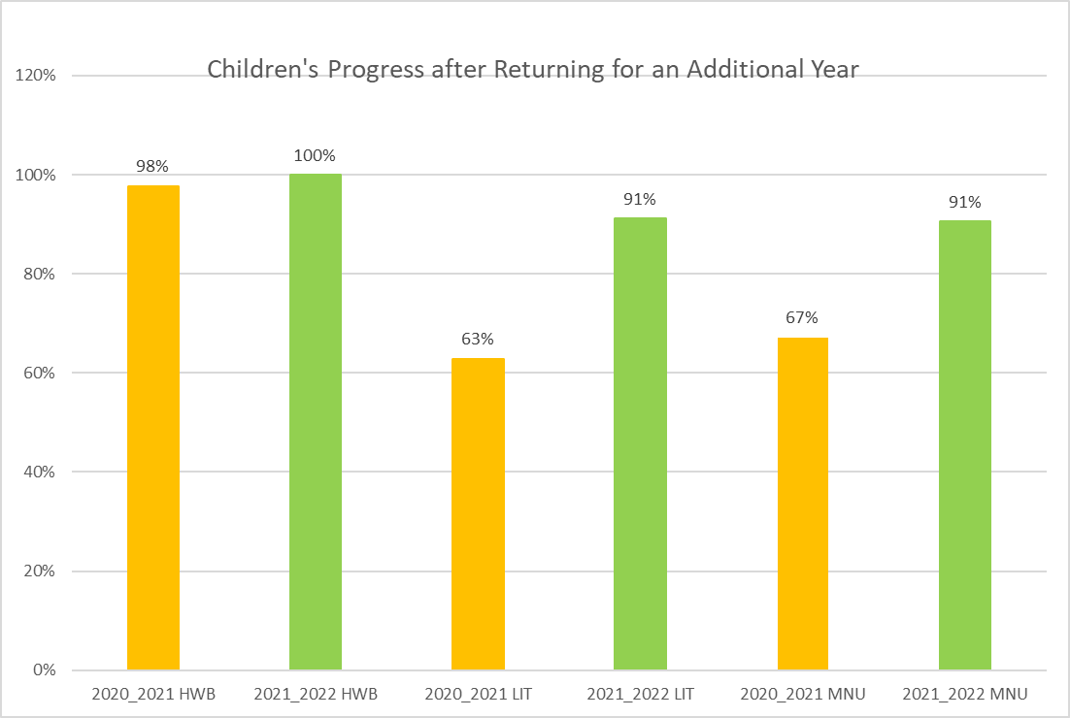

Appendix 3

