[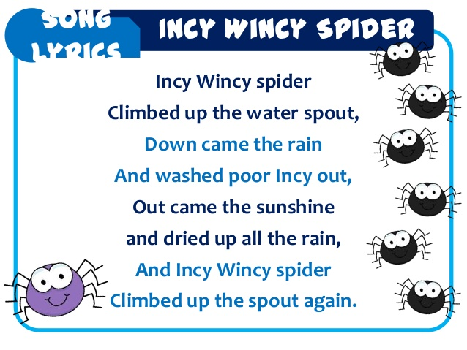](https://www.google.co.uk/url?sa=i&rct=j&q=&esrc=s&source=images&cd=&ved=0ahUKEwjQouTtmp3XAhULKlAKHb05AE0QjRwIBw&url=https://www.slideshare.net/aliffaniki1/lyrics-25548946&psig=AOvVaw0VSapdKc4Tas0_a5KO6VHh&ust=1509619983874084)

Please point out the Rhyming words to your child:

**spout and out**

**rain and again**