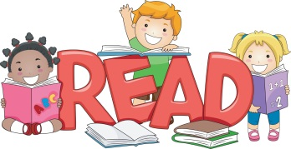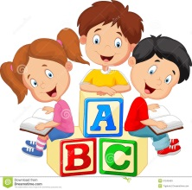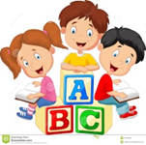

Reading to your child improves their communication skills. This allows a child to gain knowledge of language both visually and verbally as well as assisting with making connections to the world around them. This aids your child’s ability to express themselves appropriately to others.

Parents/carers play a vital part in their child’s development and education. Parents/ carers can aid their child’s literacy skills within the home environment by reading to your child regularly this is essential in encouraging children to have a positive perspective on reading and exploring books and also develops their well emotional wellbeing.

Reading to your child at bedtime can assist with a good night’s sleep as this helps settle your child down for the night putting their mind at ease. It is important a child receives enough rest in order to reach their full potential and to hold a positive attitude towards learning new things.

Reading to your child allows them to think logically as they problem solve and learn to predict different events.

**benefits of reading to your child…**