[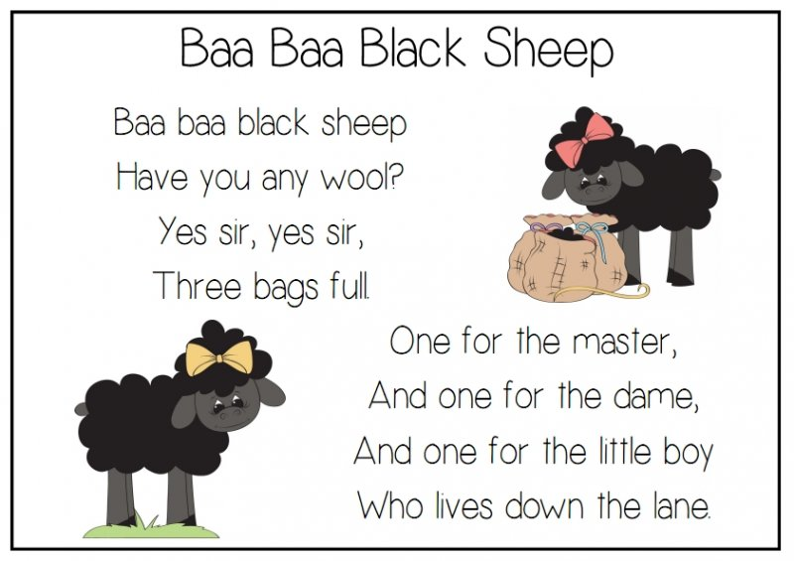](http://www.google.co.uk/url?sa=i&rct=j&q=&esrc=s&source=images&cd=&cad=rja&uact=8&ved=0ahUKEwiriMjFw9bWAhULK1AKHUmACoAQjRwIBw&url=http://www.topteacher.com.au/class-themes/nursery-rhymes/baa-baa-black-sheep-poem&psig=AOvVaw0zu5Hl-vjokp4evrppEHOf&ust=1507191372680052)