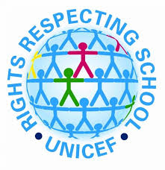

In a week when we are celebrating the “Rights Respecting Schools” agenda here is a quick reminder of where and how expressive arts activities fit in with the UN Convention on the Rights of the Child:

Article 12 (respect for the views of the child) Every child has the right to express their views, feelings and wishes in all matters affecting them, and to have their views considered and taken seriously.

Article 13 (freedom of expression) Every child must be free to express their thoughts and opinions and to access all kinds of information, as long as it is within the law.

Article 28 (right to education) Every child has the right to an education. Primary education must be free and different forms of secondary education must be available to every child. Discipline in schools must respect children’s dignity and their rights. Richer countries must help poorer countries achieve this.

Article 29 (goals of education) Education must develop every child’s personality, talents and abilities to the full. It must encourage the child’s respect for human rights, as well as respect for their parents, their own and other cultures, and the environment.

Article 31 (leisure, play and culture) Every child has the right to relax, play and take part in a wide range of cultural and artistic activities.
Activities for P1-P3
Do these activities with a partner (brother, sister, mum or dad?).
(a) Story time – Read a favourite story with a parent or sibling. Choose a character from the story to be. Act out a scene from the story being that character. Can you give the story a different (surprise) ending?

(b) Guess Who? – Using props or old clothes dress up and act out a character from a story you know. Keep it short. Ask your audience if they can guess who you are.

(c) Animal Charades – Choose an animal to mimic (copy). Act them out. How do they move, eat, sound, sleep? Can your audience guess which animal you are? Take turns to see if you can guess each other’s animals.

(d) Roll the Dice
Choose a movement or sound and create a dice which gives options for moving or sounding like a particular animal (see the picture). You can print these out onto cards if that is easier.
Take it in turns to roll the dice (or pick a card) and act out the animal you get.
Whose animal was the most realistic? Which made you laugh the most?

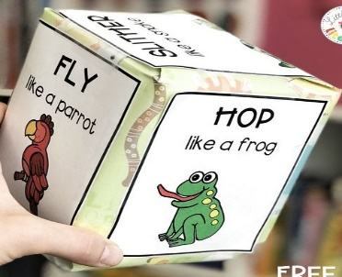

Activities for P4 – P7
These activities might be more fun if done with a sibling or other partner (mum and dad might want to join in).
- Character(s)
- Think of some of your favourite and well-known stories and pick a character you like. This could be Little Red Riding Hood, Harry Potter, or Aslan. What is it about them that makes them interesting? Can you describe how they look, think, feel in certain situations?
- Now make up a character of your own. Are they human, animal or something else? Do they live in a real or magical world? Can they talk? What do they look like? What are there personality traits? What age are they? Are they like you, or completely different? Choose a name for them. You can record your ideas on paper if you wish.
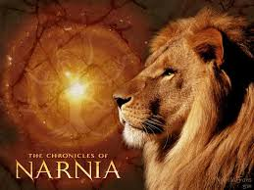
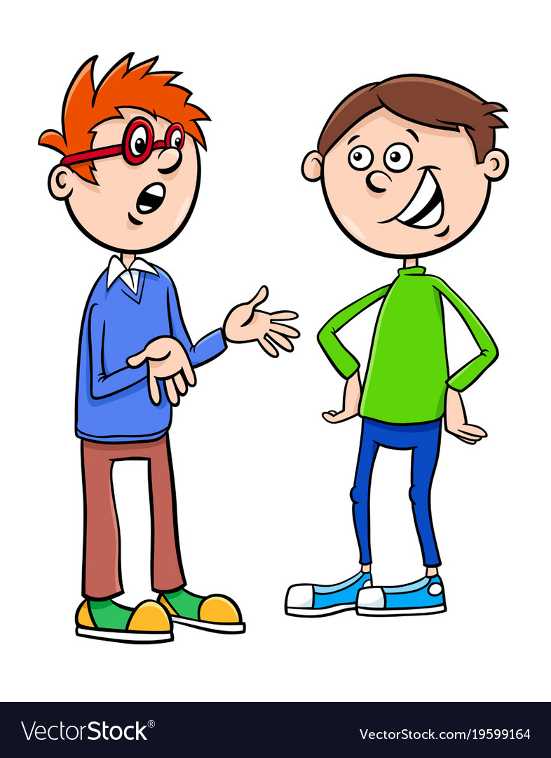
(b) Dialogue
- Think about the following: Who does you character come into contact with? What would they say to each other? Does the dialogue move the story along? If not, it could be quite boring! What would your character say to you if they met you? Sometimes characters talk to themselves out loud. This is called a monologue or a soliloquy and can tell the audience a lot about a character.
- Think up a short conversation that your character might have with another person in the story. Record this conversation on paper or using a voice recorder.

(c) Write a Script
- Using your characters and the dialogue from the previous tasks begin to shape your ideas into a script.
- Each character should take turns to speak. Use a new line for each character. You might wish to include a few stage directions which give an idea of any actions a character might be making:

Tom [pouring from the teapot]: Anyway, time for another cuppa!
Sarah [sitting down]: Sounds ideal.

(d) Performance
- Time to put all your hard work together and show it off. You might want to enhance your performance using props and costumes or you might choose to do without anything and let your audience use their imagination.
- Your performance doesn’t have to take long or tell the whole of a story. It could just be an interesting snippet which you could develop later if you wish.
