
Make your own musical instrument
- Find an old box – a cereal box is ideal.
- Paint or colour it.
- Cut out a large circular hole near the middle (you might need an adult to help with this bit).
- Make a triangular wedge from a piece of stiff card and glue it above the hole.
- Glue a cardboard tube (from the inside of the kitchen roll) onto the side of the box at the same end as the wedge.
- Attach six rubber bands from the top of the tube to the bottom of the box and secure them with sellotape. Make sure the bands go over the cardboard wedge.
- When you pluck the strings (rubber bands) you should be able to hear a sound. Can you play a tune?

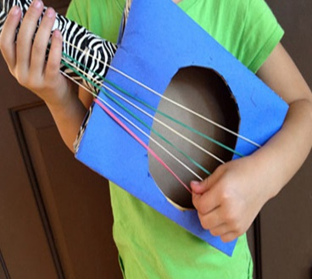

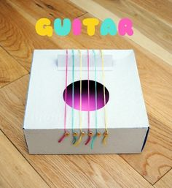
Little Maestros
Equipment: Sheets of paper & pencils or pens
How to play
- Start by designating some symbols for the different sounds that your child can make using their bodies. You can assign different symbols for clapping, whistling, tapping the table, stomping, slapping themselves on the thighs, shouting a word and so on. The symbols need to be things that can be written quickly, like lines, circles, waves, and triangles. Assign at least 4 symbols to different sounds.
- Next, demonstrate how to write down a simple rhythm that you have made up. For example, triangle, circle, triangle circle = tap, clap, tap, clap
- Once your child understands the concept, write down a few more examples and have the child “read” and demonstrate the musical rhythms.
- Now encourage your child to write their own unique rhythms and perform them.
Name That Tune
How to Play
You will need a selection of different songs to play. Split the household into 2 teams. Play 1 to 2 seconds of a song for a team and see if they can guess the song’s title and the artist’s name. The portion of the song you play can be from the beginning or half-way through the song, depending on how difficult you want to make the game.
How to Score
If the team guesses the song title and the artist’s name, they will receive 3 points. If they don’t know it, you can play another 2 to 3 seconds of the song. If they get it right on the second attempt, they will earn 2 points. The winner of the game is the first team to reach 30 points.
Cross-curricular Challenge: Music & Movement (PE)
- Ask everyone in your family to join in a game of musical chairs.
- Play a game of musical statues. Dance to the music and FREEZE when it stops.
- Each family member picks their favourite piece of music to play and everybody dances to each song. Be serious or silly. Which song did you enjoy dancing to the most?

