For these activities choose some music and move. There is no “wrong” way to dance!

Ideas for younger children:
- Dance with a prop – use a hat, ribbons, a hula hoop or a balloon.
- Animal Dancing – become an animal (alligator, tiger, shark or giraffe) and move to the music the way you think this animal would move.
- Dance with a partner – can you mirror their moves?
- Musical statues – dance to the music and freeze when it stops.
- Do the “hokeycokey”. Sing the words too.

Activities for older children:
- Pick some music that has a good beat and clap or jump to the beat.
- Choreograph a short dance routine to a well-known piece of music.
- Play along to the music on an “air guitar” or become the conductor of the orchestra.
- Look up some dance moves on YouTube and learn a routine (dancefitnesskids). https://www.youtube.com/watch?v=6QOI1RRUL8o
- Learn the “haka”. Do some research on where the haka comes from and what it means.
CROSS-CURRICULAR CHALLENGE: Dance and Art (for children of all ages)
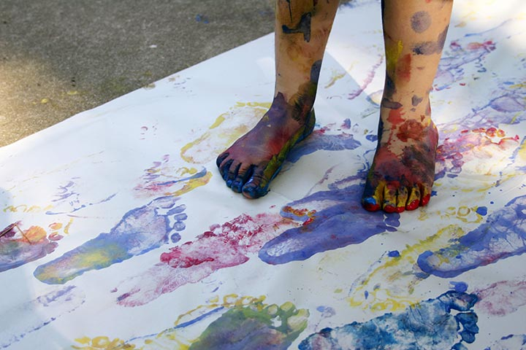
Equipment

- Music
- Large sheet of paper (maybe the back of an old roll of wallpaper)
- Paint of various colours
Instructions
- Paint your feet with any colour of paint.
- Turn on the music and dance your way along the paper.
- If each person has a different colour of paint on their feet you can make some interesting art together.
Benefits of dancing (information for parents)
Dance can help children develop:  - co-ordination  - communication  - co-operation  Dance can help improve:  - agility and flexibility  - heart and lung condition  - muscular strength; endurance and motor fitness | Regular dance/physical activity can increase:  - aerobic fitness.  - bone density  - muscle tone  Dance can improve mental health by:  - releasing/reducing stress  - lifting low mood/depression  - providing opportunities for social bonding
I’d love to see any photographs or video clips you are able to post on the blog.

