Activities for P1-P3
(a) Finger puppets  You can buy or make finger puppets from basic materials. However, I recommend an inexpensive alternative is to draw faces on your fingers and give each ‘character’ a unique voice. Involve your child in the telling of a story and let them help you to unfold it. Asking open questions (“What do you think will happen next?”) helps your child to be creative.  (b) Dress Up  Dress-up clothes are a staple in most dramatic play. Try using basic clothing and accessory items, such as:  - hats  - empty wallets/purses  - bags/handbags  - mittens or gloves  - scarves and ties  Let your child explore every-day items. Avoid clothing items with beads, sequins or other small pieces that could pop off or end up in their mouth. | (c) Nursery Rhyme Charades  Begin by naming as many nursery rhymes together as you can. Take it in turns to mime a rhyme. This means no words or sounds. Can the other person guess your nursery rhyme (e.g, you might mime falling of a wall for Humpty Dumpty)?  (d) Musical Freeze  - You will need some simple music that your child can move to, which you can pause easily.  - Play the music and move or dance along.  - When you pause the music you have to freeze like a particular animal or object which changes every time. You call out the object whenever the music stops.  Example, “freeze like a cat” (child stretches like a cat); “freeze like a tree” (child uses arms as branches), etc.
Activities for P4 – P7
Three word sentences: Warm up activity  Find a partner – mum or dad or a brother or a sister?  Invent a scene where each character has to speak in sentences of only three words, see the example below. It’s harder than you think! Work in some actions to give you thinking time if you need to. How long can you keep it going? If you get good you could try to include an extra person to make it more varied.  Person A: Cup of tea?  Person B: I’d love that!  Person A: Here you are.  Person B: May I sit?  Person A: Oh, of course. etc etc etc | Alphabet Game: Focus on dialogue  Find a partner – mum or dad or a brother or a sister?  Create a scene where each line of dialogue begins with a certain letter of the alphabet. Traditionally the game starts with “a”, see the example below.  Person A: All right, our first annual comic-book club meeting is called to order.  Person B: But I’m the only one wearing a costume.  Person A: Cool!  Person B: Does it make me look taller?  Person A: Excuse me, but what’s the name of your character?  Person B: Frogmonster Zinky!  Person A: Good, it really suits you, you look great in green.  Person B: Ha ha, that’s what my mum said!
Creative Challenge: Improvisation  Make a scene for two characters without rehearsing first and see what happens. Your scene can be serious or comical.  For example, The Job Interview. Person A wants a job and is quite a show-off. Person B is interviewing and is very fussy. | Curtain’s Up: Performance  - Pick a story you know really well like “The Three Little Pigs” or “Goldilocks”.  - Think about which characters you need and who will play who.  - Make a costume from things already lying around the house.  - Choose a scene or two to act out for an audience (you don’t need to perform the whole story).
CROSS-CURRICULAR CHALLENGE: Art and Drama – Making a mask (no, not that kind of mask!)  - You will need some basic art materials such as thin card, pens or paints, glue or tape, and string. If you have glitter or feathers or other materials so much the better.  - Decide what kind of mask you want. Is it for the character of the Big Bad Wolf? Or is it for something else?  - Draw the desired shape onto the cardboard before cutting. Make sure it is large enough to cover your face.  - Draw the features – eyes, nose (or snout), mouth, etc. Cut small holes in the eyes so you can see out (an adult might need to help with this bit).  - Paint or colour the mask. Glue on any additional pieces.  - Attach pieces of string at each side of your mask long enough to tie around your head. |  | 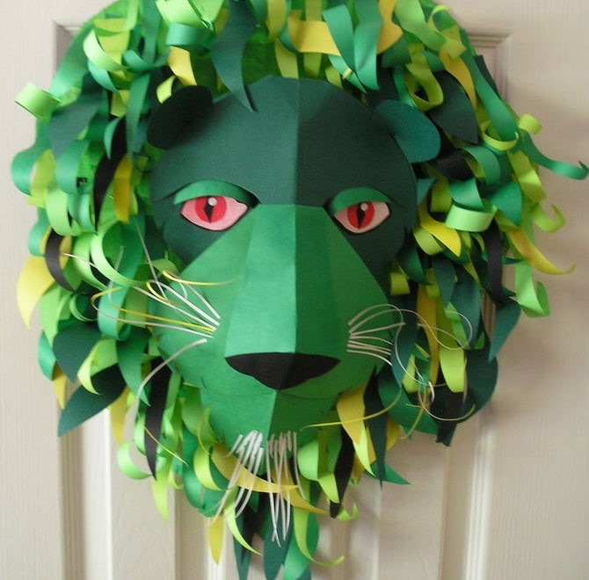
Ten benefits of drama for children (information for parents)

Dramatic play activities:
- may help children improve gross and fine motor skills;
- may teach children self-regulation;
- may teach children co-operation;
- gives children an outlet to express emotions;
- may encourage children to resolve conflict, consider alternative perspectives and recognize the various roles and responsibilities individuals have in our society;
- may encourage a child to consider a specific problem and propose their own solutions;
- support literacy by giving children a deeper understanding of the narrative structure and character motivations found in familiar stories;
- can encourage children to develop social skills such as empathy;
- can build your child’s confidence;
- can help children to improve their concentration when they are encouraged to listen to another person's ideas / thoughts and asked to take turns.

I hope you and your child enjoy these activities. I would be delighted if you were able to post any photographs/video clips on the blog about how you got along when trying the activities.

