Making art from found objects
Make a butterfly (or other animal) from objects easily found around the house.
Take a photograph to record your art before you take it all apart again.

“Creativity is intelligence having fun.”
Albert Einstein
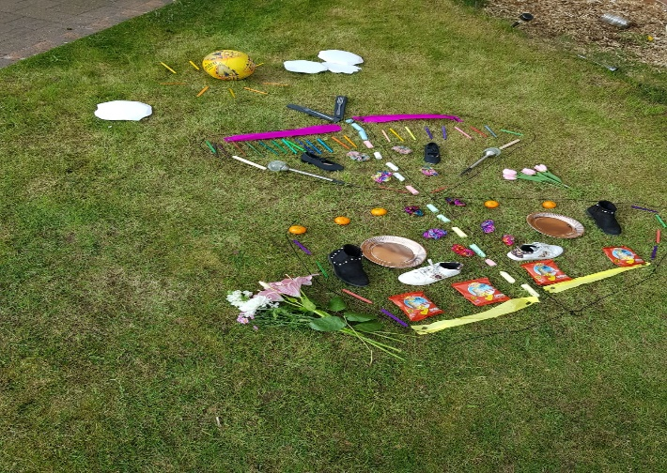
Printing
Mix up some colourful paint in small pots or plates.
Use the bottom of a small balloon instead of a paintbrush to print the shapes on to your paper.
You can reuse the balloon for different colours if you wipe it carefully or you can use balloons of different sizes for different effects.
Make a hungry caterpillar (or other animal of your choice).

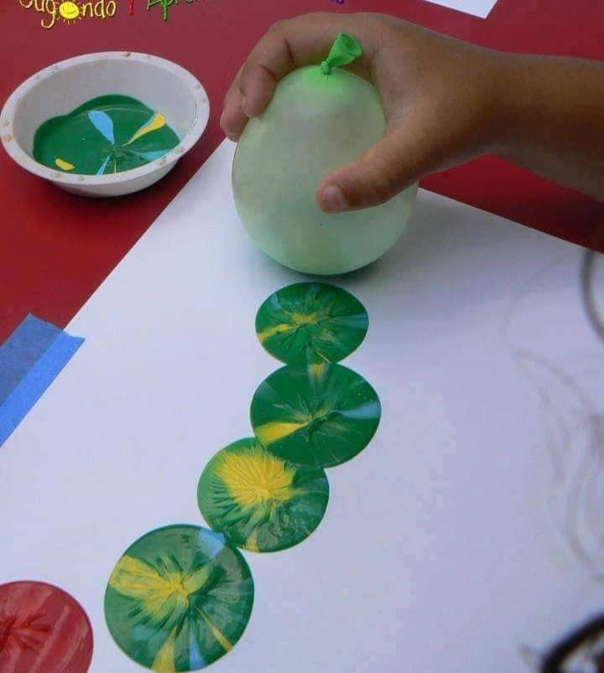
Making art with nature
How to make an “ice egg”.
- Pick some wild flowers when out for a walk.
- Crack the very top off an uncooked egg leaving a small hole the size of a fingertip.
- Empty the egg out (don’t waste it, you can scramble it and eat it) and rinse.
- Put some of the wild flowers into the empty shell and fill up the rest of the eggshell with water.
- Put the shell in the freezer inside an eggbox, so it stays upright. Freeze overnight.
- The next day run some hot water over the shell and pick it off. You should be left with a very pretty “ice egg”.

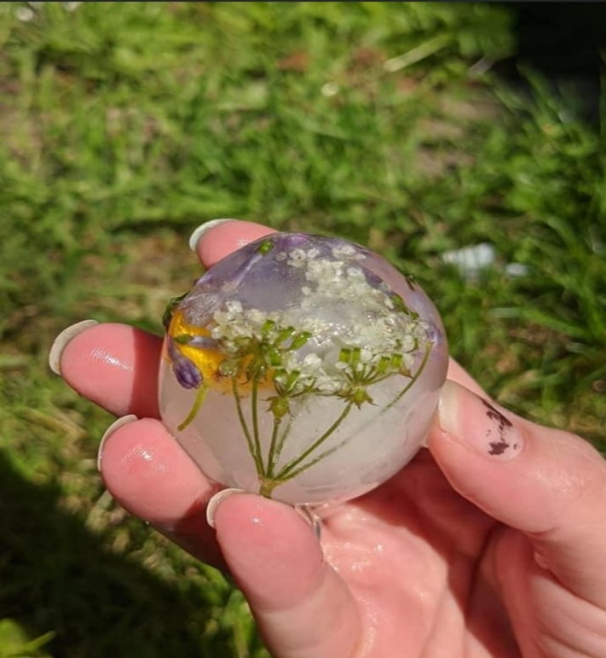
Click on the National Galleries of Scotland website for free fun art activities designed for children of all ages. They aim to develop creativity skills, such as problem-solving, imagination, curiosity and open-mindedness: https://www.nationalgalleries.org/art-and-artists/features/home-where-art-creative-curriculum-kids
CROSS-CURRICULAR CHALLENGE: Art and Science, Grow a Rainbow
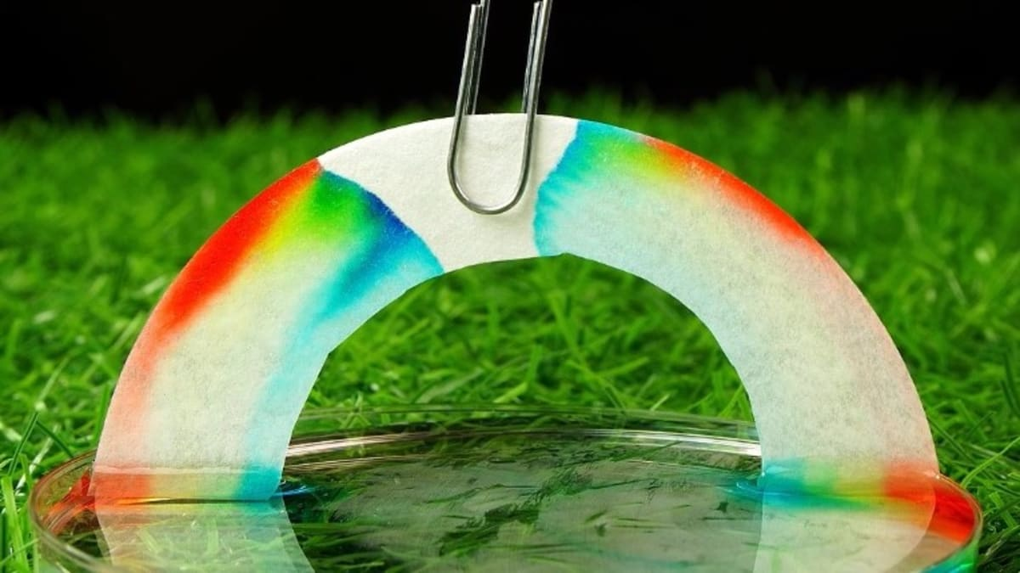
The Science (in brief)!
- This is called “capillary action”!
- Water molecules like to stick to things – including themselves. Sticking to other things is called adhesion and sticking to itself is called cohesion.
- The fibres in kitchen roll makes lots of little holes. Water is sucked through the holes because of adhesion, and cohesion means the rest of the water follows.
- The water pressure will eventually slow down and the pressure of gravity will mean it stops moving.

Instructions
- Cut a sheet of kitchen roll into rh shape of a rainbow/arc.
- Colour a rainbow with felt tis abut 2cm up on both sides
- Attach your paper clip to the top and tie a piece of string/thread to it. This will give you something to hold on to the rainbow with.
- Fill each glass or container with water.
- Hold your rainbow with the ends slightly submerged in the water and watch your rainbow grow. You will have to be patient.

Equipment
- I x sheet kitchen roll
- Felt tip pens
- Paper clip
- String/thread
- Water in 2 separate dishes

Why is creating art good for you? (Information for parents)

- Cognitive benefits – researchers have found that there are multiple cognitive benefits to making art. They believe that art encourages creative thinking and enhances problem-solving skills and critical thinking skills. Out-of-the-box thinking also stimulates your brain to grow new neurons and every time you engage in a new or complex activity, your brain creates new connections between brain cells. This is called neuroplasticity.

Research into neuron regeneration suggests that mental decline is due mainly to the loss of neuroplasticity, not from the death of brain cells themselves. Researchers have coined the phrase “neurobics” to describe brain exercises that use your senses in new and novel ways, and creating art certainly fits this definition.

Creating and making art is also said to increase the production of the feel-good neurotransmitter dopamine. Dopamine has been called the “motivation molecule.” It boosts drive, focus, and concentration. It enables you to plan ahead and resist impulses.

- Mental Health benefits - Creating art provides a distraction, giving your brain a break from your usual thoughts and so can decrease stress. Art can boost your self-esteem and give you a sense of accomplishment. Art allows you to express your feelings. Art is about the process, not the product.

- Physical benefits – engaging with creative projects is thought to boost your immune system.

Don’t forget to post any photographs or video clips on the blog if you can.

