

**Homework**

**menu**

Dickens

NEW

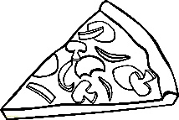 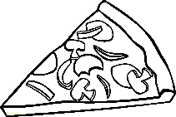 

**Massage story**

Design a massage story to be used in class using the strokes we know or create a new one!

**Book review**

Complete a review of a book you have read recently. Use the template from class.

**Create a poster**

all about you! Include hobbies, interests and facts. Use photos, text and drawings.

  

**Description quiz**

Write a description of a well-known character and quiz the class to see if they can solve it.

**Maths poster**

Use a past or present topic to demonstrate important points use colour.

**Glow Blog**

Create a post for your glow blog. It could be a book or film review or wider achievement.

**Get your cook on!**

Bake or cook something. Remember to check with an adult first and be safe in the kitchen. Write out a recipe for what you have made sample if you can)

**Bug club**

Access your bug club account and read one of the many books assigned to you. Complete the questions with the book.

**Mental Maths**

Practice your mental maths using topmarks.co.uk or one of the numeracy games assigned on bug club

**Book Cover**

Use the template to create an alternative cover of a book you have read. Think about the themes and characters.

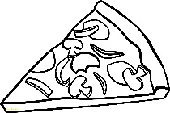

**Art attack**

Visit [www.arthubforkids.com](http://www.arthubforkids.com)

And complete a drawing of your choice. Colour it and bring it in for our wall.

**Maths Game**

Design and make a maths game to help you and other in the class to practice a skill we have been working on in class.



CLASSICS

Chosen by you!

