
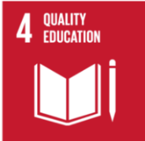
P7 Termly 3 Overview

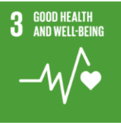
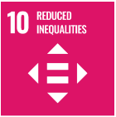


2024/2025
Interdisciplinary Learning
- Europe
- RME – The 6 main world Religions (Islam)
- ICT – Teams, Research, Spreadsheets using Excel, Touch Typing, Appropriate use of AI and
Coding with Adobe
- STEM – Mixed activities and investigations/experiments
- P7 Fun Day

Mathematics and
Numeracy across Learning
P7Mo
- Number Talks mental maths strategies
- Money Sense
- Probability
- Capacity
- Area & Perimeter
- 3rd Level Number Work
- Long multiplication and Division
- Number Patterns
- Bearings and direction

Trips/Events

- Visits to and from KA staff to support transition
- Lockerbie Manor Residential
- Millport

Health and Wellbeing

- PE– Developing Team Games and Sportsmanship/Mixed Sports, P7 Sports Championship
- Children’s Rights - Class Charter and Right of the Month
- PATHS – Organisational skills, Endings and Transitions
- RSHP and LGBTQ+
- Substance Misuse
- Mental and Emotional Wellbeing
- Cyber Resilience and Safety
- Soccer Aid

Mathematics and
Numeracy across Learning
P7M
- Number Talks mental maths strategies
- Money Sense
- Probability
- Capacity
- Area & Perimeter
- Shape – Triangles, Quadrilaterals and Circles
- Long multiplication and Division
- Number Patterns
- 3rd Level Number Work

Mathematics and
Numeracy across Learning
P7T
- Number Talks mental maths strategies
- Money Sense
- Probability
- Capacity
- Shape – Triangles, Quadrilaterals and Circles
- Bearings and direction
- 3rd Level Number Work
- Number Patterns
- Long multiplication and Division

Language and Literacy across Learning
- Bug Club/Rapid Readers– Differentiated reading activities
- Divided City – whole class novel study
- Reading Strategies Reinforcement - Prior Knowledge, Metalinguistics, Visualisation, Inference, Main Themes and Summarising
- Grammar- Prepositions, Idioms, Word Roots, Personification and VCOP
- Active Literacy Spelling Programme - Differentiated Activities.
- Reinforcement of all strategies.
- Writing – Narrative/Discursive/Letter
- Writing groups – focus on punctuation, connectives, openers and paragraphing
- Handwriting – Refining a Joined Script
- Talking & Listening – Solo talks and group discussions based on thematic classwork, debates around themes raised in Divided City.
- French and Spanish (1 Plus 2 Languages input)

