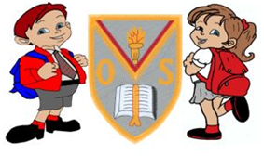
P7 2024-2025

January to March Overview
Language and Literacy across Learning
- Bug Club /Literacy World– differentiated reading activities (book allocation)
- Myths and Legends (as part of topic) – Whole class.
- Atticus and the Ancient Greeks – Reading Comprehension Skills
- Reading Strategies- Inference, Making Predictions, Metalinguistics, Main Themes and
Summarising.
- Grammar- Prepositions, speech marks and commas used in direct speech, indirect and direct speech, apostrophes for possession and daily VCOP activities.
- Active Literacy Spelling Programme - Differentiated Activities. Consolidation of Elkonin Boxes, Diacritical Marking and Spelling strategies including morphology.
- Writing – Discursive/Poetry/Reports and Recounts.
- Handwriting – Developing a Joined Script
- Talking & Listening – Poetry recital, Group work and Discussions (cross curricular).
- French – Revision of basic language, develop written skills, age, dates, birthday, weather, praising language, manners, colours, commands, snacks
- Spanish – Consolidation of previous vocabulary, Family, Weather, Animals and Food.

Mathematics and
Numeracy across Learning
P7T

- Number Talks mental maths strategies (Place Value)
- Bar Models
- Percentages
- Algebra
- Data Handling
- BODMAS
- Angles
- Bearings
- Circles

Mathematics and
Numeracy across Learning
P7Mo

- Number Talks mental maths strategies (Place Value)
- Bar Models
- Percentages
- Algebra
- Data Handling
- BODMAS
- Angles
- Bearings
- Circles

Mathematics and
Numeracy across Learning
P7M

- Number Talks mental maths strategies (Place Value)
- Bar Models
- Percentages
- Algebra
- Data Handling
- BODMAS
- Angles
- Bearings
- Circles

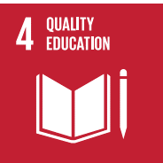
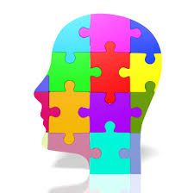
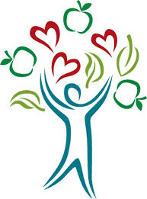
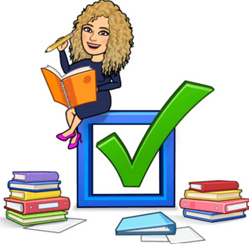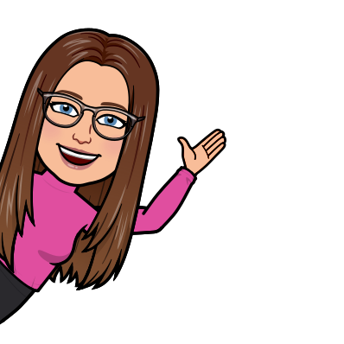

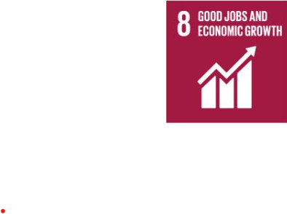
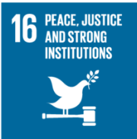
Trips/Events

- Visits from KA staff to support transition
- Burn’s Day
- Big Garden Birdwatch
- Safer Internet Day
- World Thinking Day
- Fairtrade Fortnight
- World Book Day
- Red Nose Day

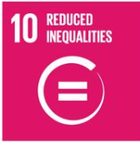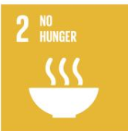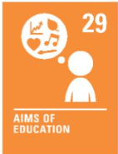

Interdisciplinary Learning
- KA Citizenship Challenge
- Mythical Creatures
- Ancient Greece
- Anti-Bullying – pupil led topic
- RME - Buddhism (life of Buddha, beliefs, marriage, Tipitaka) and Easter
- ICT – Teams, Class Notebook, E-portfolios, Research, Word Processing, PowerPoint, Cyber Resilience, Spreadsheets, Coding, WOW (developing your own brand), Book Creator, Blooket
- STEM – Mixed activities and investigations/experiments

Health and Wellbeing

- PE– Aesthetics, Target games, Netball, Dance
- Children’s Rights - Class Charter and Right of the Month with links to Global Goals (ongoing)
- PATHS – Study and Organisational skills, Developing Social and Emotional Language:
Cooperative and Growth Mind-set activities
