Alphabet Avengers | Letter Ninjas
ue  cue  due  rescue  venue  value  fuel  argue  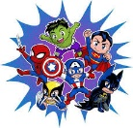  continue | ue / ew  rescue  value  fuel  continue  new  knew  few  stew  
Spelling Bees | Word Wizards
ue / ew / u-e  rescue  value  continue  new  knew  curfew  use  cute  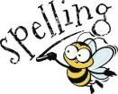  tube | ue / ew / u-e / u  rescue  continue  barbeque  new  knew  curfew  confuse  computer    costume  music  student  human

