The Jeely Piece Song (Adam McNaughton)
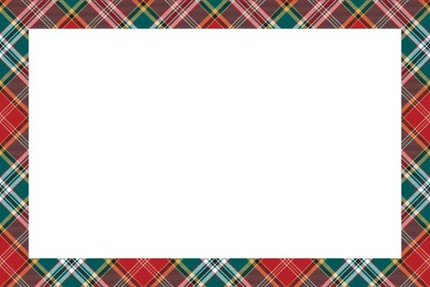
[Verse 1]
I'm a skyscraper wean
I live on the nineteenth flair
But I'm no goin' oot tae play anymair
'Cause since we moved tae Castlemilk I'm wasting away
'Cause I'm getting wan less meal every day
[Chorus]
Oh, ye cannae fling pieces oot a twenty-story flat
Seven hundred hungry weans will testify tae that
If it's butter, cheese or jeely
If the breed is plain or pan
The odds against it reaching earth are ninety-nine tae wan
[Verse 2]
On the first-day ma' maw flung oot a dod o' Hovis Broon
It come skiting oot the windaе, and went up insteed a' doon
Noo every twеnty-seven hours it comes back intae sight
'Cause ma' piece went intae orbit, and became a satellite
[Chorus]
Oh, ye cannae fling pieces oot a twenty-story flat
Seven hundred hungry weans will testify tae that
If it's butter, cheese or jeely
If the breed is plain or pan
The odds against it reaching earth are ninety-nine tae wan

[Verse 3]
On the next day, ma' maw flung me a piece out wance again
It went an' hit the pilot in a fast, low-flying plane
He scraped it aff 'is goggles, shouting through the intercom
"The Clydeside Reds have got me with a breed and jeely bomb!"
[Chorus]
Oh, ye cannae fling pieces oot a twenty-story flat
Seven hundred hungry weans will testify tae that
If it's butter, cheese or jeely
If the breed is plain or pan
The odds against it reaching earth are ninety-nine tae wan
[Verse 4]
On the third-day ma' maw thought she would try another throw
The Salvation Army band was storming doun below
'Onward Christian Soldiers' was the piece they should of played
But the oompah man was playin' a piece and marmalade
[Chorus]
Oh, ye cannae fling pieces oot a twenty-story flat
Seven hundred hungry weans will testify tae that
If it's butter, cheese or jeely
If the breed is plain or pan
The odds against it reaching earth are ninety-nine tae wan

[Verse 5]
We've wrote away tae Oxfam
Tae try and get some aid
And aw' the weans in Castlemilk have formed a piece brigade
We're gonnae march tae George's Square demanding civil rights
Like nae mair hooses ower piece flingin' height
[Chorus]
Oh, ye cannae fling pieces oot a twenty-story flat
Seven hundred hungry weans will testify tae that
If it's butter, cheese or jeely
If the breed is plain or pan
The odds against it reaching earth are ninety-nine tae wan

