Alphabet Avengers | Letter Ninjas
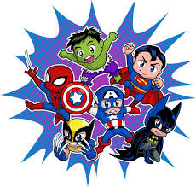  oa  boat  goal  soap  toad  float  roast  toast  groan | oa / ow  float  roast  toast  groan  blow  show  bowl  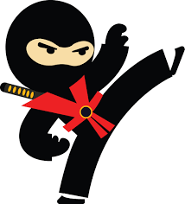  snow
Spelling Bees | Word Wizards
oa / ow / o-e  float  toast  groan  show  bowl  snow  cone  hope  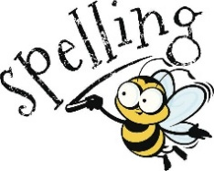  globe | oa / ow / o-e / oe / o  float  toast  cloak  snow  bowl  pillow  globe  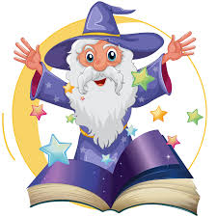  alone  toe  foe  photo  robot

