Alphabet Avengers | Letter Ninjas
into  upon  upset  sunset  hotdog  laptop  bedbug  catnap  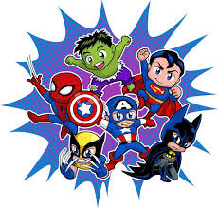   | cowboy  airport  eyelid  eyebrow  eggshell  popcorn  fishnet  forget
Spelling Bees | Word Wizards
football  indoors  haircut  himself  herself  jellybean  jellyfish  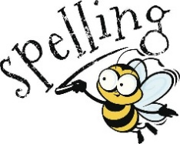  afternoon  carwash  earring | butterflies  basketball  moonlight  moonbeam  newsletter  newspaper  lipstick  raincoat  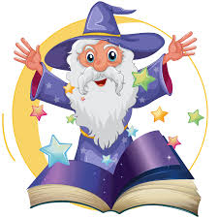  sailboat  aircraft

