


P2/3
Newsletter
Term 2
2022/2023

T

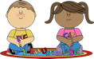  Literacy |  | 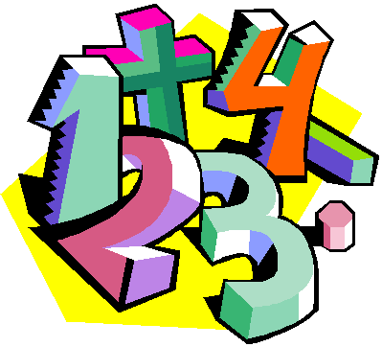  Numeracy |  |   Health & Wellbeing
This term the children in P2/3 will continue to work on Active literacy spelling. This includes phonemes and tricky words.  The children will continue to receive a new reading book/or new chapter of their book each week to read at home and in class. Every week the children will complete reading tasks that relate to their book, topic text or an unseen text for example from Giglets.  Primary 3  The children reading chapters will be introduced to metalinguistics, visualisation, prediction and prior knowledge.  All children  Each week the class will take part in a taught writing lesson that focuses on a particular writing genre.  Listening & Talking This term the children will learn a poem as part of our Scotland Fortnight. Primary 2 will learn Mince and Tatties, Primary three will learn Twa Leggit Mice.The children will all say their poem to their own class. Primary three will take part in the poetry competition.  .  Reading Primary 2 (some Primary three children)  The children will continue to read Oxford Reading Tree books appropriate to their stage. Please try to read the books each at home as often as possible. Reading books should be put back into schoolbags as the children read in class and complete comprehension activities.  It is also important children are reading for pleasure, if the reading book has been read once during the week anything they choose to try to read is great. |  | The children continue to work on their mental maths skills using Number Talks activities each day which help them understand mathematical ideas and relationships essential for successful reasoning and problemsolving.  All children  This term the children will be exploring time. The children will revise days of the week, months of the year and seasons.  The children will also learn how many minutes are in an hour, hours in a day, and days in a week.  The children will read and record times in analogue and digital. The children will learn to tell read and display times that show half past (P2/some P3’s), o’clock (P2/some P3’s), quarter past and quarter to (P3).  This term the children will be exploring money. The children will recognise all coins to £2 (all children), count in 2p,5p and 10p, find totals of coins, use the £ and p symbol, give change and explore amounts under £1 being written as a decimal notation.  The children will continue to sequence numbers forwards and backwards from a given number. The children will count on and back in 2’s, 5’s and 10’s.  The children will continue use Number Talks. |  | Health & Wellbeing P.E. days will continue to be Wednesday and Friday.  The children will also take part in creative dance. (Miss McCrae)  We will be continue to look at Emotion Works through class discussions, books and Circle Time.  We will be learning about equality and diversity as part of our together time and this will continue into the classroom.  The children will also be learning ways to keep safe. For example stranger danger.  For P.E the children will focus on small ball skills, this will include passing, catching and throwing. The children will also take part in team games using small ball skills.
Social Studies/Science  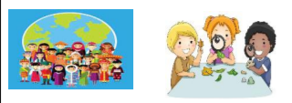 |  |   Technologies |  |   Expressive Arts
This term will begin by learning about Scottish inventors.  The children will also be given a poem to learn. Primary two will learn ‘Mince and Tatties’, Primary three will learn ‘Twa Leggit Mice’.  We will also do a topic on Birds alongside the RSPB big bird watch week. |  | Technologies  We will continue to be using laptops and desktops to learn different skills.  The children will design and create a product of the future. |  | Art and Design will be linked to our Social Studies and Science.  We will draw and paint different landmarks.  We will draw and paint different birds and we will use collage to create our own birds.  For music we will learn different Scottish Songs and some spring songs too and we will complete Sounds of Music Unit 3 while also exploring non-pitched and tuned percussion instruments, body percussion activities and recognising some simple music symbols. (Miss McCrae).

