- Record the number of each colour Smarties you had in your tube in the table below:

Colour | Number
Red
Yellow
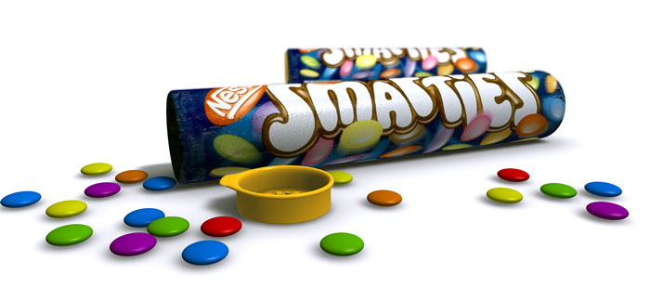
Blue
Green
Pink
Orange
Brown
Purple

- Use your Smarties data to create a bar chart using the squares below.

