L.I. To find the missing number.

Use your number line to solve the following calculations. Remember the strategies we have practised are jumping on from what we have or jumping back from the total.

**1.** 3 + ___ = 9

**2.** 3 + ___ = 10

**3.** 5 + ___ = 8

4. 7 + ___ = 11

5. 7 + ___ = 14

6. 8 + ___ = 14

7. 10 + ___ = 16

8. 12 + ___ = 14

9. 12 + ___ = 18

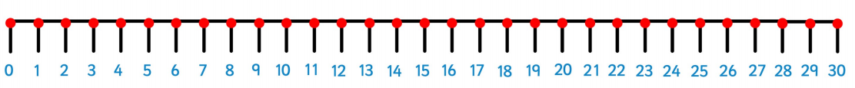10. 9 + ___ = 19