This grid gives some suggestions of activities that you could do with your spelling and common words.
Write your spelling words in bubble letters. Colour your words with a crayon or coloured pencil. | 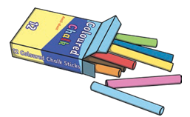  Use chalk to write your spelling words outside. | Pop some paint in a freezer bag and seal it. Then, use your finger to write in the paint without getting messy! | 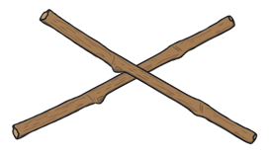  Make your words using sticks or twigs. | Write your words in the air with your finger. Ask someone to read your words as you write.
Write your words out in alphabetical order.  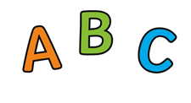 | Give an adult a spelling test! How many of your words can they get correct? |   Sing your words. | Say the word then jump for each letter, shouting them out as you jump. | Write your words out in pencil. Next write over each word three more times using a different coloured pencil.
Use pasta, buttons or small toys to make your words. |   Type your words on a computer. Can you make each word have a different font? | Using an old magazine, cut out the letters you need to make your words and glue them down on a piece of paper. | Write out each of your words. Go over the vowels in each word using a blue pencil. |   Make your spelling words using playdough.

