My Christmas tree:  Draw a picture of your Christmas tree?  How many baubles are on it?  How many different colours are on your tree? | Sound Detectives:  How many b and u words can you think of?  Can you spot any ‘b’ or ‘u’ objects in your house?    This Photo by Unknown Author is licensed under CC BY-SA | Away in a Manger  During the week we sang Away in a Manger, all about the baby Jesus.  Can you remember the words and sing it to your grownup?
Practise your Learn Its  Can you use your finger tools to practise addition and subtraction? Maybe a grownup can lend you a hand! Haha!  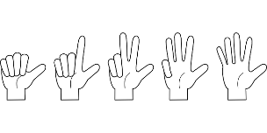 | Read this poem with your grown-up  When Santa got stuck up the chimney, he began to shout  “You girls and boys won’t get any toys if you don’t pull me out!  My beard is black.  There’s soot in my sack  My nose is tickling too!”  When Santa got stuck up the chimney  A-choo, a-choo, a-choo! | Santa in the chimney  Talk to your grownup about how you would get Santa out of the chimney.  Be as creative as you can!  You could draw a picture of you getting Santa out!!  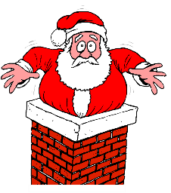
Thank you, God, for my family  Can you draw a picture of your family?  Say a prayer to God about how much you  appreciate those who look after you. | The Holy family  Can you draw a picture of the Holy Family? Mary, Joseph and baby Jesus in the stable. Or use your toys to create a scene.  You could add the  shepherds and the  three wise men as well. | Agadoo  Get active, get moving!  Try and do the Agadoo!!  