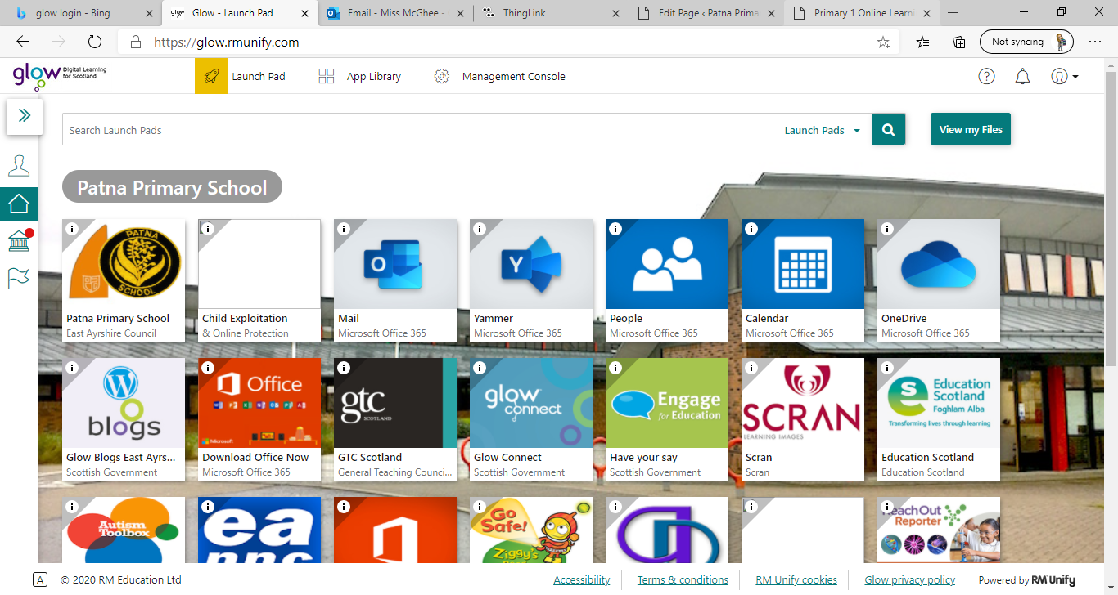**Primary 1** / Miss McGhee   
Patna Primary School   
Literacy Overview 01.02.21 Chilli Challenge Task Difficultly: Mild, Spicy, Flaming Hot

**No videos this week to reduce screen time**

|  |  |  |  |  |
| --- | --- | --- | --- | --- |
| **Monday** | **Tuesday** | **Wednesday** | **Thursday** | **Friday** |
| Handwriting  Dictated sentences: **I am in a den.** **I sat at my desk.  Mum and Dad went to the shops.**  Letter formation  Practice the following letters. Please make sure you are following the correct letter formation. This week we are practicing ‘zig-zag’ letters:  z x v w y k    Complete the word building worksheet:[**https://glowscotland-my.sharepoint.com/:b:/g /personal/eashannon_mcg hee1_glow_sch_uk/EanzKu n6QMlGpQx8vXRLdbUBO4 Ma3e8vwvE1bpXfrhgg2g?e=GGckVO**](https://glowscotland-my.sharepoint.com/:b:/g/personal/eashannon_mcghee1_glow_sch_uk/EanzKun6QMlGpQx8vXRLdbUBO4Ma3e8vwvE1bpXfrhgg2g?e=GGckVO) | Phonics  Phonics Revision  Write the following words: **shop ship shift cash crash shorts mash flash shrubs** This week we are learning a **new sound:**   **th**  Click on the hyperlink to find each sound. Here you can watch videos about the letter and its sound. You can take part in activities, games and letter formation practice. [https://www.thin glink.com/media card/1340989677 775093762](https://www.thinglink.com/mediacard/1340989677775093762) | Spelling  Spelling test *did can as we he into*  New Spelling Words: ***go if  got for  get on***  Pick an activity from this week’s spelling menu:    [**https://glowscotland-my.sharepoint.com/:u: /g/personal/eashannon_ mcghee1_glow_sch_uk/ EXheGDuALMBIv8pJ3V QUvOYBsfzZTUXRYjGl Y5L4afs_eA?e=iaHSJc**](https://glowscotland-my.sharepoint.com/:u:/g/personal/eashannon_mcghee1_glow_sch_uk/EXheGDuALMBIv8pJ3VQUvOYBsfzZTUXRYjGlY5L4afs_eA?e=iaHSJc)  Common word lesson:[**https://glowscotland-my.sharepoint.com/: v:/g/personal/eashannon_mc ghee1_glow_sch_uk/EUdjEVpIJkRHmcmABlw kwhwBb34y_WTSG3iPr5fDsqUY4g?e=dKid5B**](https://glowscotland-my.sharepoint.com/:v:/g/personal/eashannon_mcghee1_glow_sch_uk/EUdjEVpIJkRHmcmABlwkwhwBb34y_WTSG3iPr5fDsqUY4g?e=dKid5B) | Reading  Reading  Read pages 5 and 6 from our reading booklet. Please click the link below to access: [https://glowscotland -my.sharepoint.com/:b: /g/personal/eashannon _mcghee1_glow_sch_u k/EZTLFHLsPh9Gp- rHkUtrvtQBwybng 7UIdDbWB1rY8SQ 7sw?e=2bp9uC](https://glowscotland-my.sharepoint.com/:b:/g/personal/eashannon_mcghee1_glow_sch_uk/EZTLFHLsPh9Gp-rHkUtrvtQBwybng7UIdDbWB1rY8SQ7sw?e=2bp9uC)  Bugclub  All Bugclub accounts are now live! Chose a book to read on Bugclub. Get in touch if you need a password reminder | Writing Self Assessment Marking Stickers Set 3 – Primary Classroom Resources***“I got in the car.”*** **Write a sentence- cut the words out and put it in the right order. Fill in the missing words.  Try and write the sentence on your own.**  **Think about our targets and talk about the following:** |

**Primary 1** / Miss McGhee   
Patna Primary School   
Numeracy Overview 01.02 .21 Chilli Challenge Task Difficultly: Mild, Spicy, Flaming Hot

|  |  |  |  |  |
| --- | --- | --- | --- | --- |
| **Monday** | **Tuesday** | **Wednesday** | **Thursday** | **Friday** |
| Revision Money  Coin recognition Can you put these coin in order from the smallest to largest value.  Coin Hunt Ask an adult to hide different coins around the house. How many can you find and do you know how much they are worth?  How much money is in the piggy bank?  [https://glowscotland-my.sharepoint.com/:b:/ g/personal/eashannon_mc ghee1_glow_sch_uk/EeAhSM rcOmJJr3dBgpSv7UMB68QlUrZ0-X84AFKnYzN0Tw?e=5kauPb](https://glowscotland-my.sharepoint.com/:b:/g/personal/eashannon_mcghee1_glow_sch_uk/EeAhSMrcOmJJr3dBgpSv7UMB68QlUrZ0-X84AFKnYzN0Tw?e=5kauPb) | ICT Tuesday  [Coins Game for 4-10 year olds (topmarks.co.uk)](https://www.topmarks.co.uk/money/coins-game)  [Coin Calculator - mobile friendly (ictgames.com)](http://www.ictgames.com/mobilePage/coinCalculator/index.html) [Pay using 1 coin - 5-7 year olds - Topmarks](https://www.topmarks.co.uk/Flash.aspx?f=payusingonecoinv3) | Finding Half  Ca you split a number of objects in two equal parts? Draw two circles with chalk. Choose a number- can you share out that quantity between the two?  What numbers can and cannot be shared equally?  When sharing an amount (such as sweets) try saying “one to me, one to you…” | Odd Todd and Even Steven poster | Teaching ResourcesOdd and Even  Even numbers are those which can be halved. Make a poster about odd and even numbers. | Mixed Calculations  **2 + 1= 5- 3=**  **4 + 1=**  **3 – 2=**  **7 + 1=**  **9 – 3= 10 + 2=**  **6 – 2=**  **9 – 3= 10 + 4= 5 + 3= 15 – 2=** |