Primary 2/3 / Miss Connelly Literacy Overview wk beginning 25/01/21
Patna Primary School Chilli Challenge: Mild, Spicy, Hot
Monday | Tuesday | Wednesday | Thursday | Friday
Writing  Today we are learning to write a poem.  Watch this video about what you should include in your poem:  https://www.bbc.co.uk/  bitesize/topics/zkxp2v4/  articles/zm7nxbk  Task: Can you write and perform your own poem? This could be a Scots poem as today is Burns Night! I have included a video of a famous Scottish poem ‘A Dug, A Dug.’  https://sway.office.com/vVT5pip  BAS67xghx?ref=Link  Remember to include your core targets: capital letters, full stops and finger spaces. | Phonics  Primary 2: magic e  Primary 3: ou  Task 1:  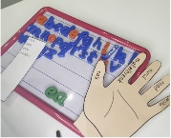  Use your magnetic board to say, make/break, blend, read and write the words on your word list.  Task 2:  Create a phoneme flower.  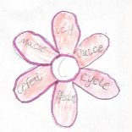  Extension: write sentences for each word. Remember to use connectives, adjectives and WOW words. | Spelling  have, just, your, by  five, time, life, line  own, small, something, live, give  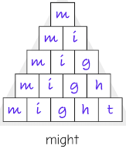  Task1: Pyramid Spelling  Task 2: Elkonin Boxes  Task 3: Messy Words | Reading  Scottish Stories  Listen to the story ‘Neeps and Tatties’ by Carey Morning.  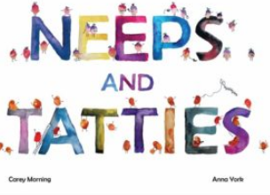  Neeps and Tatties Sway  Reading Tasks:  Neeps and Tatties Reading Activities.pptx  BugClub  Choose at least  2 books on Bug Club to read this week and answer the comprehension questions. | Grammar  Verbs and Tenses:  Watch the verb tenses song:  https://sway.office.com/tEmshWDLlaM0CfVk?ref=Link  Task:  Can you write a silly story. Try and include as many nouns, adjectives and verbs in your story.  Once you are finished your story, highlight the:  Nouns- green  Adjectives- pink  Verbs: orange  Extension activity: Can you make up a grammar rap to help you remember what a noun, adjective and verb is? Please send your rap in to our Teams page or ask adult to email it to Miss Connelly!
Primary 2/3 / Miss Connelly Numeracy Overview wk beginning 25/01/21
Patna Primary School Chilli Challenge: Mild, Spicy, Hot
Monday | Tuesday | Wednesday | Thursday | Friday
Making Equal Groups: Sharing  Starter Activity:  https://pbskids.org/curious  george/busyday/dogs/  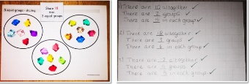  Practical Activity:  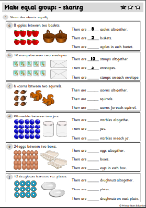  Worksheets:  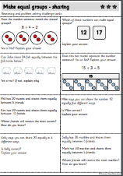  Challenge Cards: | Odd or Even Numbers: Grouping  Starter Activity:  https://www.topmarks.co.uk  /Flash.aspx?f=grouping ~  No remainder  With a remainder  Practical Activity:  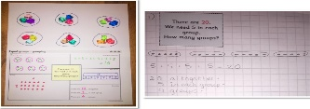  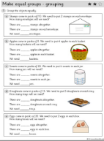  Worksheets:  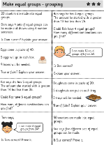  Challenge Cards: | Divide by 2, 4, 6  Coconut Multiples: Choose your selected times table for today.  https://www.topmarks.co.uk/times-tables/coconut-multiples  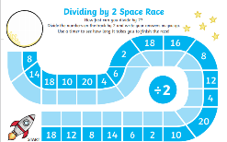  Space Race Game:  Sharing Activity:  Can you choose a number of objects and share them into groups of 2, 4 and 6. You might get a remainder if you can’t make equal groups! Can you write a calculation?  8 ÷ 2 = 4 | Repeated Subtraction for Division  Divide by: 5, 3, 7.  Coconut Multiples: Choose your selected times table for today.  https://www.topmarks.co.uk/times-tables/coconut-multiples  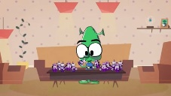  Watch this video to help explain the repeated subtraction strategy:  https://www.bbc.co.uk/bitesize/  topics/znj7hyc/articles/zv86382  Daily 10: Level 3- Division- Choose which number you are dividing by. https://www.topmarks.co.uk/maths-games/daily10 | Using Arrays for Division  Divide by: 10, 8, 9  Coconut Multiples: Choose your selected times table for today.  https://www.topmarks.co.uk/times-tables/coconut-multiples  Watch this video:  https://www.bbc.co.uk/bitesize/  topics/znj7hyc/articles/zhgjpg8  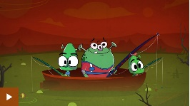  Use arrays to work out these calculations:  40÷10= 20÷10= 70÷10=  48÷8= 80÷8= 24÷8=  18÷9= 108÷9= 45÷9=

