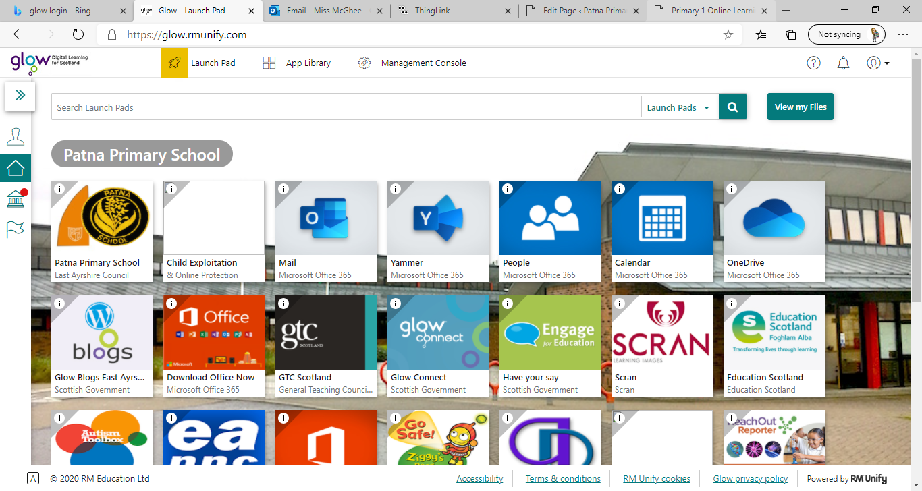**Primary 1** / Miss McGhee   
Patna Primary School   
Literacy Overview 25.01.21 Chilli Challenge Task Difficultly: Mild, Spicy, Flaming Hot

**Video to follow!**

|  |  |  |  |  |
| --- | --- | --- | --- | --- |
| **Monday** | **Tuesday** | **Wednesday** | **Thursday** | **Friday** |
| Handwriting  Dictated sentences: **I can run. I am in a car.  Can I go to the park?**  Letter formation  Practice the following letters. Please make sure you are following the correct letter formation. This week we are practicing ‘one-armed robot’ letters:  r n m h b k p    **For letter formation rhymes**  **click here:** [https://glowscotland- my.sharepoint.com/:i:/g/per sonal/eashannon_mcghee1_ glow_sch_uk/ETdJ1mCMhjlKob-5KwrBr7cBGbYNj51pX4kewu1 6p4TDpw?e=1ejiyl](https://glowscotland-my.sharepoint.com/:i:/g/personal/eashannon_mcghee1_glow_sch_uk/ETdJ1mCMhjlKob-5KwrBr7cBGbYNj51pX4kewu16p4TDpw?e=1ejiyl)  **Don’t forget to read today’s story in Scots language “Neeps and Tatties” By Anna York** | Video icon » SAT-7 UKPhonics  Flashcards Please practice your single sound flashcards.  This week we are learning a **new sound:**   **sh** Click on the hyperlink to find each sound. Here you can watch videos about the letter and its sound. You can take part in activities, games and letter formation practice. [https://www.thin glink.com/media card/1340989677 775093762](https://www.thinglink.com/mediacard/1340989677775093762) | Spelling  Spelling test  an am  is me  and my  New Spelling Words: ***did can as we he into***  **-**LSCWC – Look at  the word, say it,  cover it, write it  down and check to  see if you have  written your word  correctly. **-**Upper/lower case  Write your words  using upper case  and lower case  letters.  **iNtO  Common word lesson:** [**https://glowscotland-my.sharepoint.com/: v:/g/personal/eashannon_mc ghee1_glow_sch_uk/EUdjEVpIJkRHmcmABlw kwhwBb34y_WTSG3iPr5fDsqUY4g?e=dKid5B**](https://glowscotland-my.sharepoint.com/:v:/g/personal/eashannon_mcghee1_glow_sch_uk/EUdjEVpIJkRHmcmABlwkwhwBb34y_WTSG3iPr5fDsqUY4g?e=dKid5B) | Video icon » SAT-7 UKReading  Reading  Read pages 3 and 4 from our reading booklet. Please click the link below to access: [https://glowscotland -my.sharepoint.com/:b: /g/personal/eashannon _mcghee1_glow_sch_u k/EZTLFHLsPh9Gp- rHkUtrvtQBwybng 7UIdDbWB1rY8SQ 7sw?e=2bp9uC](https://glowscotland-my.sharepoint.com/:b:/g/personal/eashannon_mcghee1_glow_sch_uk/EZTLFHLsPh9Gp-rHkUtrvtQBwybng7UIdDbWB1rY8SQ7sw?e=2bp9uC)  Bugclub  All Bugclub accounts are now live! Chose a book to read on Bugclub. Get in touch if you need a password reminder     **Join in with Miss McGhee’s reading lesson!** | Reading into Writing    *Monkey Puzzle by Julia*  *Donaldson*  **Listen to the story:** [https://glowscotland-my .sharepoint.c om/:v:/g/person al/eashannon_mcghee1_glow _sch_uk/EWIsqfCA8kBOuuEgKn 8gutMBhRnFdW2IpSDrdPu 5QeGZWg?e=ZsQ0Si](https://glowscotland-my.sharepoint.com/:v:/g/personal/eashannon_mcghee1_glow_sch_uk/EWIsqfCA8kBOuuEgKn8gutMBhRnFdW2IpSDrdPu5QeGZWg?e=ZsQ0Si)    **Take part in the writing activities:**[https://glowscotland-my.sharepoint. com/:b:/g/personal /eashannon_mcghee1_glow_sch_uk /ES5NefWR9mdEqVPrIIl7E1gBFDESQq ZJhBocZvapT4almg?e=rWbeEH](https://glowscotland-my.sharepoint.com/:b:/g/personal/eashannon_mcghee1_glow_sch_uk/ES5NefWR9mdEqVPrIIl7E1gBFDESQqZJhBocZvapT4almg?e=rWbeEH) |

**Primary 1** / Miss McGhee   
Patna Primary School   
Numeracy Overview 25.01.21 Chilli Challenge Task Difficultly: Mild, Spicy, Flaming Hot

|  |  |  |  |  |
| --- | --- | --- | --- | --- |
| **Monday** | **Tuesday** | **Wednesday** | **Thursday** | **Friday** |
| Money  Watch the money song:  [https://sway.office.co m/HciPoHb1RcCs0DV c?ref=Link](https://sway.office.com/HciPoHb1RcCs0DVc?ref=Link)  Coin recognition Learn the name of the following coins and their value. Why not play splat, make labels for them or go on a coin hunt. Which coins are bronze and silver? Which coin has the largest value? **Focus on 1p, 2p. 5p and 10p** | ICT Tuesday  [Coins Game for 4-10 year olds (topmarks.co.uk)](https://www.topmarks.co.uk/money/coins-game)  [Doorway Cashing In (doorwayonline.org.uk)](https://www.doorwayonline.org.uk/activities/cashing-in/cashing-in.html)    [Toy Shop Money Game (GBP) - 4 to 11 year olds - Topmarks](https://www.topmarks.co.uk/money/toy-shop-money) | Money  Equivalent Amounts Watch Miss McGhee’s video on the class blog 😊    Watch the video  Think about equivalent amounts  Equivalent Amounts Challenge  With an adult try some problem solving. How many ways are there to make:   * **2p** * **3p** * **4p** * **5p** * **6p** * **7p** * **8p** | Money  Create your own shop Why not set up your own shop at home! Who will be the shopkeeper and what sort of shop will you design? Don’t forget to make a price list and label your items. Please send some photographs if you can.    Something to think about:   * When we buy something an exchange takes place * When we give more than the price for an item we get change * We need to use our addition skills to pay for amounts such as 3p, 4p, 6p | Calculations  2 IN 1 Minecraft Games Transforming Diamond Sword And Pickaxe Hoe Toys  Kid's UK - £20.99 | PicClick UKMaking Amounts Join Miss McGhee’s lesson and make amounts to pay for items in the shop! What will you buy?  **5p**    **6p**  **8p**  **3p** |