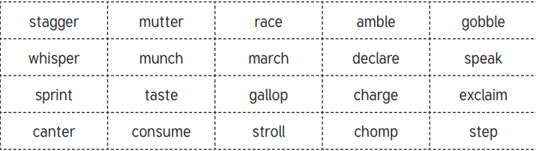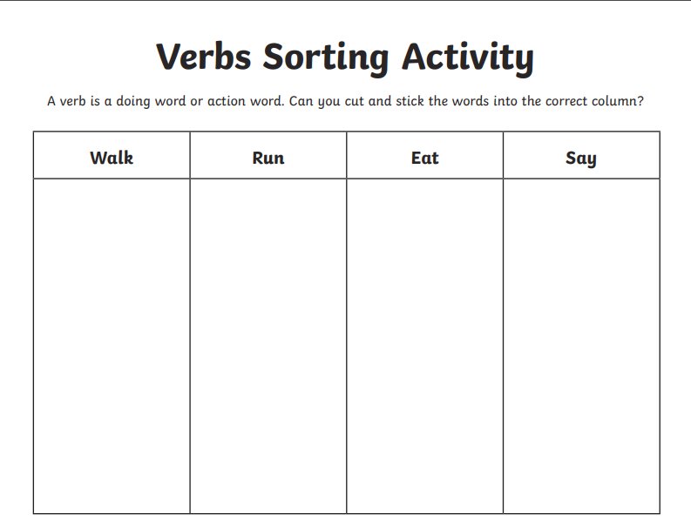Chilli Challenge

* Ask an adult to read some of these verbs to you and choose which heading they would come under.
* Ask an adult to read all of these verbs to you and choose which heading they would come under.
* Read these verbs independently and choose which heading they would come under.

**You might want to check your answers by looking the verbs up in the dictionary! 😊**